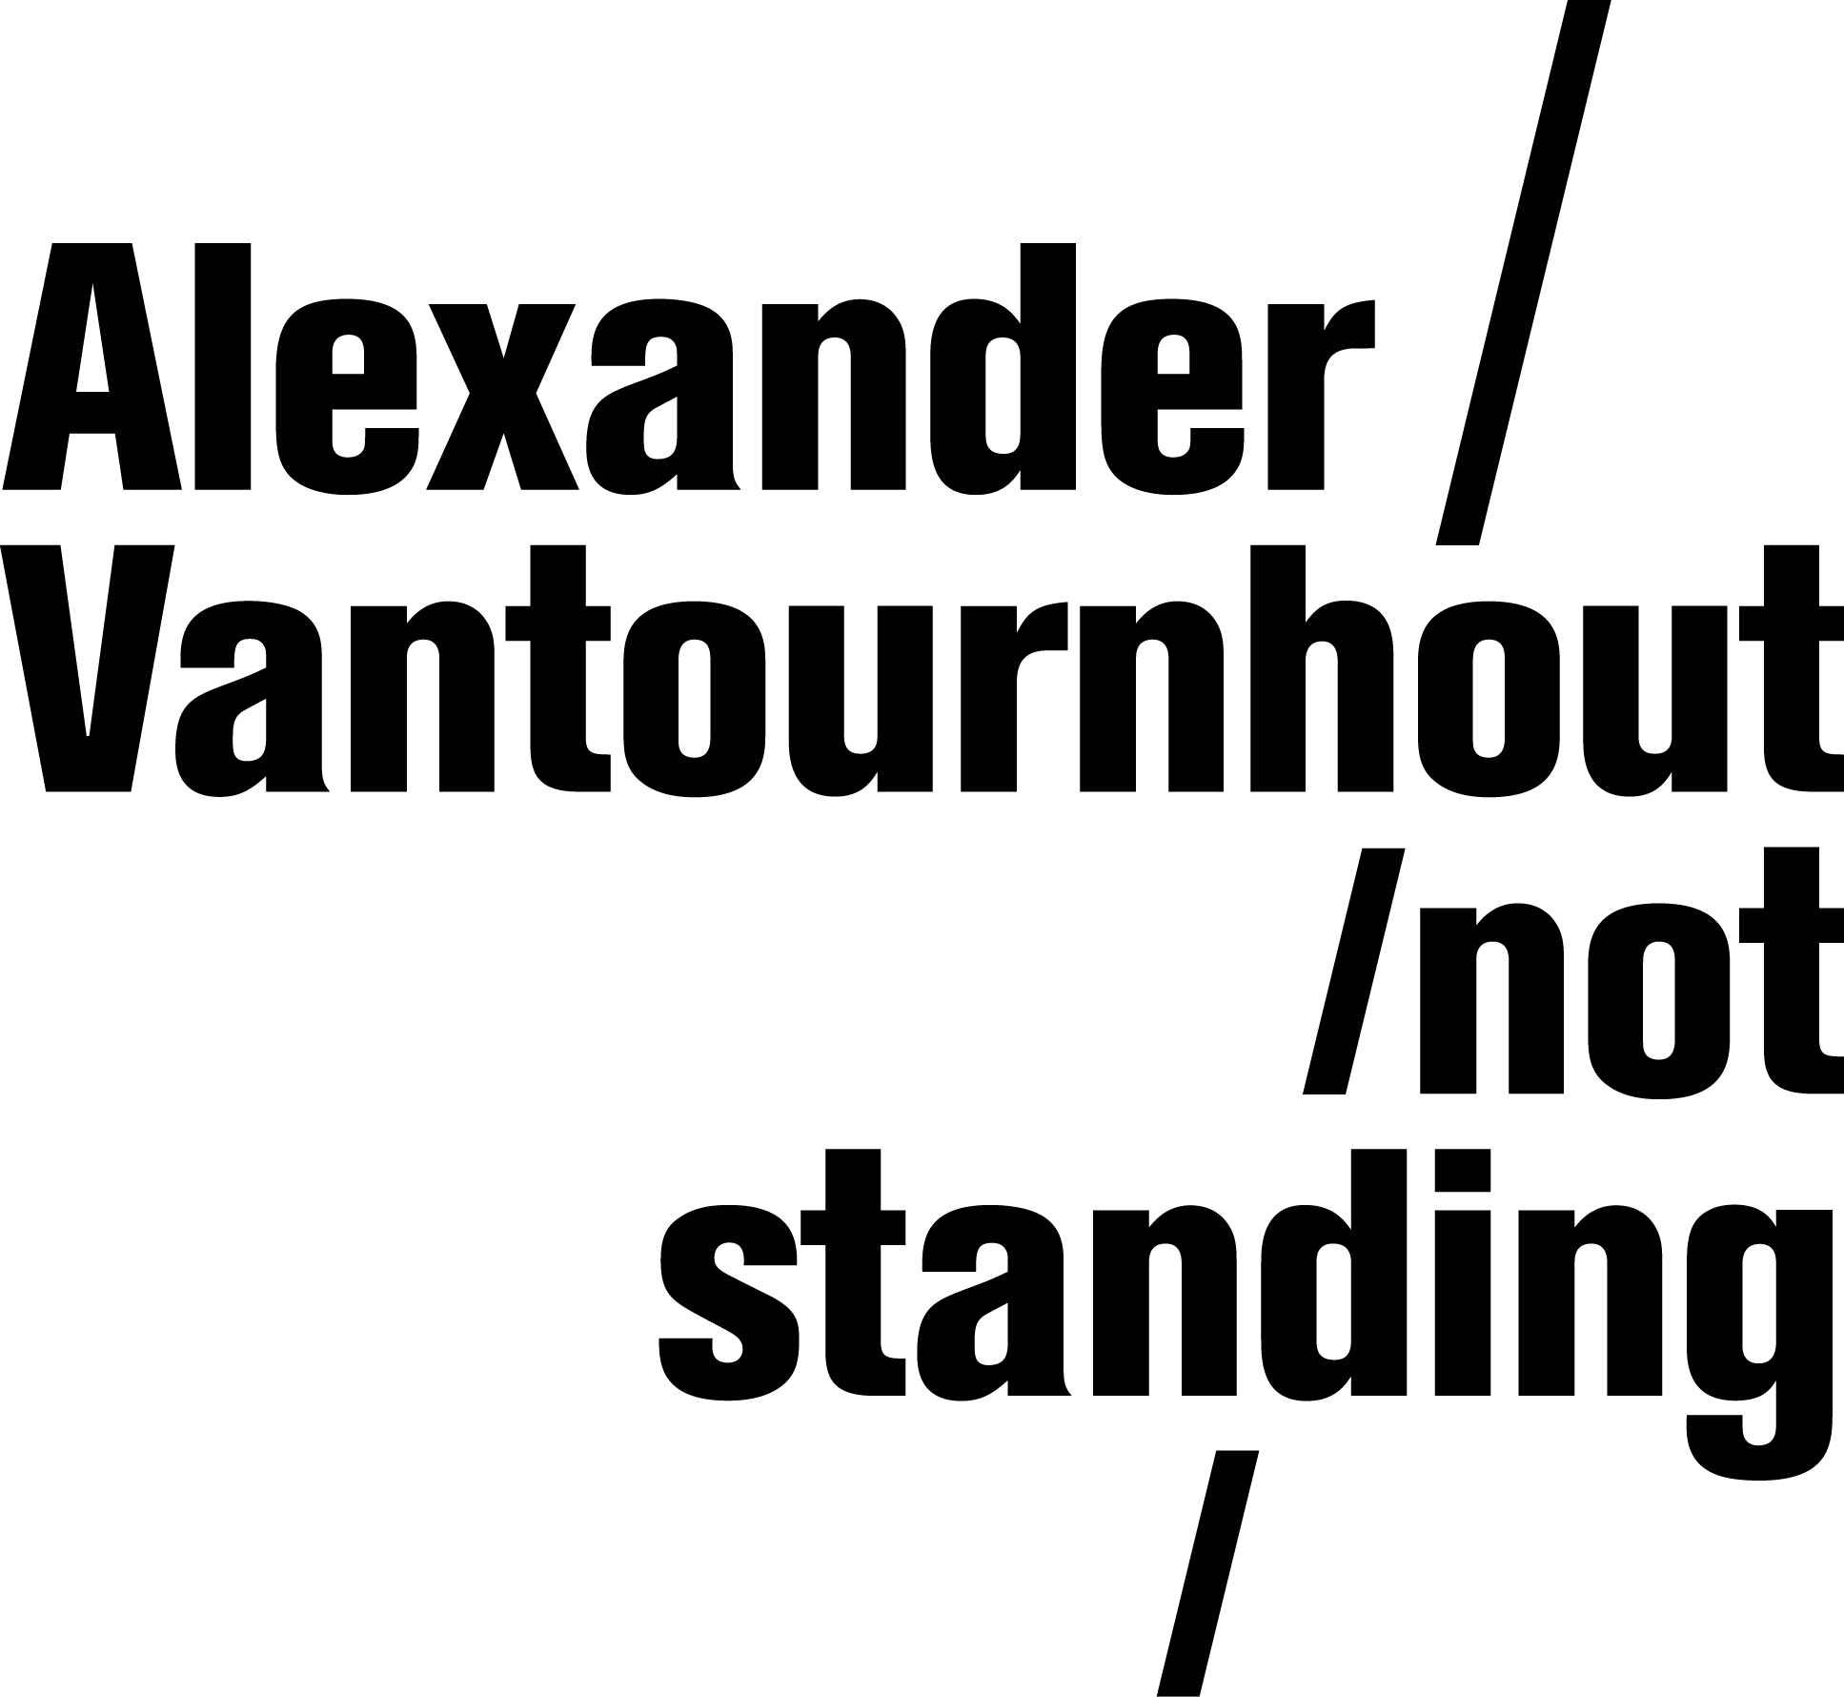
Through the Grapevine (2020)

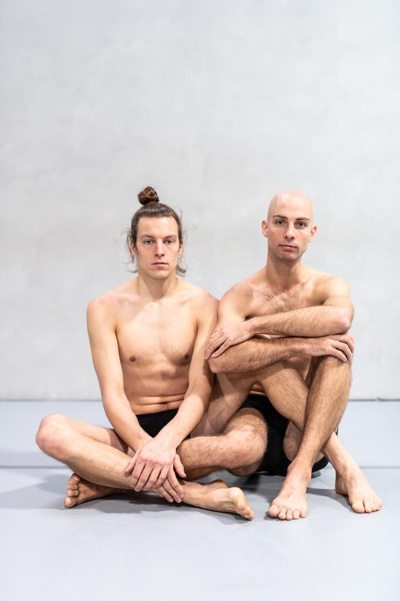

Through the Grapevine (2020)

Through the Grapevine is a quirky pas de deux between two men. Performers Alexander Vantournhout and Axel Guérin show their bodies, stripped of all frills. They are trained but certainly not perfect, do not resemble beautiful Instagram pictures and do not try to impress with virtuosity, but instead demonstrate the beauty of reality.

The choreography plays with the differences in physique and physical strength. With great effort and concentration, the performers search for balance, equilibrium and harmony without shying away from humour. They challenge themselves and one another. They push each other forward, alternately leading the dance. Through constant mutual physical contact, the synergy between touching and being touched unfolds as the base-melody of this performance.

Through the Grapevine situates itself in the contemporary context in which the human body is often reduced to a 'false image' or 'non-existent, depicted body', a kind of virtual object or simulacrum. Bodies are adapted and corrected with programs like Photoshop and are more often seen through the eyes of social media platforms such as Instagram. The image of the real body fades with each day. This new, virtual body image rarely encounters real touch. Gradually, the human animal is transformed into a lonely, sensory unit, an 'image body' with a speaking head.

This pas de deux strives to shed new light on the importance of touching and in particular, touch as a separate and irreplaceable form of intimacy. To avoid an overly simplistic romantic interpretation, the choreography opts for contact between two male bodies. At the same time, without evading the duet's intimacy and sensuality, touch is redefined: the emphasis is deliberately averted from the difference between touching and being touched. When two people shake hands, for example, it is difficult to determine who instigates the touch and who undergoes it. In Through the Grapevine, prolonged contact and physical strength are used as counterbalances to shape the ambiguous and hybrid character of touch.

THE ROADS THAT LED TO THROUGH THE GRAPEVINE

The structure of Through the Grapevine is freely inspired by the classic pas de deux, which is strongly determined by the different gender of the dancers and consists of five parts: an introduction, an adagio with two variations, a solo of one dancer followed by a solo of the other dancer and finally a coda, a closing piece, in which both dancers demonstrate their virtuosity.

However, in Through the Grapevine the solos will be 'assisted solos'. One dancer will not lift the other into the air; Axel and Alexander will start from a symmetrical collaborative relationship which will be continuously reshaped and transformed during the piece.

Alexander previously created two (pseudo) duets: La Rose en Céramique (with Scali Delpeyrat, 2018) and Raphael (with Bauke Lievens, 2017). Additionally, Screws (2019), Alexander's first location performance, features ongoing reference to the duet form. Moving from a completely symmetrical relationship between Alexander and Axel, Through the Grapevine is an extended, deeper search for the duet form.
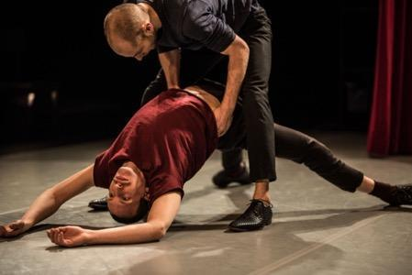
With the faux solo or the « solo with two » Raphael (2017), Alexander, together with Bauke Lievens, created an intimate and forced duet for two bodies, one of which was active as an animator (he), and the other took the position of passive or inert object (him). He tries to manipulate him into an ideal dance or sparring partner, but at the same time, he is turned into an object himself. This relationship is comparable to that of the 'material' animated by the puppeteer. The latter is seldom present as a subject. Perhaps the passive body was never more than a mere object?

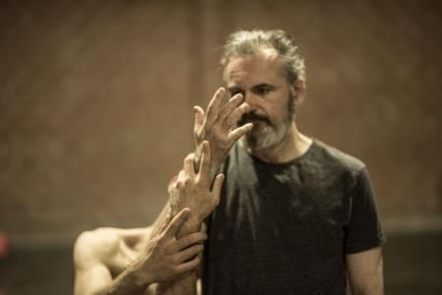
While Raphael was a forced duet, La Rose en Céramique (2018) was inspired by the « assisted duet ». Scali Delpeyrat speaks of his inner struggles and love affairs while Alexander acts as an assistant or amplifier of Scali's feelings, something of a projection of what Scali has become. During rehearsals Alexander observed Scali's spontaneous movements and asked him to reproduce them very accurately. He then strengthened them by means of grips that held Scali's elbows or shoulders. This process led to an assisted dance.

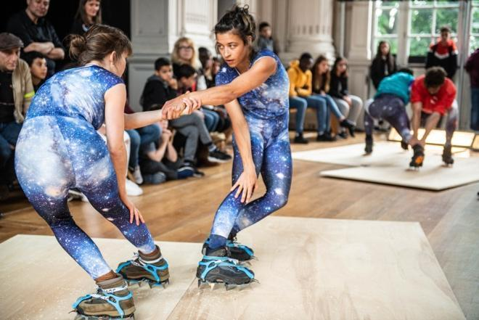
Screws (2019), Alexander's most recent work, is a collection of micro-performances which take place amongst and around the audience, including duets with ice grips and anti-gravity shoes. The performance explores the different possibilities that arise within the choreography and looks for ways to support or transform existing movement.

The piece also includes a solo in which Alexander manipulates and is manipulated by a bowling ball, an indirect reference to the duet form. Duets are often presented in a circular or bi-frontal constellation. This study of motion is based on the vortex, the screw form and the spiral along with the counterweight as a parameter which must be taken into account at all times.

THE PROPORTIONS

Another theme in Through the Grapevine is the performative effect of differences in body proportions. The duet form is used to emphasize the physical differences between the two performers (Alexander Vantournhout and Axel Guérin) and to investigate how these vary according to the position of the body. This specific choreographic approach, which draws directly on the physical, involves more than a purely formal or artistic interplay of differences. By accentuating the differences in physique between the two performers, Through the Grapevine indirectly questions the standardized 'image body' portrayed by advertising and social media.

Observe the differences:
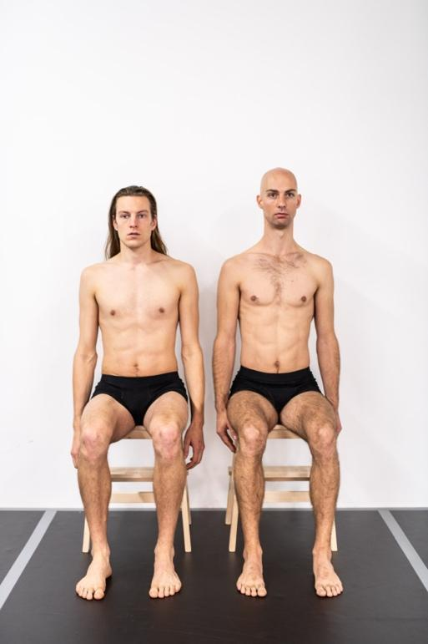
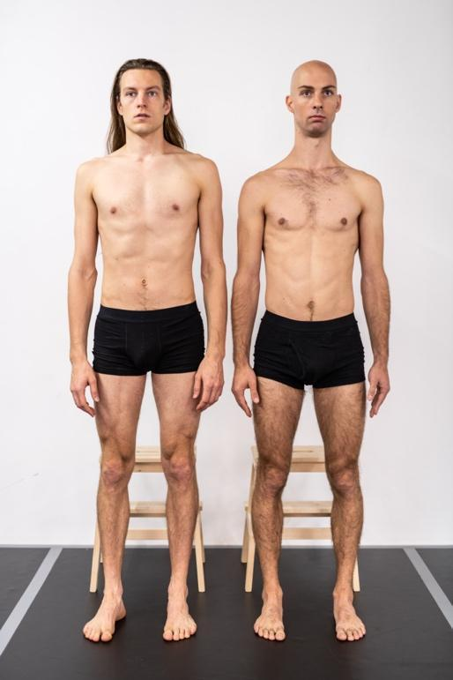
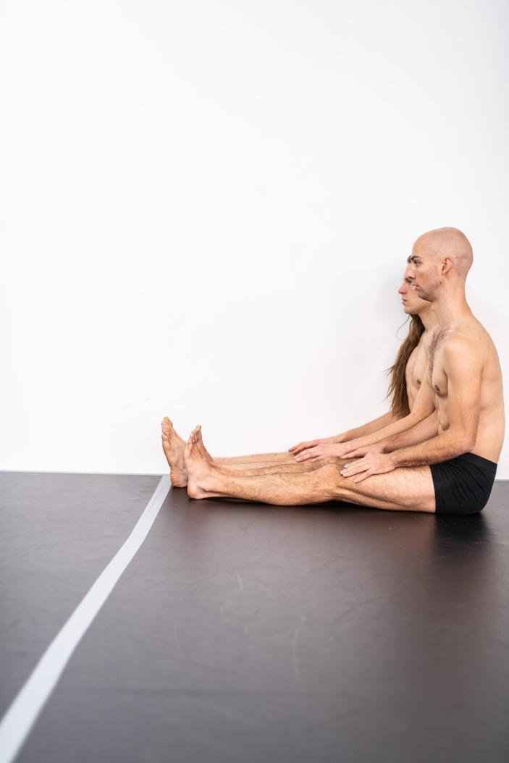
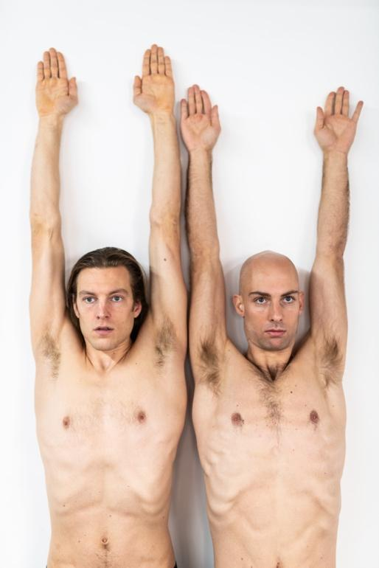
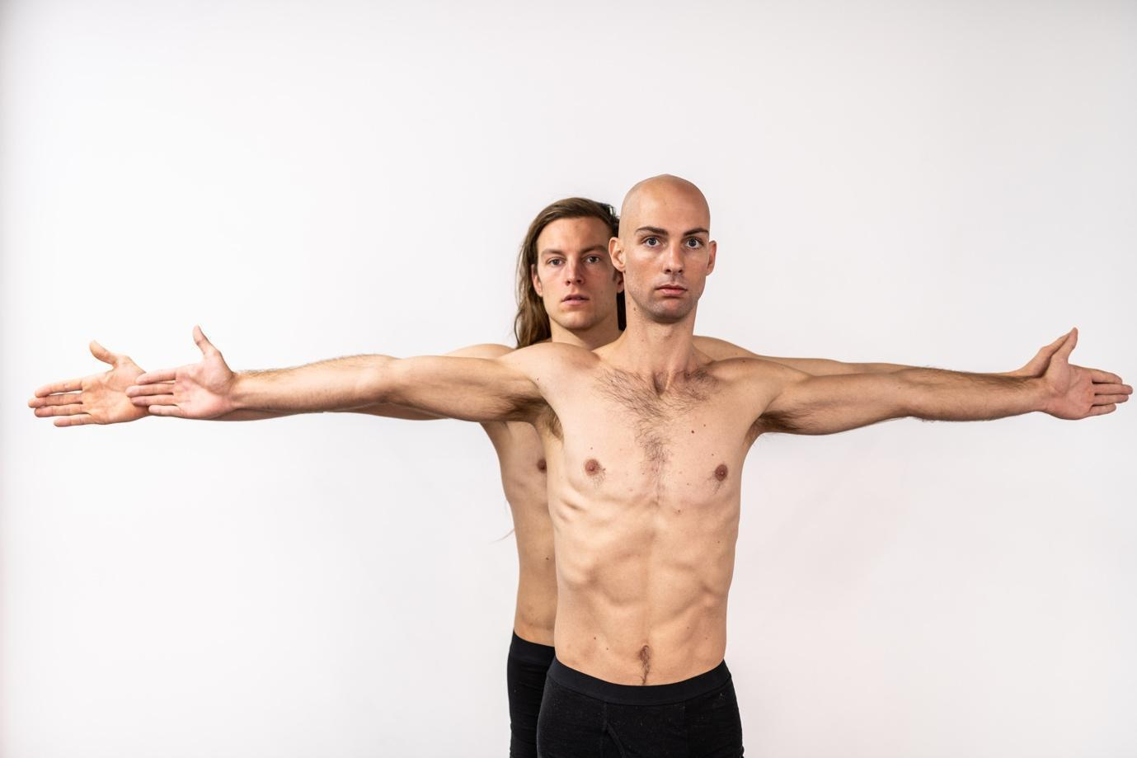
Axel Guérin
- long limbs (legs and arms); long shins;
- short trunk: this often results in more flexibility in the back;
- short neck, long hair;
- high centre of gravity;
- shoe size 45

Alexander Vantournhout
- short limbs (arms and legs): slightly curved legs (bowlegs), arms slightly X-shaped
(the forearms are thicker than the biceps);
- long trunk, very high sitting height (longer spine creates more torsion);
- very long neck, no hair;
- low centre of gravity;
- shoe size 42

Alexander and Axel are precisely the same height, while their bodies are feature completely different builds. Alexander has a long upper body and short legs, a long neck, and a low centre of gravity. Axel, on the other hand, has long legs and a short upper body and, therefore, a high centre of gravity. The differences in physical proportions create a mathematical right to who initiates and who leads. Axel, with an additional 10 centimetres in arm span, leads a handshake, for example, while Alexander's advantage heightens when the choreography is situated in the torso.
The solo ANECKXANDER (2015), in co-creation with Bauke Lievens, also focused partly on (dis)proportions. The performance shows how the gaze of the Other, which has become simultaneously omnipresent and anonymous with today's social media, reduces our identity to several physical characteristics. The objects on stage are used exclusively to camouflage the vulnerabilities and disproportionate features of Alexander's/Aneckxander's body. However, as is often the case with disguises, these prostheses emphasize the weaknesses rather than conceal them.

SYMMETRY
In Through the Grapevine, the duet partner Axel will replace these objects, and symmetry will be developed, which can never be entirely symmetrical given the physical differences. This theme also reflects a deepening of Alexander's previous works. The opening scene of Screws, titled 'Snakelegs,' is based on the intertwining of legs and investigates how the lower leg could have the same rotation as the forearm, resulting in screws or helixes in the bodies. Inspiration for this study of motion is drawn from the gibbon, an ape with a unique wrist joint that functions as our shoulder joint. What if this was also possible for humans, and not only in the arm but also in the leg.
Animals always form a great source of inspiration for Alexander's work, which also calls into question the 'physical anthropocentrism' in dance as a physical art. This is never merely imitation, but rather the incorporation of a specific animal characteristic into the language of movement. Alexander often experiments with varying animal locomotion (walking patterns), and the two performers will investigate the result of attempts to incorporate different locomotion, such as the ipsilaterality of the camel (left-left/right-right) and the unpredictable walking pattern of the eight-legged spider, which can walk forwards or backwards with equal speed, or the aquatic locomotion of a sponge or reptile.
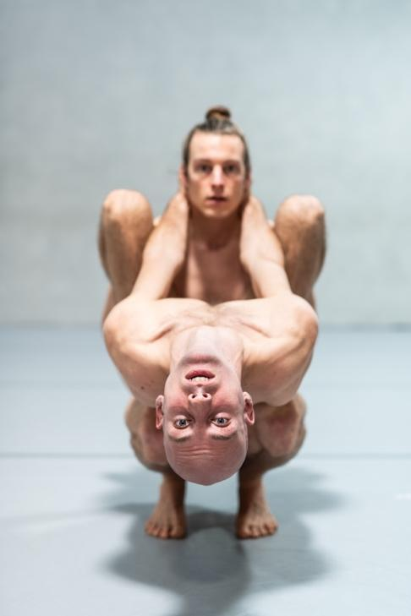
Whereas Screws was still investigating point symmetry, Alexander's aim with Through the Grapevine is to expand upon the investigation of symmetry on the vertical mirror line to include the horizontal and diagonal line. Man is bilaterally symmetrical, and Axel and Alexander sometimes try to relate to each other as a unit, sometimes as radially symmetrical figures (such as the octopus). The movement matter therefore investigates how we can evolve from duality to unity, and then split back into a multiplicity like a flock of wolves or an ant colony, by focusing on the extremities: 4 hands and 4 feet / 40 fingers and 40 toes. With this unique, masculine duet, Alexander invites the spectators to reflect on both the human body form and the duet form, through alienation and transformation of both bodies. To which performer does this arm belong? And to whom does this leg belong? The bodies continually separate and unite, making it difficult for the spectator to differentiate the performer's individual bodies.

LEADING/FOLLOWING
In dance, the audience's attention is always also guided by the recognition of a movement's origin and primarily its traceability: who is leading and who is following? The physical differences between Alexander and Axel inevitably produce a 'back and forth', a rapid fluctuation between leading and following, in which the performers both position themselves alternately as protagonist and antagonist, initiator and facilitator. At the same time, physical and proportional differences also ensure that bodies can be better attuned to one another. As the heights of the three physical centres of gravity (neck, chest, and hip/navel) of the two artists differ by an extreme five to ten centimetres, it is always possible to collectively create a mutual balance. The bodies fit together, as it were, and loss of balance can be rectified immediately by mutual exchange of forces.
In Through the Grapevine, the constellations strive for complete symmetry. As a result, the performance will also illustrate a utopian-looking togetherness that puts the engrained difference between subordinate and insubordinate into perspective through ongoing shifts in positioning. Visually, this blurs the position of Alexander as choreographer and author. As the rules in the studio are strictly predetermined, Alexander sooner defines his role as a co-performer with self-imposed rules, a working method that can be found throughout his entire œuvre.

SCENOGRAPHY AND LIGHT

With Through the Grapevine, Alexander Vantournhout returns to the theatre following the on-scene performance of Screws. It will be the first time that Alexander does not integrate objects in his performance, an invitation to invest added focus on scenography and lighting design, for which Harry Cole (Jan Fabre, Voetvolk,...) was recruited.

The scenography draws its inspiration from the traditional concept of the Italian proscenium: from a specific perspective, that of the king on the first balcony, the spectator observes an ascending scene, converging towards a vanishing point, often in the form of a frame (trompe l'oeil) to represent infinity. The scene will consist of a vertically (upstage- downstage) running white dance floor, which will be cut into a trapezium. At the beginning of Through the Grapevine, the focus of the light will be downstage, allowing the viewer to experience a classical scene arrangement (with a floor in an apparent rectangle). As the performance progresses, and Alexander and Axel begin to move in the space and relate not only to one another's different proportions but also to the dimensions of the performance area/trapezium, the spectator is drawn into the vanishing point.

MUSIC

Axel and Alexander incorporate the concept of abstract body percussion in which sound and movement are inherently connected. Alongside the development of the choreography, percussionist Andrea Belfi composed a soundtrack which first acts as a driving force and then stops or counteracts it. This gives rise to an organic interplay between what our eyes and ears will perceive. Costume designer Ann-Catherine Kunz (Rosas, Claire Croizé,...) contributes to the discovery with the experimentation and use of materials and textures for the costumes.

PRACTICAL INFORMATION

Team on tour: max. 6 (2 performers, 2 technicians (depending on the tour), 1 production manager, 1 company manager)
Duration: 60 minutes
Montage: on the day of the performance
Audience: max. 500 people (depending the space and in consultation with the company)
Minimum surface: 9 x 9m

TEAM

Alexander Vantournhout (choreographer and performer)

Alexander Vantournhout (Brussels, 1989) studied contemporary dance at P.A.R.T.S. (Performing Arts and Research Training Studios, Brussels), and single wheel, juggling and dance acrobatics at ESAC (Ecole Supérieure des Arts du Cirque, Brussels).

Alexander made his debut with CAPRICES (2014), a choreographic solo to the music of Sciarrino. In 2015 he created ANECKXANDER together with Bauke Lievens. This solo was awarded the Circus Next Prize in 2014, the Public and Young Theatre Prize in Theater Aan Zee (Ostend, 2015) and was selected for the Aerowaves Network and 'Theatre Festival' which presents the most remarkable Belgian performances of the year. Raphaël (2017) is a forced duet created and performed with Bauke Lievens. Red Haired Men (2018) is the first ensemble piece for four men, inspired by the poet of Daniil Charms. In 2019, Alexander created Screws (2019), his first piece in situ, where he accompanies the audience along a route of micro-performances with four dancer acrobats. With Through the Grapevine (2020) Alexander returns to the concept of the duet. Together with Axel Guérin, Alexander investigates the formula of the pas de deux.

Alexander's movement language is influenced by different pedagogical processes and by breaking through the boundaries of the varying art forms. Two constants within his artistic ventures are the search for creative and kinetic potential in physicality and an investigation into the many possibilities of the relationship between performer and object.

Alexander is artist in residence at Vooruit centre of arts in Ghent (2017-2021). He is artist associé de Cirque-théâtre Elbeuf (2020-2021) and CENTQUATRE-PARIS (2020-2021). Alexander's company is supported by Fondation BNP Paribas for the development of his projects.

Axel Guérin (performer)

Axel Guerin (Brussels, 1992) studied acrodance with Winston Reynolds in Circomedia, Bristol (UK) (Centre for Contemporary Circus and Physical Theatre) and specialized in acrobatics and physical theatre. He then continued his studies in ACAPE (Academy of Circus and Performance Arts) where Alexander Vantournhout was a guest lecturer at the time.
Axel has worked with various choreographers such as Florentina Holzinger, Mor Shani, Marc Van Loon and Janni van Goor (Kopergietery). Guérin is associated with NofitState Circus for several projects and is one of the performers of Red Haired Men (2018), Alexander Vantournhout's first group creation.

Rudi Laermans (dramaturge)

Rudi Laermans (Brussels, 1957) is professor of social theory at the Faculty of Social Sciences of the University of Leuven (KULeuven). From 1992 to 2006 he was also responsible for the Centre for Sociology of Culture.

Laermans has also been involved in the theoretical programme of P.A.R.T.S. since 1995, the international dance school in Brussels led by A.T. De Keersmaeker. He has also been a guest professor at many art academies such as the Design Academy in Eindhoven, the Willem De Kooning Academy in Rotterdam, the Royal Danish Art Academy in Copenhagen, the Malmö Art Academy and DOCH School of Dance and Circus in Stockholm.

Laermans has published numerous essays and books on social and cultural theory, cultural politics and participation, contemporary dance and the visual arts. He often uses a sociological perspective while also developing a broader vision inspired by contemporary philosophy and political theory. Among his most recent books, Moving Together: Theorizing and Making Contemporary Dance (2015) and Max Weber (2017, with Dick Houtman).

In the past, Laermans has been an advisor to several former P.A.R.T.S. students such as Ula Sickle and Eleanor Bauer. He was also jointly involved as a dramaturge in Alexander's latest creation, Screws (2019).

Emmi Väisänen (artistic collaborator/researcher)

Emmi Väisänen (Pieksamaki, Finland) is a contemporary dancer, living in Brussels. She studied dance at Turku Conservatoire and S.E.A.D (Salzburg Experimental Academy of Dance). Following her studies, she worked with Willi Dorner, Julia Schwarzbach, Alexandra Waierstall, ECCE/Claire Croizé and Etienne Guilloteau and Rakesh Sukesh. She performed in Alexander Vantournhout’s Screws (2019).

Andrea Belfi (composer)

The Italian Andrea Belfi is a percussionist, composer and experimental musician. His music seamlessly merges the acoustic and electronic. The energetic and hypnotic soundscapes are multilayered and immersive. Belfi's music propels through an exploration of deep, mysterious night landscapes. As a born live-artist, his music truly comes to life on stage and he has built a strong live reputation thanks to his captivating drum solos and boundless improvisations. Throughout 2019, he contributed to Thom Yorke's Tomorrow's Modern Boxes tour. In the past he also worked with Nils Frahm, Jóhann Jóhannsson, Mike Watt, David Grubbs, Ben Frost, Mouse on Mars and others. Belfi has made his mark on international venues such as Philarmonie de Paris, Montreaux Jazz Festival, The Greek Theatre (Los Angeles), Unsound Festival (Krakow), Barbican Centre (London), Issue Project Room (New York), CTM festival (Berlin). His latest EP 'Strata' was released by FLOAT.

Caroline Mathieu (lighting design)

Caroline Mathieu is active as a designer for theatre creations. Her role takes various forms: scenographer, light designer, performer and researcher. After a Master study in Product Design and a Master after Master in Theatre Studies, design and theatre came together in a Scenography course at the Royal Academy of Fine Arts in Antwerp. After her training, she started as an assistant lighting design for the performance It's going to get worse and worse, my friend by Voetvolk/Lisbeth Gruwez. Later she worked as a light designer for Mercedes Dassy, Vera Tussing, Igor Shyshko & Tale Dolven, among others. Recently she started collaborating with Prof. Dr. Valéry Ann Jacobs (VUB) on her own lighting research project as part of a PhD in the arts.

Harry Cole (lighting proposal)

Harry Cole began in 1989 and immersed himself in the art of light drawing as a light design assistant in the then KJT, now hetPaleis. In 1997 he started as a freelance lighting designer for various theatre and dance productions, including Jan Fabre, Alain Platel, Arne Sierens, Voetvolk/Lisbeth Gruwez, Het Gevolg, hetPaleis, KVS, Dito Dito, Young@Heart Chorus Northampton USA, RuhrTriennale, Compagnie Lamaison in Toulouse, and "Anonymous Society", a tribute to J. Brel in London. Within this period, he also decided to dedicate his collected knowledge for various training courses and workshops, and more specifically for RITCS in Brussels, BASTTvzw (now STEPP), Sabbattini, among others. In 2010, Harry was asked to join the permanent team of professors as Head of the Professional Bachelor of Stage Techniques programme at the School of Arts RITCS in Brussels.

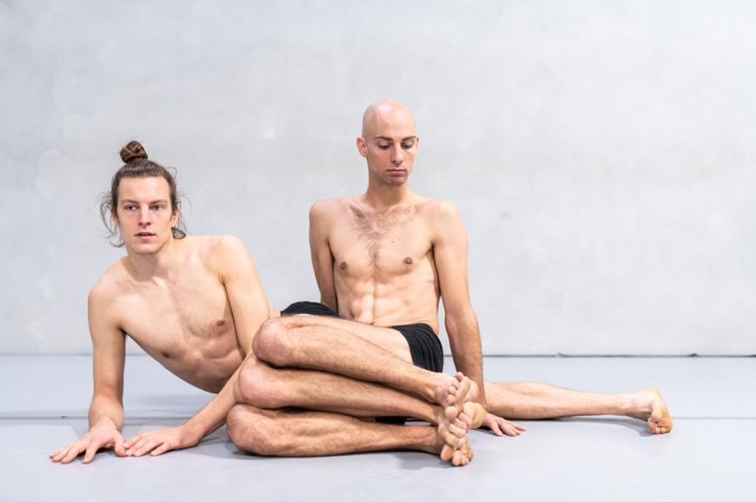
CREDITS

Concept & choreography: Alexander Vantournhout
Created in collaboration with: Emmi Väisänen & Axel Guérin
Performers: Axel Guérin & Alexander Vantournhout

Composer: Andrea Belfi

Dramaturgy: Rudi Laermans

Lighting design: Caroline Mathieu
Lighting proposal: Harry Cole
Technics: Rinus Samyn

Costumes: Anne-Catherine Kunz
Concept scenography: Bjorn Verlinde

Outside eye: Anneleen Keppens, Maria Ferreira Silva
Thanks to: Sébastien Hendrickx, Vera Tussing, Esse Vanderbruggen, Gerald Kurdian

International première:
25-27/06/2020 Subsistances, Lyon (cancelled due to COVID-19)
3-4/10/2020 Actoral, Marseille
Dutch avant-première / site-specific: 13-21/06/2020 Oerol TerSchelling (cancelled due to COVID-19)
Belgian première: 8-9/10/2020 Vooruit, Gent

Distribution: Frans Brood Productions
Company manager: Esther Maas
Production manager: Aïda Gabriëls
Photos: Bart Grietens

Coproducers: Arts Centre Vooruit, Ghent (BE), PERPLX, Marke (BE), CENTQUATRE, Paris (FR), Cirque-théâtre Elbeuf (FR), Subsistances, Lyon (FR), Théâtre de la Ville de Luxembourg, Luxembourg (LU), MA scène nationale – Pays de Montbéliard (FR), Les Hivernales CDCN, Avignon (FR), Malpertuis, Tielt (BE), Theater Freiburg (DE), Théâtre des Quatre Saisons, Gradignan (FR), Théâtre de l’Arsenal, Val-de-Reuil (FR)

Residencies: les ballets C de la B, Ghent (BE), Arts Centre Vooruit, Ghent (BE), STUK, Leuven (BE), Subsistances, Lyon (FR), Wood Cube, Roeselare (BE), Workspacebrussels, Brussels (BE)

Residencies cancelled due to COVID-19: Arts Printing House, Vilnius (LT) Oerol, Ter Schelling (NL), Le Gymnase CDCN, Roubaix (FR), Grand Théâtre, Groningen (NL)

Production: Not Standing vzw
address: Beversesteenweg 78, 8800 Roeselare (BE)

With the support of the Flemish authorities.
Alexander Vantournhout is artist-in-residence in Arts Centre Vooruit in Ghent, associated artist of le CENTQUATRE Paris and Cirque-théâtre Elbeuf and cultural ambassador of the city of Roeselare.
Alexander Vantournhout is supported by Fondation BNP Paribas for the development of his projects.

CONTACT

www.notstanding.com

Tour planning
info@fransbrood.com
www.fransbrood.com

Artist
Alexander Vantournhout
info@notstanding.com
Company manager
Esther Maas
esther@notstanding.com

Production & administration
Barbara Falter
barbara@notstanding.com

Tourmanager
Kiki Verschueren
kiki@notstanding.com

Technical coordination
Bram Vandeghinste
bram@notstanding.com

Communication
Aïda Gabriëls
aida@notstanding.com

