London Mime Festival, Aneckxander, review – Original, engrossing, weird

Dancer and circus artist Alexander Vantournhout's nakedness quickly becomes abstract in this odd but absorbing performance, says Lyndsey Winship
25 January 2016, by Lyndsey Winship
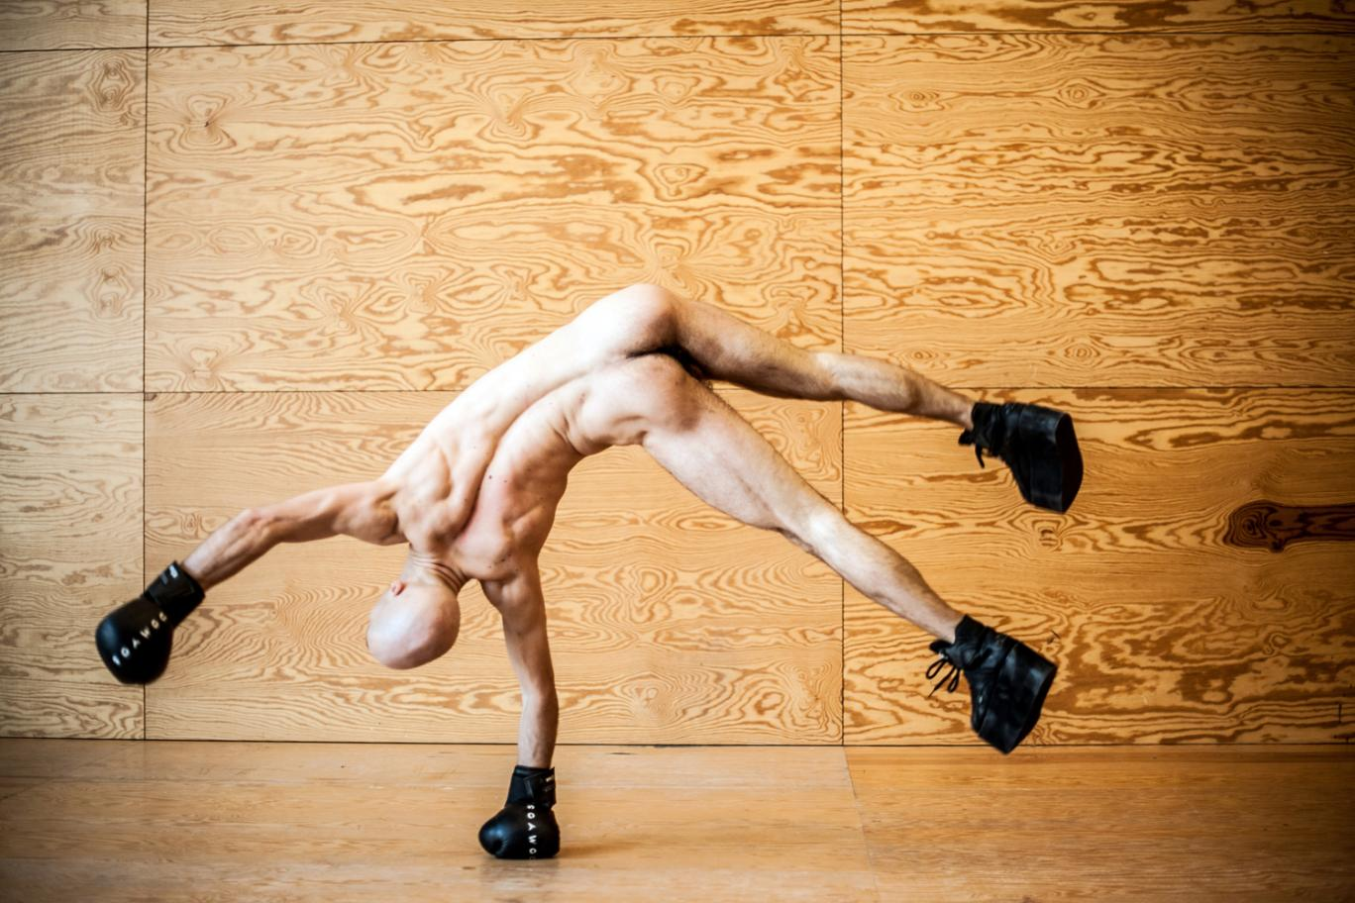
Weird and kind of wonderful: Alexander Vantournhout ©Bart Grietens
The prospect of watching a naked Belgian doing cartwheels might not sound like your idea of a great night out (or maybe it does?) but it turns out to be unexpectedly engaging in this show from dancer and circus artist Alexander Vantournhout, part of the London International Mime Festival, an annual fest of uncategorisable surprises.
Apparently the seed for Aneckxander came when someone told Vantournhout that he has a very long neck — and it’s true, he does. He’s a man with an extraordinary body, although what we might take from this is that all bodies are rather extraordinary when you really look at them.
Vantournhout’s nakedness quickly becomes abstract as he folds limbs and torso into Rorschach shapes. But the stuff beneath the skin feels real: ribbons of muscle, curious protuberances, the blood all rushing to his bald pink scalp when he tips upside down. Vantournhout dons platform boots and boxing gloves and levers himself into handstands and windmills and flips, repeatedly testing himself as if serving some sort of gymnastic penance. He crashes to the ground and we all flinch, the visceral reaction of our own bodies brought into the performance. It’s original and engrossing; weird, and kind of wonderful.
Source: http://www.standard.co.uk/goingout/theatre/london-mime-festival-aneckxander-review-original-engrossing-weird-a3164036.html

