Ebonyonline.net
Afrocentric Theatre, Music, Culture and Business
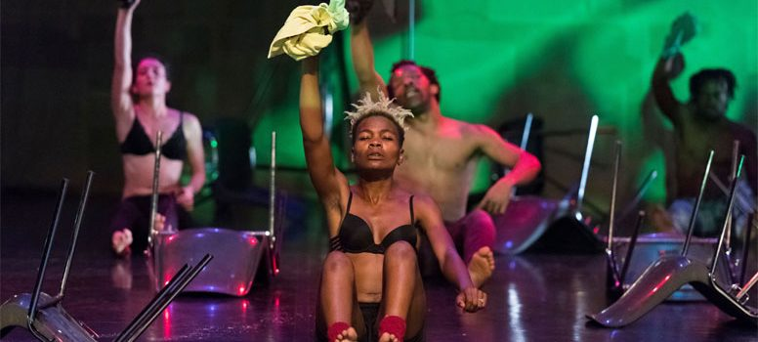

Kalakuta Republik (Dance Theatre Review)

***
Fela Kuti, was a Nigerian multi-instrumentalist, composer, pioneer of the Afrobeat and a human rights activist and cousin of the Nigerian writer and Nobel laureate Wole Soyinka, the first African to win the Nobel Prize for Literature. His mother was a feminist activist in the anti-colonial movement, whilst his father was the first president of the Nigeria Union of Teachers.
It’s therefore not surprising that there’s continued interest in the life and politics of the enigma that was Fela. Somewhere in the world there will be a music festival, art exhibition or event dedicated to his work or an Afrobeat band keeping his music alive.
This year it’s the turn of the Barbican. Who hosted over three nights, a dance theatre piece called Kalkakuta Republik by the Serge Aime Coulibaly and his Faso Danse Theatre company.
This much anticipated dance piece uses Fela’s political engagement as a springboard to question the artist’s role in today’s society.
The first half opens sombrely, all dark and monochrome. Then suddenly, the seven dancers, led by Serge himself burst into life. Writhing rhythmically to a well know Fela track, they covered the stage with a grace and athleticism that was a joy to watch. A large old sofa and rig boxes the only props on stage were used cleverly to great effect.
Projections depicting scenes of conflict serve with subliminal messages served as a backdrop for the performers, their perpetual motion an urgent metaphor for the desire to keep living. The half closes fittingly with a bass driven brooding rendition of jazz musician Archie Shepp’s, Blasé.
The second half explodes with a cacophony of colour and sound. The audience caught unawares by this visual and aural assault. The scenery has now been transformed, with tables and chairs scattered all around, reminiscent of Kuti’s Kalakuta Republic. A place where discord was confronted, just as hope blossomed from solidarity and social consciousness.
While provocative messages such as ‘Decadence can be an end in itself’ illuminate the backdrop, the dancers now covered in a mix of coloured powder and fluorescent paint, move around the stage with greater purpose and conviction firstly to the intoxicating ‘Lady’, one of Fela’s many hit songs as then later to a medley of jazz inspired music.
The performance closes with the three female dancers being carried like African queens through the audience on the shoulders of the muscular and lithe male dancers.
Coulibaly said a recent interview “This piece is a place of freedom, where we are trying to understand the world through questioning or analysing, not because we’re African artists but because we are all citizens of this world.”
This may well have been his desired sentiments, but without any form of narrative, it was difficult to fully conclude this from the night. What we were presented with was a series of well executed but disjointed dance pieces who combined meaning was hard to decipher.
As there was no formal ‘story’, it would have been good if the backdrops were used to greater effect in signpost the audience into what the various dance sequences were depicting.
Powerful and evocative as the dancers were, in particular Ida Faho and Antonia Naouele, the lack of structure let down what would otherwise have been an entertaining and original work by the renowned Burkinabé choreographer. Despite the oversight, this slice of Fela, is well recommended, if just for the vibrant energy of the dancers alone.

Source: https://ebonyonline.net/kalakuta-republik-dance-theatre-review/

