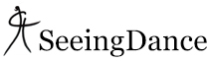

ANECKXANDER:

A tragi-comic self-portrait of the body
Published: October 10, 2016
In: Birmingham & Midlands, Reviews
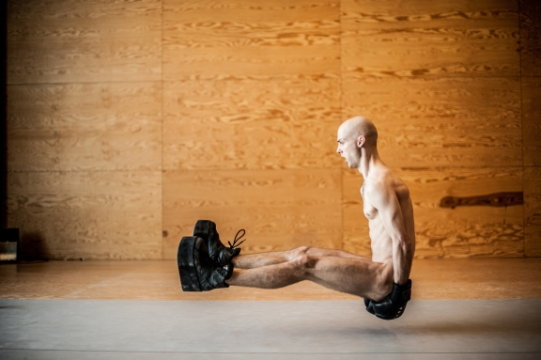
Alexander Vantournhout in ANECKXANDER
Photo Bart Grietens
Alexander Vantournhout & Bauke Lievens
Patrick Centre at the Birmingham Hippodrome
October 7, 2016
David Mead
Dancer and circus artist Alexander Vantournhout walks on carrying a few props almost apologetically. He puts them down and starts taking up a section of dance floor. Suddenly, whoosh! He’s naked, and remains so for the rest of the 45-minute or so solo in which he “rewrites,” as he puts it, the autobiography of his body. If that has you yawning, stop now, because ANECKXANDER turns out to be rather engaging and a work of surprises.
The nakedness is not gratuitous, though, and anyway your mind very quickly goes beyond it. You find yourself concentrating very much on his physical characteristics and his face. Every so often he looks at the audience; observing us observing him. And you find yourself not only watching what he is doing, but in a sense what he is thinking. He has a wonderfully disarming smile.
At first, he trundles about the stage bending and twisting his wiry and amazingly pliant body into different shapes as he stretches in strange and unusual ways. His long muscles and lean body are highlighted against the darkness. There is a neat four-legged spider-like creature and an ever-stranger three-legged I’m not sure what.
Alexander Vantournhout in ANECKXANDER
Photo Bart Grietens
Vantournhout is a fine gymnast. To a plaintive piece of Arvo Pärt from the keyboard he brought on, he performs some wonderfully controlled and graceful handstands and somersaults. The same sequence is then done wearing platform-boots, and then boots and boxing gloves.
He has what he calls a “badly proportioned body.” Those gloves and boots accentuate the length of his shorter than usual arms and legs (he also has a long neck, which he makes even longer by somehow reaching up and pulling his shoulders down simultaneously). The gloves and boots become like prosthetics; they upset expectations and cause us to look at him in new ways. As performing the sequence gets more difficult and the thuds on landing get louder, so we wince more. Is he testing himself? Or us? Is it some sort of self-punishment? Is he reliving something from the past?
There are moments of levity such as when one of those gloves comes in very handy at protecting his more delicate parts as he lands in a split from a huge leap. There’s a neat trick with sum gum too. Later the boots take on the weight of old-fashioned divers boots as he leans at impossible angles. The strength and control required is impressive.
You’ll certainly find ANECKXANDER strange and different, maybe absurd, maybe even grotesque. It may make you feel awkward. It’s also quite fascinating, appealing even. Just what a hold Vantournhout had on the audience was shown at the end when people stayed to watch him clearing the props away after his bows.
Running time: approximately 45 minutes
Source: http://www.seeingdance.com/aneckxander-10102016/

