Child review – scary scenes of untethered imagination
4 out of 5 stars - ****

Barbican, London
The final part of Peeping Tom’s trilogy surreally explores the innocence and danger of childhood – it’s definitely not for kids
Thu 23 Jan 2020
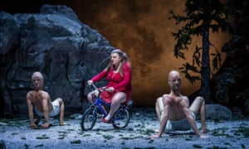
From another dimension … Eurudike de Beul (centre) in Child by Peeping Tom. Photograph: Tristram Kenton/the Guardian
Having already graced the London international mime festival with their surreal and deliriously inventive psychodramas Mother and Father, the Belgian physical theatre company Peeping Tom are back with the last part of the trilogy, Child.
It has a characteristically stunning set: a forest of pines on one side, a cliff of rock on the other. Workers in white overalls suspend a huge boulder above the stage. Into this mysterious and precarious scene blunders the Child: opera singer Eurudike de Beul, outsize on her little bicycle, wide-eyed and licking her lips insatiably. The boulder crashes, crushing one worker. De Beul gawps at us blankly, chewing on a tree.
Those elements – innocence, voraciousness, danger, destruction – are principal ingredients in the performance that follows, a string of cameos with a cast of surreal characters. There’s a forest creature, shaped like an ostrich but with a deer’s head and stilettoed human legs.

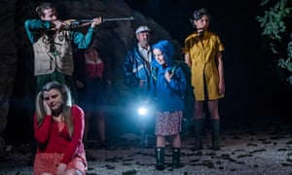
A scene from Child by Peeping Tom. Photograph: Tristram Kenton/the Guardian
A doll-like contortionist (Maria Carolina Vieira) mechanically loops her lasso before bursting into full-blown whip-crackery. Marie Gyselbrecht nurses a mewling little conifer, wrenching it to her breast as it trails umbilical roots. A giant slinky worms out from the mountainside, and a lost trekker (Yi-Chun Liu) gusts in on a storm, as if from another dimension.
This landscape of the untamed imagination may be about childhood, but Child is not a children’s show. When Liu is shot point blank by forest ranger Brandon Lagaert, De Beul gleefully grabs the rifle and blasts away at the body, mesmerised – as are we – by Liu’s virtuoso, sometimes slow-motion convulsions. Later, De Beul bashes someone’s head with a rock, as unthinkingly as she had caressed the deer. When a real child appears in this world of dreams, impulses and terrors, it’s a mighty relief to see Liu’s ghostly trekker intervening to take care of her, wrapping her up warm and sending her off with knapsack and torch. Off stage definitely feels safer.
The piece does become overstuffed, yet every scene grips on its own, with great use of sound and set, brilliantly watchable performers, and De Beul ranging from guileless vulnerability to toweringly operatic excess. You’ll leave wanting to treat children not just with care, but with caution.
• At Barbican, London, until 25 January. London international mime festival continues until 2 February.
Source: https://www.theguardian.com/stage/2020/jan/23/child-review-peeping-tom-barbican

