Peeping Tom: Child (Kind), review – A peculiar and gruesome look at childhood

As strange as it is insightful, the Belgian physical theatre company’s latest production is a dangerous treat

- Zoë Anderson

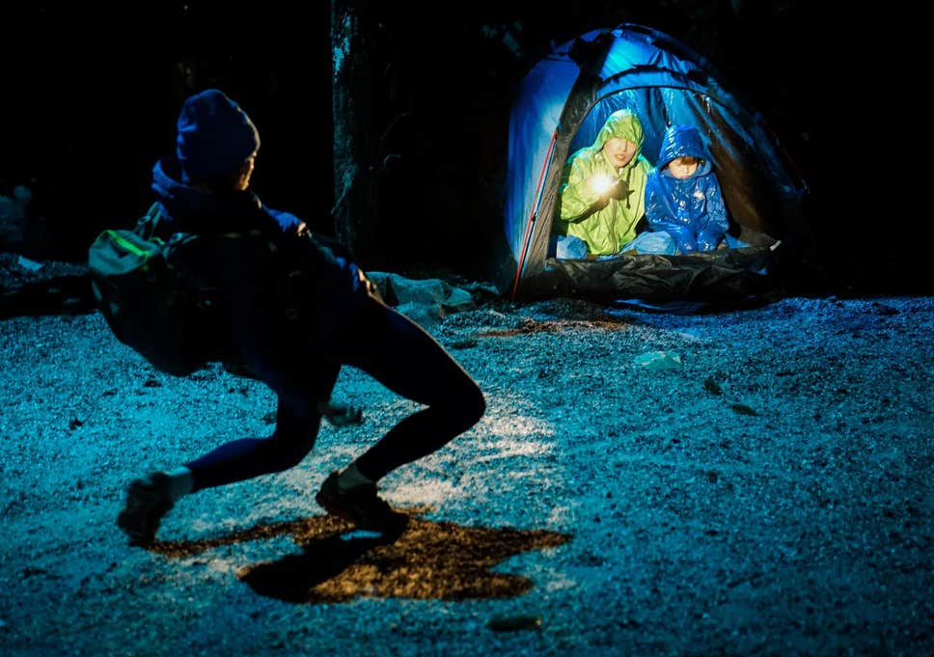
Peeping Tom's 'Child (Kind)' at the London International Mime Festival ( Olympe Tits )
Weird is home ground for Belgian physical theatre company Peeping Tom. The Olivier award-winning company returns to the London International Mime Festival with Child (Kind), completing the trilogy started by Mother and Father. It’s an unnerving look at identity and child experience, through a peculiar, sometimes gruesome mix of hyper-naturalistic scenery and very bendy bodies.
Directors Gabriela Carrizo and Franck Chartier start with a child living a friendless existence in a forest. Justine Bougerol’s set is huge and detailed, with looming cliffs and bristling pines, full of places for danger to emerge.
The adult singer Eurudike de Beul plays the child. Dressed in a short skirt and ankle socks, her hair in bunches, she rides a tiny bicycle, sticks her tongue out, skips about. In her child’s perspective, awful things are taken for granted, but smaller woes – a broken bike chain, inattentive adults – prompt literally operatic tantrums. As de Beul belts out bits of Tristan und Isolde in her rage, a dancer erupts from the rocks, throwing handfuls of glitter to make the moment even bigger.
Adult preoccupations are baffling, intriguing or infuriating. A couple kiss, ignoring everything else – our heroine holding up her new drawing, the dead body at their feet – until de Beul bites one in the leg.
There’s a lot of violence. A trigger-happy forest guard keeps shooting or threatening unlucky hikers, counting down as he points his gun. “Just shoot him already,” his girlfriend complains. “He’s waiting.” The child is encouraged to shoot at corpse, which twitches at every bullet. Dancer Yi-Chun Liu is extraordinary in this sequence, building it into a boneless, broken-puppet solo, creepy and comic.

The child copies adult behaviour, which is already surreally distorted. A woman hears a crying baby and rushes to comfort it – or rather, to kiss and croon over a trembling sapling. It grows into a wooden doll, which de Beul’s child steals, tries to breastfeed, attacks with an axe. When she places herself in sexual situations, is that imagination or abuse?
Child rambles, walking a deliberate line between bizarre and incoherent. Workers in hazard suits turn up to maintain the set, including a wriggling tube that undulates so wildly that you lose track of which way up the person inside must be. Dancers scuttle about, wearing aged facemasks back to front. Though some scenes are overextended, Peeping Tom’s stage world is insightful as well as strange.

Source: https://www.independent.co.uk/arts-entertainment/theatre-dance/reviews/peeping-tom-child-kind-london-international-mime-festival-gabriela-carrizo-a9298231.html

