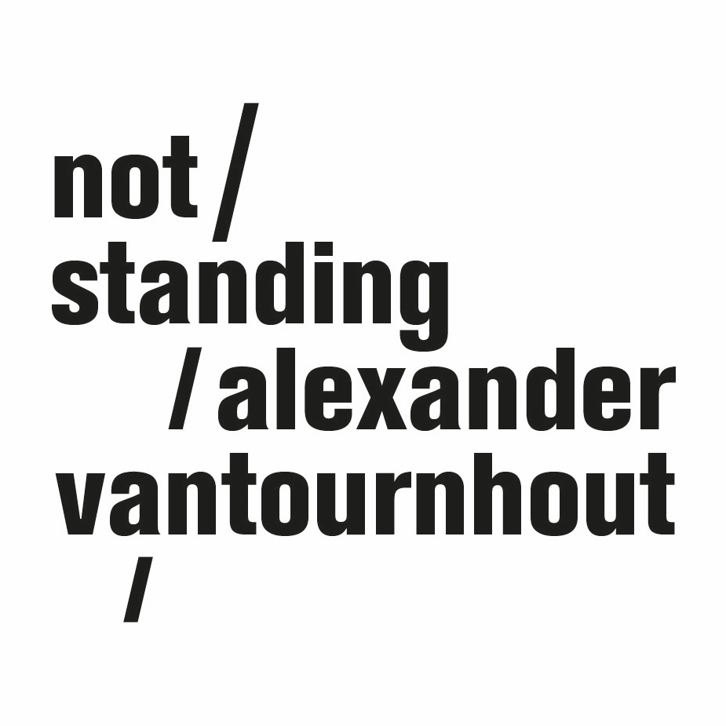
SCREWS (2019) - Alexander Vantournhout / not standing

Usually, a bowling ball has only one function: to knock over as many pins as possible at the end of the lane. But what if you remove this object from its usual environment? SCREWS redefines the relationship between the body and the object around. Objects are fastened to the body, either providing support or throwing it off balance, allowing gravity to be overcome or rather enhancing its effects. With the help of ice shoes, bowling balls, antigravity shoes and other objects, the dancers of SCREWS defy the laws of physics.
Five dancer-acrobats guide you along a route of reverberating micro performances, from short solos and duets to pointed group choreographies. This site-specific performance invites you out of your seat and guides you on a parcours through a particular building.

CREDITS
Choreography: Alexander Vantournhout
Created by: Petra Steindl, Josse De Broeck, Felix Zech, Hendrik van Maele, Emmi Väisänen & Alexander Vantournhout
Performed by: Charlotte Cétaire, Axel Guérin, Yassine Ouaamou, Nick Robaey & Esse Vanderbruggen
Dramaturgy: Sébastien Hendrickx
Intellectual in residence: Rudi Laermans
Choreographic help: Anneleen Keppens & Martin Kilvady
Costumes: Anne-Catherine Kunz
Technical director: Rinus Samyn
Light: Tim Oelbrandt
Technical design: Bert Van Dijck, Rinus Samyn, Tom Reynaerts & Tom Daniels
Constructions: Willy Cauwelier
Images: Bart Grietens
Company manager : Esther Maas
Tour manager: Barbara Falter & Kiki Verschueren
Technical coordination: Bram Vandeghinste
Communication: Aïda Gabriëls
Coproductions: Kunstencentrum VIERNULVIER, Gent (BE), MA scène nationale - Pays de Montbéliard (FR), PERPLX, Marke (BE), Circa, Auch (FR)
Residencies: Kunstencentrum VIERNULVIER, Gent (BE), Platforme 2 Pôles Cirque en Normandie/La Brêche à Cherbourg-Cirque-Théâtred'Elbeuf (FR), Cultuurcentrum, Brugge (BE) Wood Cube, Roeselare (BE), Workspace, Brussels (BE), MA scène nationale - Pays de Montbéliard (FR), Circa, Auch (FR)
Thanks to: Lore Missine, Veerle Mans, Bauke Lievens, Maria Madeira, Lien Vanbossele, Monuments Nationaux de France et Simon Pons-Rotbardt
Production: not standing
With the support of the Flemish authorities.
Alexander Vantournhout is artist-in-residence in Kunstencentrum VIERNULVIER in Ghent, associated artist of le CENTQUATRE Paris and cultural ambassador of the city of Roeselare. Alexander Vantournhout is supported by Fondation BNP Paribas for the development of his projects.

