Ghost Writer and the Broken Hand Break -
Frontal Version
Miet Warlop

General information

Duration of the show : | +/- 45 minutes
Intermission : | no
Latecomers policy : | patrons attending the show can enter late without restrictions.
Performers : | 3
Technicians (company) : | 3
Technicians (house) : | 4 (2x light, 2x sound)
Standby technicians during the show: | 2 (1x light, 1x sound)
Wardrobe (house): | 1

The working schedule will be discussed in advance with the venue, according to the local standards. Please find a general schedule in annex 1 from this rider.

In order to judge the situation and to prepare an adapted light plot, please send us a CAD-drawing (*.dwg) of the venue.

This technical rider - and the attached plans - is part of the contract between the company and the hosting organiser. Everything provided by the organisation is also paid by the organiser.

Contact information

Production : | Carla Beeckmans carla@mietwarlop.com
Technical : | Patrick Vanderhaegen sharp@mietwarlop.com

Space

Ghost Writer is a performance performed within ideal dimensions of 15m x 15m and minimum dimensions of 12m x 12m. Other spaces shall be judged upon by the technical coördinator of Irene Wool. The performance space should be covered in black marley dance floor, provided by the hosting organiser.

Audience

To get the audience in as smooth as possible without intruding the performance, we highly recommend the hosts to actively guide the audience.

Scenery

The main set element consists of a spinning ‘mill’ with three light fixtures on it. The motor for this is brought by the company. The preferably black two point truss X30 Prolyte shall be provided by the hosting organiser, 3 x 3m is needed + 6 pins with clips

The motor, including trusses and light fixtures have a total weight of 70kg. The motor unit is certified for a maximum load of 150kg. More details are to be found in annex 5. The couplers on our motor system to rig the trusses are prolyte. If the venue provides another brand of truss (e.g. eurolite), than also please provide the 6 half couplers with an M12 bolt.

Light

A pre-rig according to the adapted light plan will be discussed beforehand. In order to do so, a drawing as a .DWG file is needed in advance.

The organiser provides:

- 3 x ETC source4 zoom (25°-50°) or 3 x ETC source 4 50° with an iris.
    - The opening angles are calculated to a 6m grid height, if maximum height of the grid is under 6m we will have to discuss a solution in order to reach the desired effect
    - Important: these 3 profiles are installed on a revolving system that provides the power for those lights trough 2 slip contacts of 8A each, so the maximum for these profiles can never exceed 800 watts.
- 18 x PAR64 MFL (cp62)
- Minimum 12 floodlights of 1000W. More can be needed when performing in a larger venue.
- Gels according to the light plot (Lee 201, 202, 203 and 250)
- The light board (preferably Chamsys or GrandMA 2) of the venue shall be used, please provide a technician to program 4 submasters and 1 chaser. The details for this can be found in annex 4 of this rider. The show will be run by a technician from the company.
- In order to maximise safety on the operation of the motor structure, it is preferred to connect dmx-cable for the motor directly to the light board, in order to be able to unplug it in case of emergency. Alternatively a separate power connection can also act as a safety switch.

Sound

‘Ghost Writer’ riffs on the possibilities of spinning and turning, and the sound should reflect this. This performance is very dynamic. We will need a very powerful speaker layout for this!
Depending on the size of the venue we will decide beforehand which and how many speakers will be needed.
- The promoter will provide a high quality 4 way speaker system with frequency response of 20 Hz /20 KHz capable of a clean and undistorted 110 dB (A) slow weighted/spl at house mix position
All speaker enclosures will be of reputable name, including L-Acoustics, Adamson, Meyer , Nexo , D&B. The local supplier will be responsible for the good set-up of the PA. It is expected that all enclosures will be phase checked and all internal components are in good working order.
- The exact number of speaker enclosures will be determined in discussion between the sound supplier and production of Miet Warlop/Irene Wool.
- Also infills, outfills, nearfills will have to be provided if needed
- 4 very powerful subs, 2 x 18 inch each, pro brand only, are required. If the subs lack the power needed, we will need 6 instead of 4. A whole lot of sub is used in this show!!! Usually it goes like this: if you think you have enough sub, put some extra subs, it will be needed.
- 6 powerful stage monitors with active processors and amps of the same brand, pro brand only, all equipped with 15 inch speakers and a 2 inch driver. Same quality as L-acoustics X15.
12inch speakers will not be accepted as stage monitors!!
- All stage monitors will have the same input which is output 1 of the M32

Furthermore, the following sound equipment shall be provided by the venue.

- Mixing board must be a Midas M32.
- 10 x wireless channels SHURE UR4D+, on a SHURE UA845UWB combiner will be needed. 10 x SHURE UR1 beltpacks and 2 directional SHURE antennas on a microphone stand are also required. An XLR snake is required to connect these channels to the sound console/Motu interface, so all outputs will be needed at FOH.
  - All wireless transmitters will require fresh, professional grade batteries for each performance and rehearsal, to be provided by the presenter.
- Please see the channel list in annex 4 for all required microphones, wireless to be provided!
- 1 guitar stand

Please ensure that the complete sound system is buzz- and hum free by providing adequate power supply.

We will provide:
- 1 Laptop running Ableton
- 1 TC-HELICON Voicelive 2
- 1 MOTU 16A
- Contact micro’s/piezo pads
- 1 laptop running cuelab
- 1 floor tom
- 1 guitar fender Stratocaster with capo
- 1 saxophone (if confirmed beforehand)
- 1 20inch cymbal
- drumsticks

Costumes

Generally the costumes arrive ‘dirty’ in the theatre, so they need to be washed during the set-up. Normally a short washing programme and a drying cycle do the trick. Please refer to the costume list in annex 7 for further information.

We also bring 3 hairdryers approximately ½ hour before the show in order to dry up latex paint which is part of the maquillage. Bear this in mind as this produces quite some noise.

Miscellaneous

- During a certain moment a performers smokes a cigarette on stage. This should be addressed to patrons attending the performance according to the local regulations.
- Please provide 2 large, clean dressing rooms, equipped with adequate lighting, mirrors, shower and toilet.
- The room temperature in the dressing rooms and on stage should never be less than 21°C
- Fresh fruit (for sure bananas), chocolate (preferably dark chocolate with nuts), bread, cheese, snacks, water, multiple fresh beers and coffee, tea etc are much appreciated. Please provide dry white wine on show days.

Annex 1 : General working schedule

Planning version 1.0
date | hour |  | action | Miet Warlop crew |  |  |  |  |  | Venue crew
 | strt | end |  | Sound | Light | Extra | Perf. | Tour. |  | sound | light
day 1 |  |  | pre-rig lights & set-up sound |  |  |  |  |  |  | 2 | 2
day 2 | 9:00 | 13.00 | focus & programming lights, set-up sound | 1 | 1 |  |  |  |  | 2 | 2
 | 13:00 | 14:00 | lunch technical crew
 | 14:00 | 18.00 | sound-check, run & notes | 1 | 1 |  | 3 |  |  | 2 | 2
 | 18:00 | 19.00 | dinner
 | 19.00 | 20:00 | prepare for show | 1 | 1 |  | 3 |  |  | 1 | 1
 | 20:00 | :20:45 | show | 1 | 1 |  | 3 |  |  | 1 | 1
 | 20:45 | 22:00 | get-out | 1 | 1 |  | 3 |  |  | 2 | 2
Please note, an adapted working schedule will be agreed upon beforehand.

Annex 2: Generic light plot
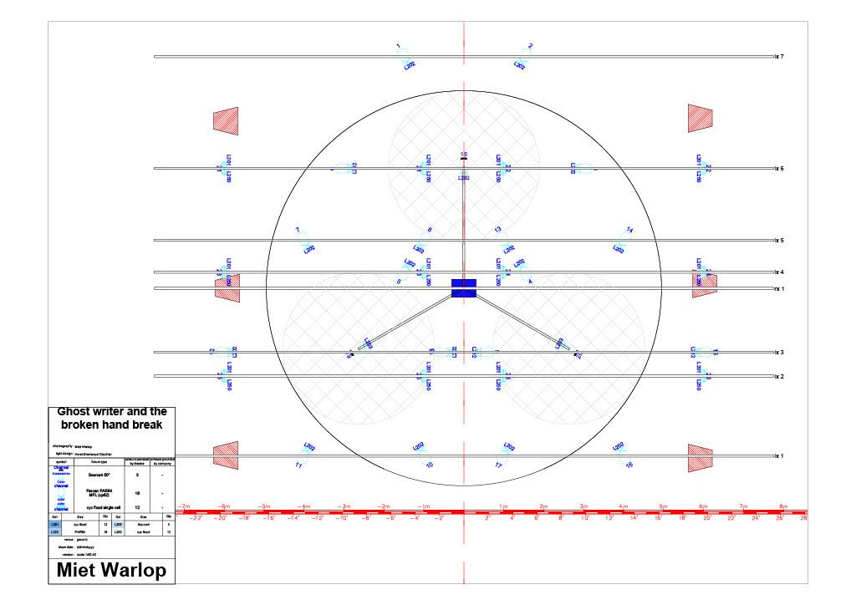

Annex 3: Light - submaster layout
Fader | Channel id | Content
1 | 304 | motor turns counterclockwise
2 | 305 | motor turns clockwise
10 | step 1: 1+7+13  step 2 : 2+8+14  step 3 : 3+9+15  step 4 : 4+10+16  step 5 : 5+11+17  step 6 : 6+12+18 | Chaser  Time: 0,13 S or 454 BPM
11 | 19+20 | 3 profiles
12 | 21 trough 26 | all floodlights

Annex 4: Sound - input and output list
Input list
Ch | Instrument | Mic/DI/xlr
1 | VOX MIET | DPA 4088 cardio headset with heavy duty lavalier (old model) with SHURE TA4F to connect to the UR1
2 | VOX JOPSTAR | DPA 4088 cardio headset with heavy duty lavalier (old model) with SHURE TA4F to connect to the UR1
3 | VOX WIETSE | DPA 4088 cardio headset with heavy duty lavalier (old model) with SHURE TA4F to connect to the UR1
4 | TC-FX | XLR from output TC Helicon,FX send is output 12
5 | GUITAR | TS (jack) adapter to SHURE TA4F to UR1
6 | Handheld drum | Sennheiser e604 + clamp + XLR F to UR1
7 | Body Slaps | DPA 4060 or 4660 skin colored + TA4F to UR1
8 | SAX, Only when specified in advance! | DPA 4099S + STC 4099 + TA4F to UR1
9 | Contact micro 1/ piëzo pad, | TS (jack) adapter with TA4F to UR1,
10 | Contact micro 2/ piëzo pad, | TS (jack) adapter with TA4F to UR1,
11 | Contact micro 3/ piëzo pad, | TS (jack) adapter with TA4F to UR1,
13 | VOX MIET 2 | XLR Split from Channel 1
14 | VOX PIET 2 | XLR Split from Channel 2
15 | VOX WIET 2 | XLR Split from Channel 3

Output list
1 | speakers on stage
9 - 10 | subs
11 | XLR to TRS FOR INPUT 1 ON MOTU 16A
12 | XLR TO XLR TO INPUT TC-HELICON
15-16 | L-R

All wireless channels must be free of any noise and all frequencies must be officially cleared by the venue. We will not share any gear or frequencies.

Annex 5: Motor certificate
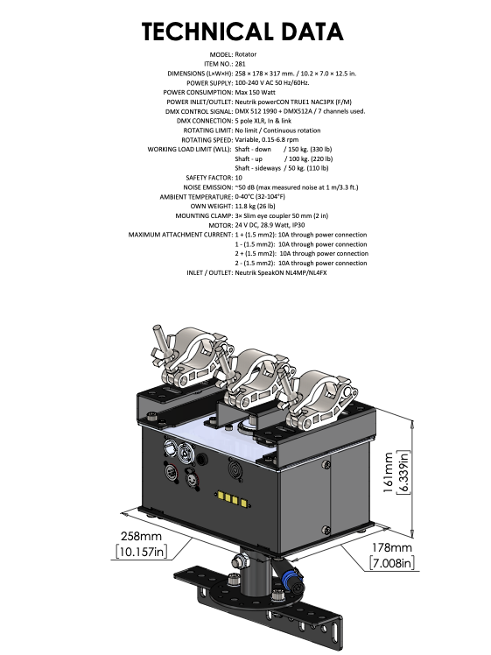

Annex 6: costume list

Miet:
Black shorts
Black pullover with zipper
White socks size 35-38,new
Adilette slippers size 5
Wietse:
Trackpants , with clothespin in pocket (to be removed for laundry)
Pair of marked underpants
White socks size 39/42, new
Adilette slippers size 7
Joppe:
Trackpants
Pair of marked underpants
White socks size 39/42, new
Adilette slippers size 9
Frut:
Trackpants
Pair of marked underpants
White marked socks, to be washed
Black marked sweater
Adilette slippers size 11
Sharp:
Trackpants
Pair of marked underpants
White marked socks, to be washed
Black marked sweater
Adilette slippers size 8

LAUNDRY INSTRUCTIONS:
4 pairs of black trackpants, marked by name to be washed on 30’ , short program (sports)
!! Don’t forget to take out the clothespin out of Wietse his pants and put it back afterwards!!
Underwear can be washed with pullovers : black cotton, if needed: add black textile paint
White socks (the marked ones) to be washed as white cotton,
if needed: use “ossegalzeep” (Ox Gall Soap) on the spots

In case of questions:
Karolien nuyttens
0032486374457

Pictures
