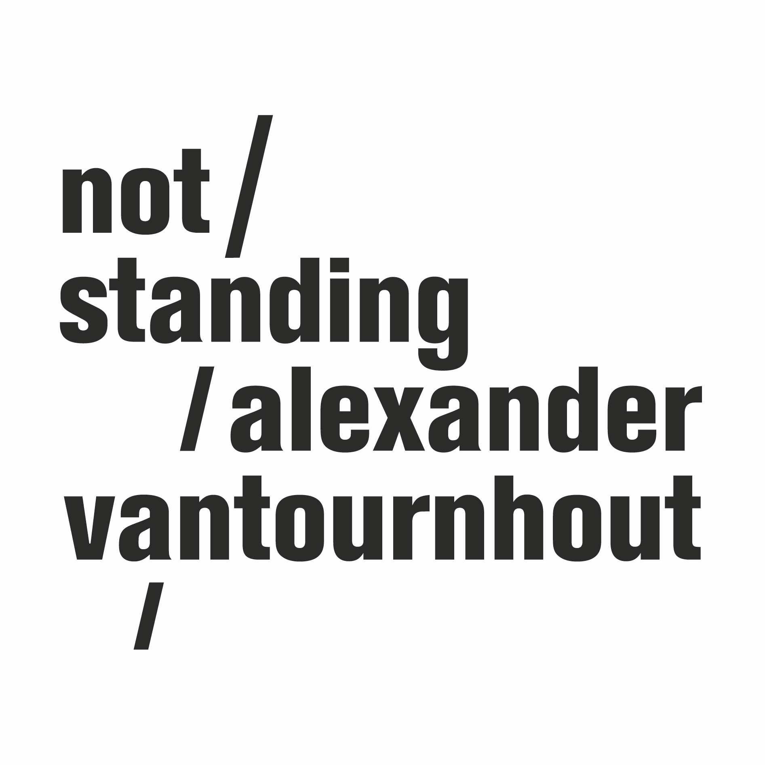
Foreshadow

2023

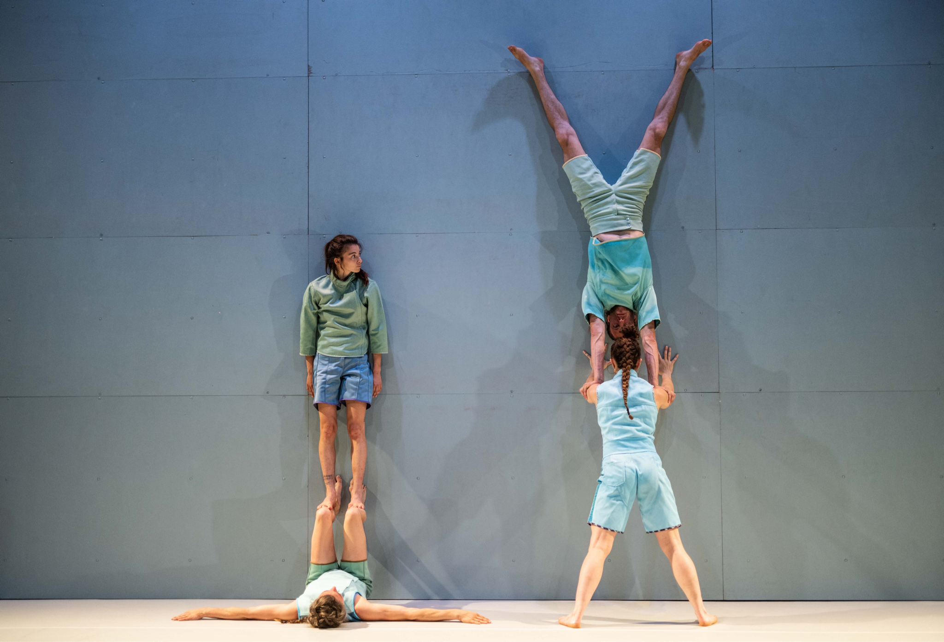

“Solo dancing does not exist: the dancer dances with the floor: add another dancer, you will have a quartet: each dancer with each other, and each with the floor". – Steve Paxton

Foreshadow, an interplay between gravity, movement, balance and spatiality

After VanThorhout, in which Alexander Vantournhout appeared solo on stage, not standing returns with a group show featuring eight acrobat-dancers. The performers move like gears of a collective body to the tunes of experimental rock music. Together they explore quasi-impossible balances, challenge each other and defy gravity.

With the tightly orchestrated chaotic movement landscapes of Foreshadow, Alexander Vantournhout takes a new step in his exploration of the relationships between gravity, movement, balance, and spatiality. In addition to the floor, which played a prominent role in SCREWS and Through the Grapevine, the wall now also becomes a dance partner.

Tour dates
Première: 2 & 3 July 2023, Julidans, Amsterdam (NL)
1 & 2 August 2023 - Tanswerkstatt, Munich (DE)
9 & 10 September 2023 - La Bâtie - Festival de Genève, Genève (CH)
22 & 23 September 2023 - La Biennale de la Danse, Lyon (FR)
28, 29 & 30 September 2023 - Kunstencentrum VIERNULVIER, Ghent (BE)
3 & 4 October 2023 - Festival Actoral, Marseille (FR)
14 October 2023 - Festival Aperto, Reggio Emilia (IT)
18 & 19 October 2023 - Les Halles de Schaerbeek, Brussels (BE)
27 & 28 October 2023 - Theater op de Markt, Neerpelt (BE)
9 & 10 November 2023 - NEXT Festival, Le Phénix, Valenciennes (FR)
21 November 2023 - NEXT Festival, Le Bateau Feu, Dunkirk (FR)
More dates: https://notstanding.com/tourdates

Communication info (images, trailer, presentation text, press quotes)

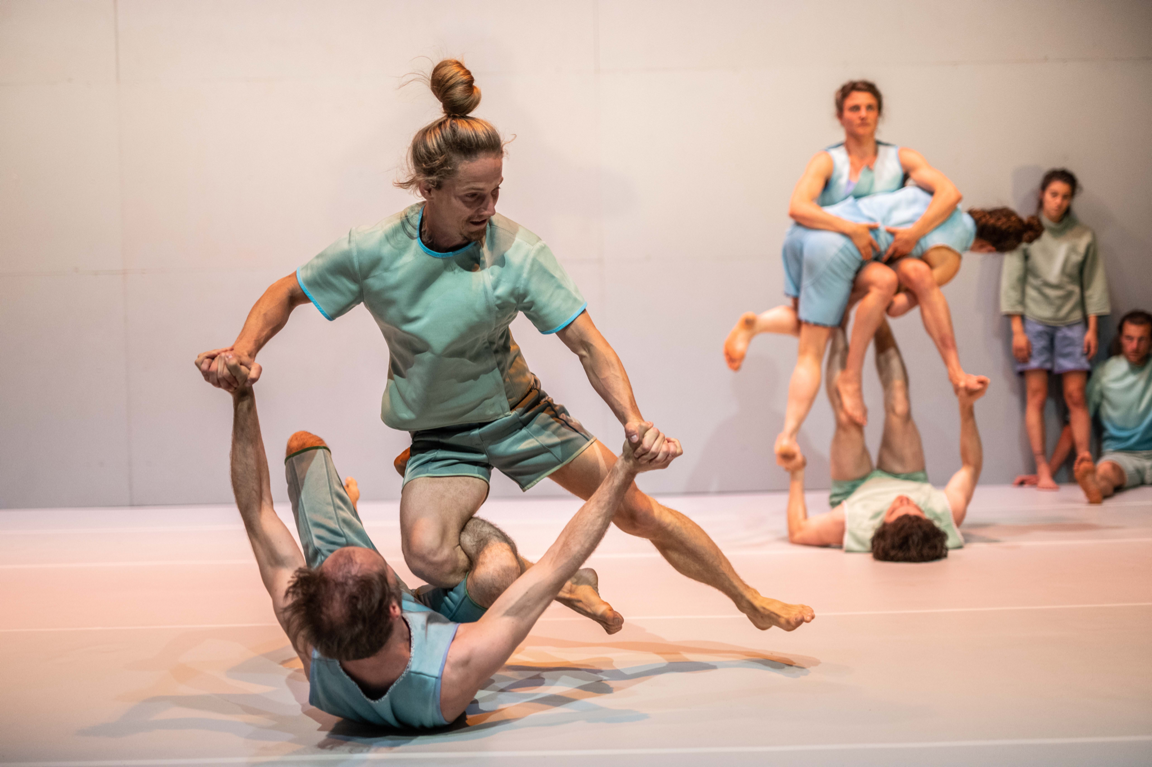

A foreshadowing exploration of horizontality and verticality

In Foreshadow, the human body embeds in an orchestrated symphony of limbs and joints. Body mechanics are challenged by gravitational forces and reverse, resulting in an interplay of physical systems. Together, eight performers create an ever-evolving landscape of human sculptures.

"At the exciting point of almost falling or not, Alexander Vantournhout and his team discover moments of equilibrium that appear utterly impossible at first glance, and even upon closer look." – Het Parool

Rather than a static backdrop, the wall - as object - emerges as an accomplice, a catalyst that challenges gravity's dominion. Through meticulous calibration of body positioning, an ongoing dialogue emerges among the performers, the wall, and inevitably, the floor. This collective exploration yields new dimensions of movement and acrobatics.

While the wall is traditionally employed as a tool to cultivate symmetry and alignment in practices like yoga, dance, and martial arts, here it assumes a multifaceted role. It becomes the pivotal point of support, a scaffold that permits the confrontation of gravity's pull. The performers push the boundaries of balance, leveraging the wall's resistance to adjust the speed of descent, resulting in a nuanced interconnection of control and downward motion that transcends the wall itself.

In literary terms, 'foreshadowing' serves as a cue to hint from the beginning at future developments within a story. In Foreshadow, all the elements are laid out from the start. Set to the resonant sounds of This Heat, the cast comprises eight performers, with the wall emerging as a ninth participant—or an agrès*. This ninth performer functions as more than mere scenery; it becomes a reactive surface that not only accommodates vertical movement but also facilitates the translation of horizontal actions into a vertical context.

Natural forces governing verticality and horizontality entwine, constituting a holistic choreographic canvas. The wall, with its inherently static disposition, sets fire to a symphony of body research. In contrast, the floor becomes a canvas for dynamic movement and fluid acrobatic motions. However, the gradual pace of the vertical dimension engenders a friction that challenges the exploration of horizontality.

*Agrès is a French word commonly used in the context of circus arts, gymnastics, and physical performance. It refers to any type of equipment or apparatus used in these performances, such as trapezes, rings, poles, ropes, and other similar structures. Performers use these apparatuses for their acts, incorporating them into various routines that may involve balancing, swinging, climbing, and other forms of skilled movement.

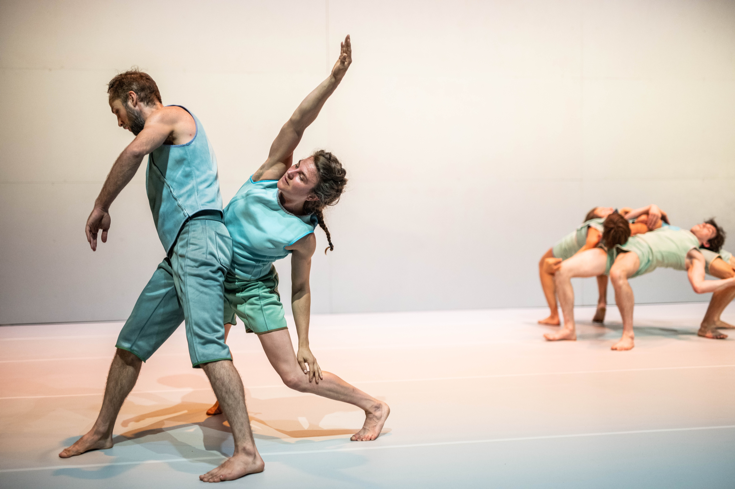

The human animal

As usual, Alexander Vantournhout finds inspiration in the animal world for his movement material, this time in the adhesive powers of reptiles like lizards. Geckos and lizards employ a dry adhesion system using a combination of microscopic hairs (setae) on their toe pads as well as other aspects of internal anatomy to climb on vertical walls and run on ceilings. Lizards and geckos have no suction cups, hooks or glue on their feet but employ a mechanical principle called contact splitting: each of the microscopic hairs found on their feet split up into hundreds of flat tips. The ends temporarily rearrange electrons on the walking surface, creating an electrodynamic attraction.

“Vantournhout has been inspired by ‘locomotions’ (walking like animals) since his first creation ten years ago. From the wrist joint of a gibbon (which rotates exactly like our shoulder) to the circular symmetry of an octopus, starfish, jellyfish, or sea anemone. Not by imitating the movements of the animals, as that is impossible for humans, but by incorporating them slightly differently into his movement language.”
— de Volkskrant

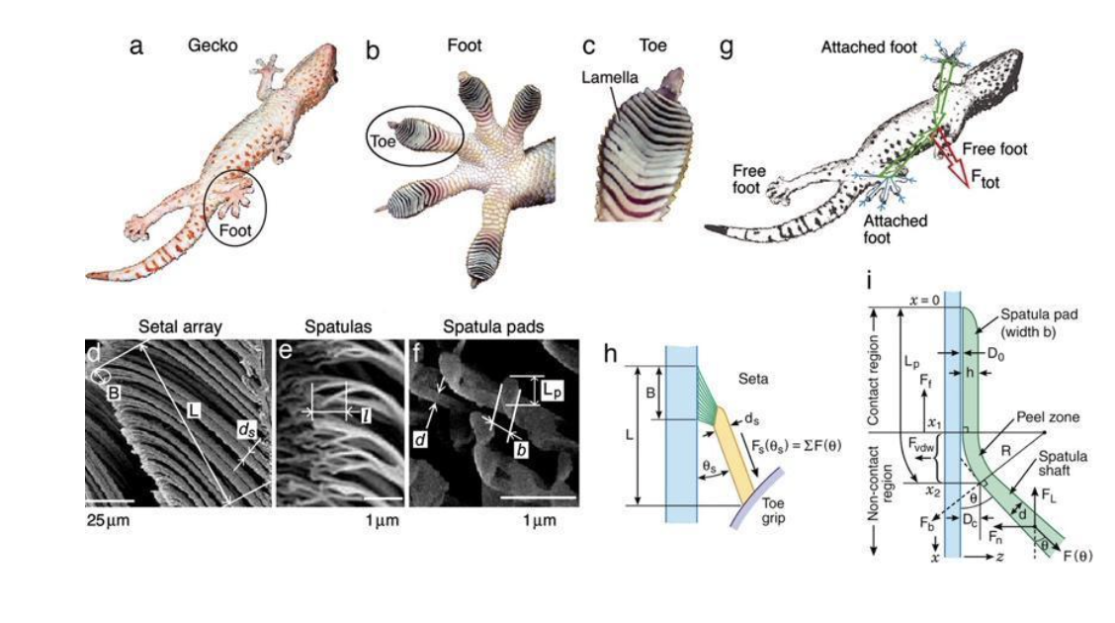

Costumes

The costumes are not uniform but vary from their homogeneous base in terms of shade and texture. In the lighting design, this "color mass," which corresponds to the color of the wall and the floor, is further emphasized to transform the silhouettes of the dancers and encourage them to blend with each other or with the scenography. This creates a camouflage effect inspired by the animal world (similar to the chameleon), and the dancers intertwine seamlessly with each other, both on the floor and against the wall. The resulting confusion regarding which limb belongs to whom, as also observed in SCREWS and Through the Grapevine, is further accentuated.

The transformative and deliberately degendered qualities of the costumes encapsulate the interrogation of stereotypical roles within acrobatics and dance. Conventional expectations dictate that individuals with more weight tend to assume supportive roles, whereas those with lighter bodies are frequently carried. It is these very archetypes that are challenged and transformed within a gravity-defying context. The choreography creates scenarios where bases intermittently take on the roles of flyers, and vice versa. Through collaborative efforts, eight distinct bodies successfully defy gravity.

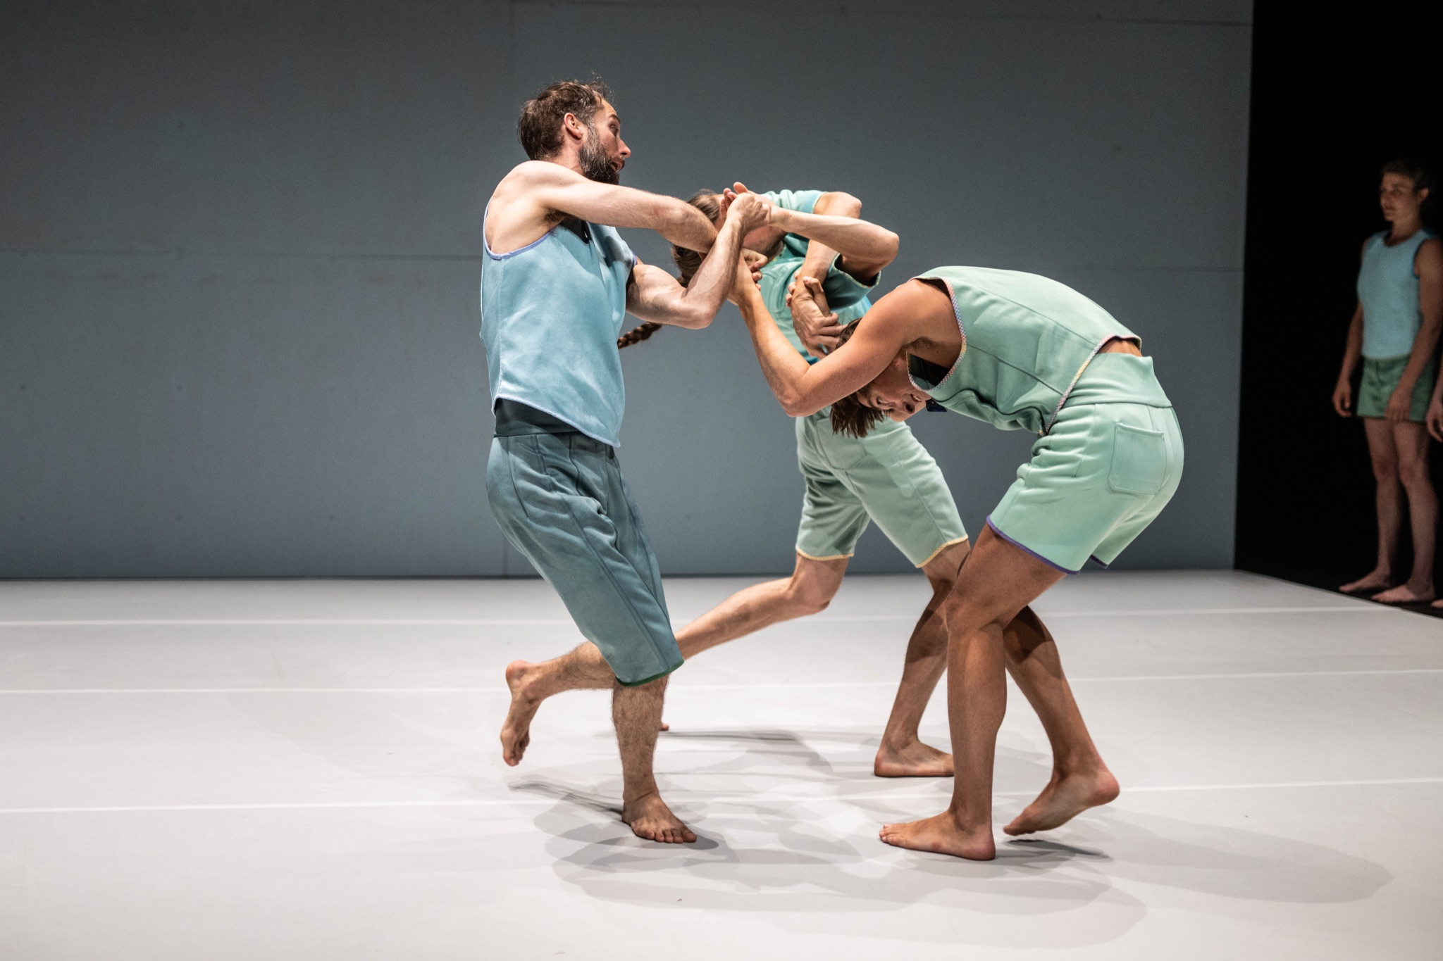
Music

Alexander Vantournhout's movement language presents a unique challenge when it comes to translating it into music. Over the past few years, his research has led to composition commissions, such as Andrea Belfi’s percussion based work for Through the Grapevine. However, also existing material, as seen in his use of music by Nils Frahm in SCREWS, has been incorporated.

After previous attempts to translate movement into music, Alexander Vantournhout has now chosen to utilise music of This Heat as a soundtrack. Rather than interpreting the movements directly, the music captures a sense of heterogeneity without a central focal point, avoiding the chaos of mere juxtaposition.

This Heat is an experimental avant-garde rock band often regarded as the missing link between 1970s progressive rock and post-punk genres like no wave, noise rock, industrial, and post-rock. This Heat's existence was fleeting. In 1975, amidst the US withdrawal from Saigon and the slow ascent of Margaret Thatcher's Conservative Party, Charles Hayward and Charles Bullen, veterans of London's rock underground, recruited self-styled "non-musician" Gareth Williams to form a rock trio. Settling ironically in a once-refrigerated food cupboard within an abandoned meat factory called The Cold Storage, they embarked on their journey as This Heat. The sounds and ideas birthed within The Cold Storage defied genre conventions.

“This Heat incorporated drums, guitar, bass guitar, vocals, and samples as the primary musical components. In not standing’s oeuvre, various structural elements such as walls, floors, flyers, and bases are utilized. Since SCREWS, I have been deeply captivated by the acrobatic duo of bases-flyers and their fascinating relationship with gravity. This dynamic is a fundamental aspect of Alexander Vantournhout’s work, particularly evident in Foreshadow. The downward force gives rise to a delicate equilibrium that requires significant effort, particularly from the base. Additionally, there are more dynamic acrobatic routines where the focus shifts from supporting the base to revealing the flight of the flyer.”
— Sébastien Hendrickx, dramaturge

The cast

The cast of Foreshadow primarily consists of performers with whom Alexander Vantournhout has cultivated enduring relationships over the past years. Axel Guérin, an acrodancer, shares the stage with Alexander for the fourth time in this production. Emmi Väisänen, a Finnish dancer and artistic assistant, is also a four-time participant in the team. Esse Vanderbruggen, Alexander's fellow student-colleague at P.A.R.T.S., has contributed to various not standing creations for several years. Additionally, Noémi Devaux and Nick Robaey have previously appeared in Contre-jour and SCREWS, respectively. Patryk Kłos, a Polish martial arts dancer, Belgian acrobat Josse Roger, and dancer Margaux Lissandre from France are collaborating with not standing for the first time in Foreshadow.

Biographies of all performers: https://notstanding.com/foreshadow-cast

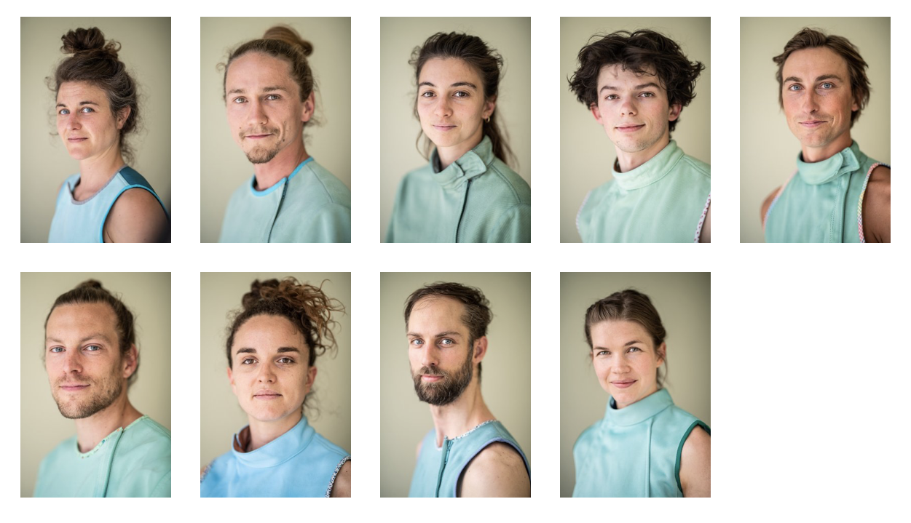

Team

Concept & choreography: Alexander Vantournhout
Created with and performed by: Noémi Devaux, Axel Guérin, Patryk Klos, Nick Robaey, Josse Roger, Emmi Väisänen/Margaux Lissandre, Esse Vanderbruggen & Alexander Vantournhout/Chia-Hung Chung

Dramaturgy: Rudi Laermans & Sébastien Hendrickx
Rehearsal director: Sandy Williams
Costumes: Patty Eggerickx
Light design: Bert Van Dijck
Music: This Heat
Sound: Ruben Nachtergaele

Tour planning: Frans Brood Productions
Company management: Esther Maas
Technical coordination: Bram Vandeghinste
Technicians on tour: Helmi Demeulemeester, Jonathan Maes, Bram Vandeghinste & Bert Van Dijck
Production & tourmanagement: Barbara Falter & Kiki Verschueren
Communication: Aïda Gabriëls

Production: not standing

Co-production: le CENTQUATRE, Paris (FR), Kunstencentrum VIERNULVIER, Ghent (BE), Julidans, Amsterdam (NL), Biennale de la Danse, Lyon (FR), Le Maillon, Strasbourg (FR), Les Halles de Schaerbeek (BE), MA scène nationale – Pays de Montbéliard (FR), La Passerelle, scène nationale de Saint-Brieuc (FR), Theater Freiburg (DE) & Le Carreau Scène nationale de Forbach et de l'Est mosellan (FR).

Special thanks to: De Grote Post, Ostend (BE), Plateforme 2 Pôles Cirque en Normandie / La Brèche à Cherbourg & le Cirque-Théâtre d’Elbeuf (FR), Maison de la Danse, Lyon (FR), Urte Groblyte, Katherina Lindekens, Bjorn Verlinde & Julien Monty

Created with the support of the Tax Shelter of the Belgian Federal Government, via Flanders Tax Shelter

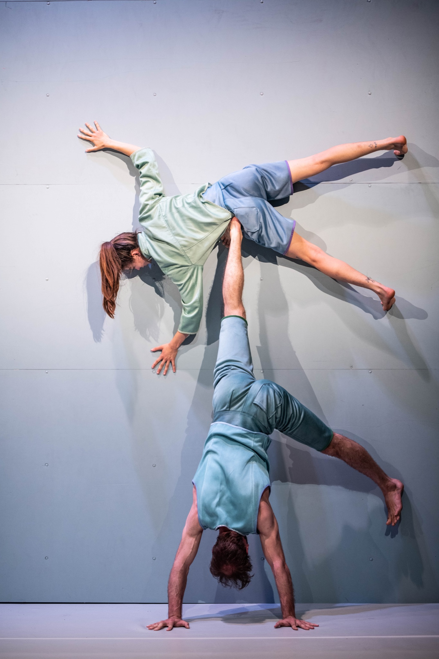
not standing is supported by the Flemish Government.

Alexander Vantournhout is artist-in-residence at Kunstencentrum VIERNULVIER in Ghent and associated artist of le CENTQUATRE Paris. He is cultural ambassador of the city of Roeselare and is also supported by Fondation BNP Paribas for the development of his projects.

Contact

Alexander Vantournhout
Artistic director, choreographer
info@notstanding.com

Esther Maas
Company manager
esther@notstanding.com

Barbara Falter
Administration, production manager
barbara@notstanding.com

Kiki Verschueren
Tour manager
kiki@notstanding.com

Aïda Gabriëls
Communication
aida@notstanding.com

Bram Vandeghinste
Technical coordination
bram@notstanding.com

Flore Roggeman - Frans Brood Productions
Tour planning
flore@fransbrood.com

Not Standing vzw
Beversesteenweg 78
8800 Roeselare
BELGIUM
BTW: BE 0849 019 917

