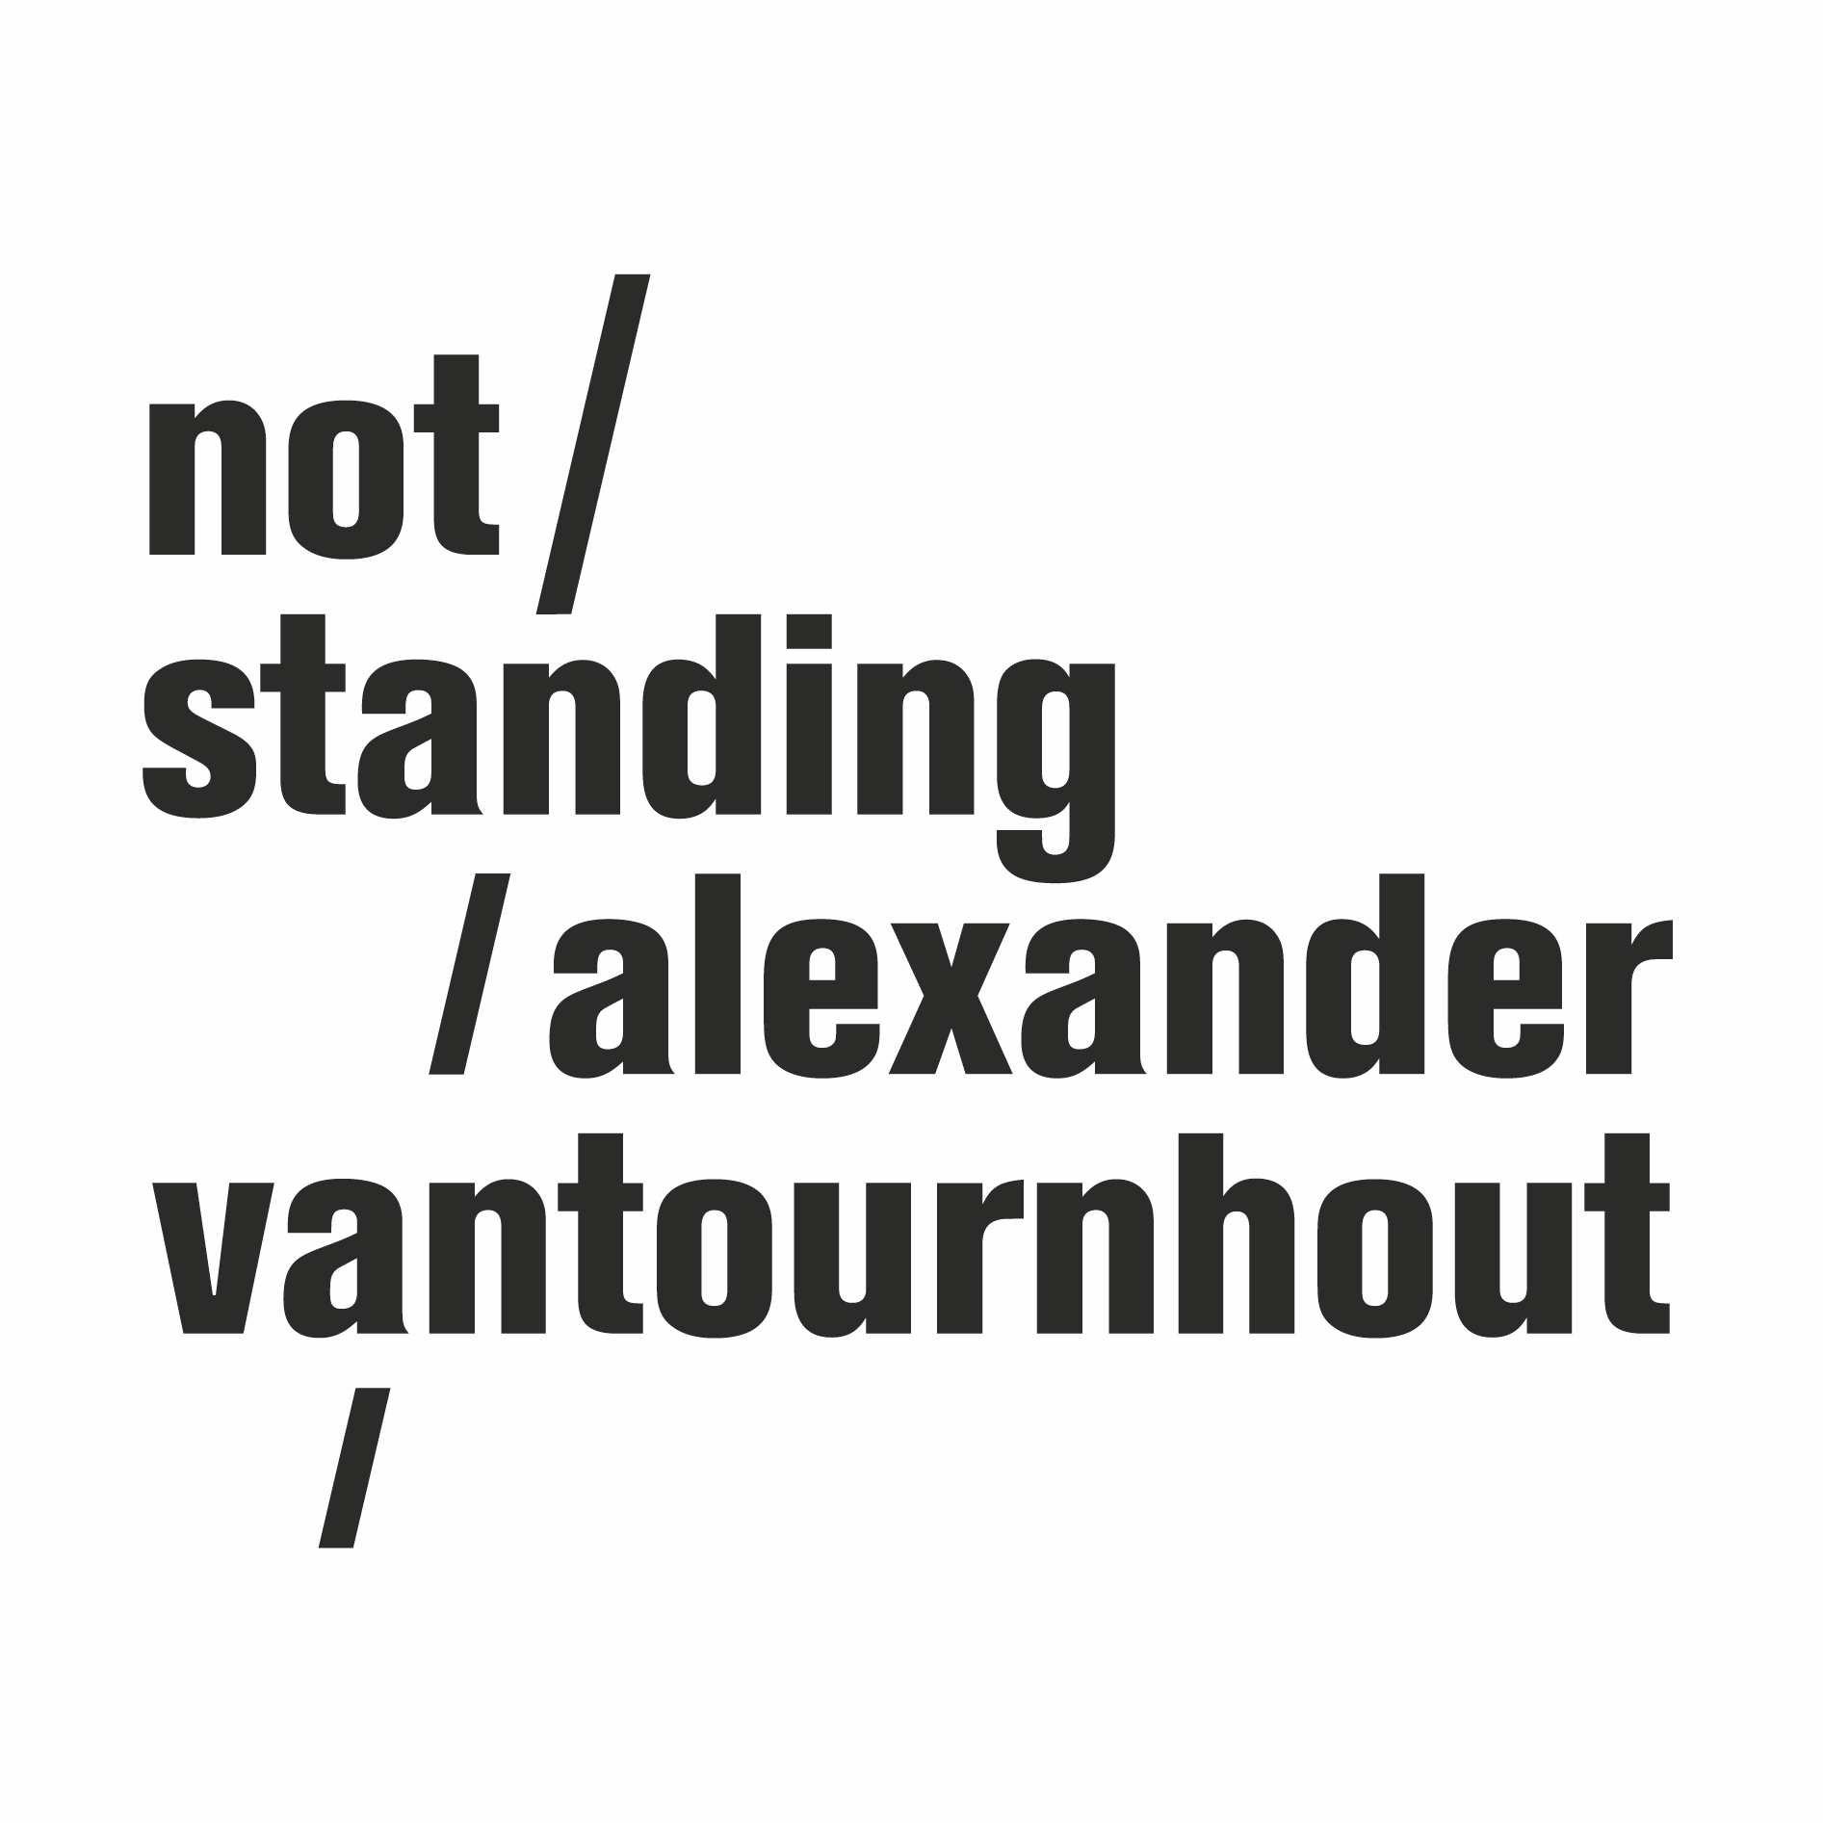
Foreshadow (2023)

After VanThorhout, in which Alexander Vantournhout appeared solo on stage, not standing returns with a group show featuring eight acrobat-dancers. The performers move like gears of a collective body to the tunes of experimental rock music. Together they explore quasi-impossible balances, challenge each other and defy gravity.

With the tightly orchestrated chaotic movement landscapes of Foreshadow, Alexander Vantournhout takes a new step in his exploration of the relationships between gravity, movement, balance, and spatiality. In addition to the floor, which played a prominent role in SCREWS and Through the Grapevine, the wall now also becomes a dance partner.

Concept & choreography: Alexander Vantournhout
Created with and performed by: Noémi Devaux, Axel Guérin, Patryk Kłos, Nick Robaey, Josse Roger, Emmi Väisänen/Margaux Lissandre, Esse Vanderbruggen & Alexander Vantournhout/Chia-Hung Chung

Dramaturgy: Rudi Laermans & Sébastien Hendrickx
Rehearsal director: Sandy Williams
Costumes: Patty Eggerickx assisted by: Isabelle Airaud
Music: This Heat
Light design: Bert Van Dijck
Sound: Ruben Nachtergaele
Technicians on tour: Helmi Demeulemeester, Jonathan Maes, Bram Vandeghinste & Bert Van Dijck

Tour planning: Frans Brood Productions
Company management: Esther Maas
Technical coordination: Bram Vandeghinste
Production & tourmanagement: Barbara Falter, Aïda Gabriëls & Kiki Verschueren

Production: not standing

Co-production: le CENTQUATRE, Paris (FR), Kunstencentrum VIERNULVIER, Ghent (BE), Julidans, Amsterdam (NL), Biennale de la Danse, Lyon (FR), Le Maillon, Strasbourg (FR), Les Halles de Schaerbeek (BE), MA scène nationale – Pays de Montbéliard (FR), La Passerelle, scène nationale de Saint-Brieuc (FR), Theater Freiburg (DE) & Le Carreau Scène nationale de Forbach et de l'Est mosellan (FR).

Special thanks to: De Grote Post, Ostend (BE), Plateforme 2 Pôles Cirque en Normandie / La Brèche à Cherbourg & le Cirque-Théâtre d’Elbeuf (FR), Maison de la Danse, Lyon (FR), Urte Groblyte, Julien Monty, Bjorn Verlinde & Katherina Lindekens

Created with the support of the Tax Shelter of the Belgian Federal Government, via Flanders Tax Shelter

not standing is supported by the Flemish Government.
Alexander Vantournhout is artist-in-residence at Kunstencentrum VIERNULVIER in Ghent and associated artist of le CENTQUATRE Paris. He is cultural ambassador of the city of Roeselare and supported by Fondation BNP Paribas for the development of his projects.

