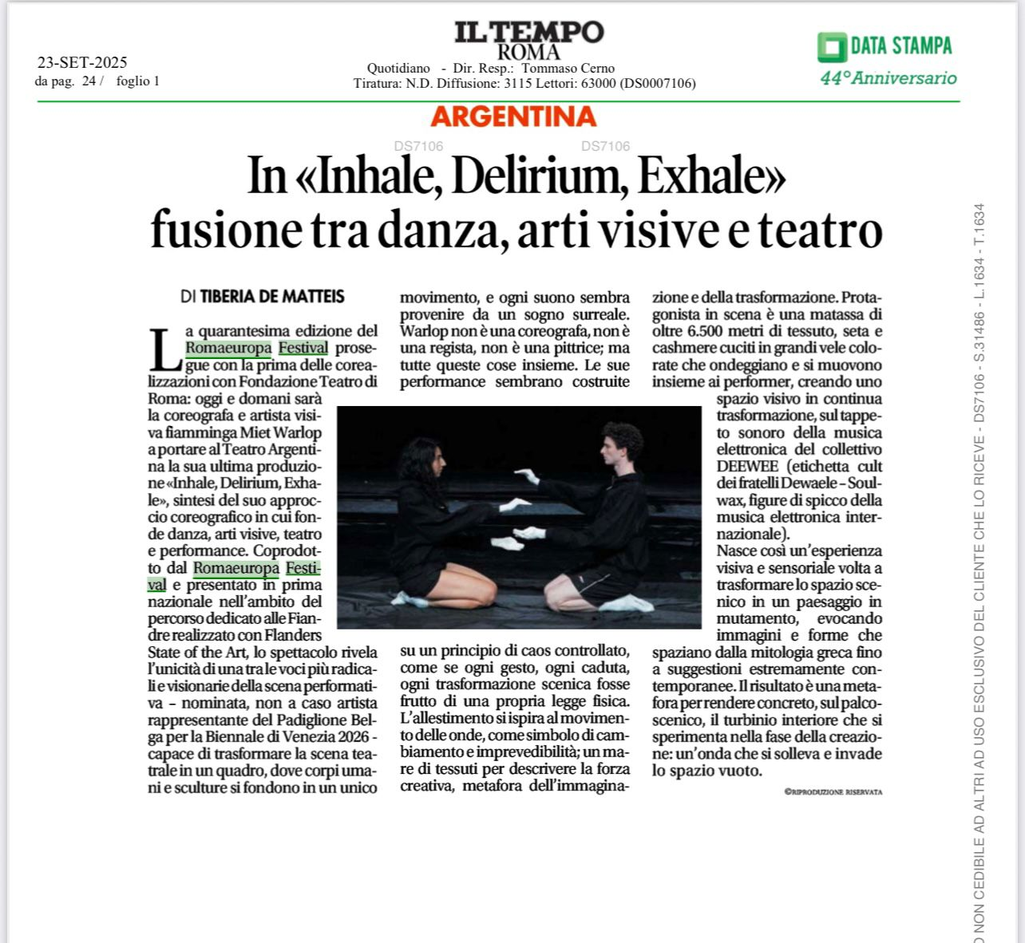

ENG Translation:

n “Inhale, Delirium, Exhale”: fusion between dance, visual arts, and theatre
by Tiberia De Matteis

The 40th edition of Romaeuropa Festival continues with the first of the co-productions with the Teatro di Roma Foundation: today and tomorrow the Flemish choreographer and visual artist Miet Warlop will bring to the Teatro Argentina her latest production Inhale, Delirium, Exhale, the synthesis of her choreographic approach that blends dance, visual arts, theatre, and performance.

Co-produced by Romaeuropa Festival and presented in national premiere within the Flanders State of the Art program, the show reveals the uniqueness of an artist whose radical and visionary voice transcends performance. Warlop—appointed as an artist representing the Belgian Pavilion for the Venice Biennale 2026—is able to transform the theatre stage into a painting, where sculptures and forms unite in a single movement, and each sound seems to give life to a surreal daydream.

Warlop is not a choreographer, nor a theatre director, nor a painter, but all of these things together. Her performances appear to be built on a principle of controlled chaos, as if every gesture, fall, or transformation on stage followed its own physical law.

The staging is inspired by the motion of waves, as a symbol of constant and unpredictable change; a sea of fabrics describing creative force, metaphor of imagination and transformation. On stage, a tangle of more than 6,500 meters of fabric, silk, and velvet surges and moves like waves around the performers, creating a living space in continuous transformation, set to the electronic music of the collective DEEWEE (label founded by the Dewaele brothers—Soulwax, leading figures in the international electronic scene).

Thus arises a visual experience aimed at transforming space into a constantly shifting landscape, evoking shapes and forms that draw from mythology and give rise to extremely contemporary suggestions. The result is a metaphor of inner turbulence, of the whirlwind experienced in the creative phase: a wave that is sensual and invades space as a whole.

