CIRCUS RONALDO
Da Capo

An evocative, filmic performance about love,
necessity, apparent coincidence, and passion.
A story of 180 years of wonder.

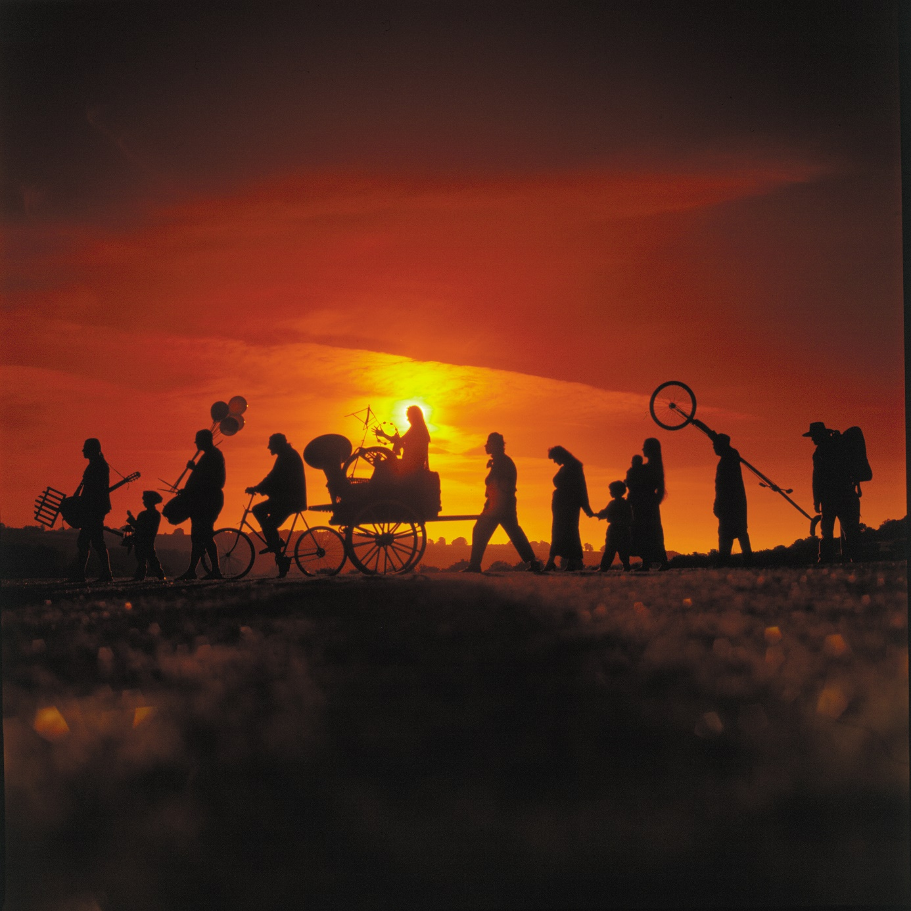

Final direction: Frank Van Laecke

Premiere 27 October 2023 Festival Theater op de Markt Neerpelt (BE)
In own tent for 385 people
The performance

‘Da Capo’ is a chronicle of a circus family. An evocative, filmic performance of a family history of love, necessity, apparent coincidence, and passion. From a 15-year-old boy who ran away with the circus in 1842 to the present day, where the seventh generation makes its entrance into the Circus Ronaldo ring.
A story of 180 years of wonder.

Circus Ronaldo is longing to tell this story. The history of its family, from the beginning into infinity. A story that is both unique and universal, familiar to every one of us, for today more than ever we are in need of support and trust, of connection, of family.

‘Da Capo’ is performed in a tent with a wide performance area running like a street between two grandstands. The performance passes by like a parade. A procession of time, moments, fragments, memories, and dreams, which comes to a sudden halt for a while and then sets off again. Each member of the family tells the story with an individuality that combines to create a harmonious diversity.
And just like in real time, the parade is a one-way street. The characters can never go back, and time is limited because the sequel usually comes faster than anticipated.

It apparently begins with Johnny Ronaldo, who seemingly conjured up Circus Ronaldo out of thin air in 1971, with the aid of an old Fortson tractor and a little Renault 4. But there is soon disagreement as to what is being shown.
Because the story actually begins with Ghent-born Adolph Peter Van den Berghe, Johnny’s great-great-grandfather, who ran away from home aged fifteen in 1842 to join the German circus Wulf. The first in the family to exchange the ordinary for the extraordinary. And so the parade tells the story, charting his evolution from clumsy stableman to the company’s leading artist.
When a small theatre company appears on the other side of the stage performing a commedia dell’Arte piece, a story of an exceptional love begins too. Adolph falls in love with one of the actresses, which culminates in a beautiful marriage.
This moment also marks the beginning of a marriage between circus and theatre, which continues to develop over subsequent generations…

The parade goes on, to successive generations, fresh opportunities, broken dreams, and the untameable evolutions of an ever-stronger, immortal longing...
With the love between circus and theatre as the common thread.

About Circus Ronaldo

Since 1996 Circus Ronaldo has been performing all over the world for prestigious theatre houses and major circus and arts festivals. With European tours from Reykjavik to Lisbon and big world trips to Australia and New Zealand. In Flanders, Circus Ronaldo is most commonly featured in the programmes of the larger Cultural Centres. The tours are still put together by Frans Brood Productions in Ghent.

Circus Ronaldo is something unique in the hearts of many spectators. It creates an innovative form of circus, which is inextricably linked to the roots from the past. Based on old performance traditions, still-authentic caravans and the reuse of material from many generations back, Circus Ronaldo presents a tribute to the old circus theatre. It draws its inspiration from the commedia dell’arte and a predilection for the power that de “Tsukomogami” (the use of the spirit of worn-out materials) exerts over the unconscious. At the same time, the audience, when it enters into Ronaldo’s world, discovers a familiarity, a self-evidence, a mirror for their own fragile identity. A world of magical realism is created, in which the spectator is in doubt as to what is real and what is not. In a virtuoso manner, the company digs down into the deeper layers of their own emotions and thereby holds up a mischievous mirror to them. Circus Ronaldo plays with an intense experience of the ‘now’, which is highly familiar to many spectators. It links a nostalgia to a reality that will unsettle you, in an intimate, passionate, everlasting dance.

Awards

- Pepijn Ronaldo chosen as best actor of 2022 in Flanders – De Acteursgilde (BE)
- Sono io? Best Production 2022 – Het Theaterfestival 2022 (BE)
- Ultima voor Circus - Flemish Culture Prize 2018 (BE)
- Fidelis Fortibus Best Circus Production in Spain - Premis Ciutat de Barcelona 2017 (ES)
- Fidelis Fortibus Best Production 2016 - Het Theaterfestival 2016 (BE)

Press

“The theatrical mastery of Circus Ronaldo lies in their subtle characterisation, but also in the way in which they explore the drama of transience.” **** - De Morgen

“Circus Ronaldo again demonstrates the wide array of styles and shocks of which it is master. And no, there’s no hint of decline. - De Standaard

“Even more haunting, even funnier, and even more moving than the previous Ronaldo productions, not least because of the powerful autobiographical undercurrent. Ronaldo’s interweaving of art and live is still unique.” - Circusmagazine

"A beautiful spectacle; hectic, hilarious scenes; surreal, Felliniesque processions; tranquil moments; an emotional take on the art of (surviving) life with bittersweet humour." - Theaterkrant

Quotes

“Through the most artistic visual poetry, I see a rucksack stuffed with responsibility to safeguard the identity of the Ronaldo family. Whereby Danny fights like a lion, because should the heritage ever die: no e comico. My respect is boundless. The biotope is as stunning as ever. I sincerely hope that the international esteem that Danny and his companions so deservedly enjoy also translates into appreciation here in Belgium, in the form of a structural subsidy to a unique ambassador of our Great Arts.” – Frank Van Laecke

“There is, I believe, only one circus in the whole world that can transport me back to the open-mouthed wonder that I experienced as a small child, and that is Circus Ronaldo. When people asked me as a child what I wanted to be when I grew up, I still know exactly what I said: trapeze artist! At Ronaldo there is the same excitement and curiosity about what they’re going to pull out of their hat next, but this goes way beyond some banal rabbit: its poignancy is overwhelming and deeply human.” - Alain Platel, les ballets C de la B

“As an artistic creator, Danny is a great circus architect. He manages to reinvent himself time and time again, gets better and better, and is always himself.” – Ultima Circus 2018

“Danny Ronaldo is without question one of the great theatre makers and circus performers, and the world that is created by the extended Ronaldo family has been transformational for the art form and for the world’s appreciation of Flemish culture. As a result, Circus Ronaldo are one of the best circus companies in the world, and continue to do inestimable credit to Flemish culture. The world needs work with the quality and charming brilliance of Circus Ronaldo now, more than ever.” - Jonathan Holloway, Melbourne International Arts Festival

“Today, most circus is rather predictable and bland. Much of it is highly skilful, of course, one thinks of the glitz and polish of Cirque du Soleil, the acrobatic flair of Australian circus and the originality of the French nouveau cirque. But Circus Ronaldo is different - it seems to carry the life-enhancing traditions of historic and popular entertainment, it is clever without being conceited or condescending, and it touches everyone’s heart. For this much credit must go to Danny Ronaldo, a hugely talented performer, creator, and thinker about circus.” - Joseph Seelig & Helen Lannaghan, London International Mime Festival

“We want to stress that circus has a unique place in the performing arts field and artists with such a long an international career deserve our support. Danny Ronaldo has developed a unique voice in the international landscape of the mixture between theatre and circus and we need to continue laughing with them.” - Cesc Casadesús, Grec Festival Barcelona

“Danny Ronaldo and his company are artists of exceptional talent, imagination and character. I have been following the company for years, hoping that one day I would have the opportunity to present them to the US. BAM is America’s oldest continually operating performing arts center and has built a loyal and engaged audience, creating an ideal venue to present this artistic achievement. I look forward to hopefully welcoming the company to BAM in December.” - David Binder, BAM Festival New York

Short Credits

Concept and direction Danny Ronaldo
Performance Danny Ronaldo, David Ronaldo, Nanosh Ronaldo, Pepijn Ronaldo, Angelo Ronaldo, Matheo Ronaldo, Maria Ronaldo, Adanya Ronaldo, Karel Creemers, Corneel Didier, Rachel Ponsonby, Marie Parrinet, Elisa Cheryl Vizioli, Brechje De Ruysscher, Frauke Verreyde, Flor Huybens, Niko Heremans
Technical crew Flor Huybens, Niko Heremans, Brechje De Ruysscher
Final direction Frank Van Laecke
Musical creation David Van Keer, Birger Embrechts , Pepijn Ronaldo, Rachel Ponsonby, Corneel Didier
Sound design Flor Huybens
Light design Flor Huybens, Frank Van Laecke
Costumes Dotje Demuynck, kostuumatelier hetpaleis, Elisa Cheryl Vizioli
Company management Lesley Verbeeck
Production Circus Ronaldo
Coproduction hetpaleis (Antwerp), Theater op de Markt – Dommelhof (Pelt), Théatre Firmin Gémier / La Piscine – Pôle national des arts du cirque (Châtenay-Malabry), Latitude 50 - pôle des arts du cirque et de la rue (Marchin)
With the support of De Warande (Turnhout), 30 CC Cultuurcentrum Leuven, Gemeenschapscentrum ’t Blikveld (Bonheiden), Tax Shelter en de Vlaamse Gemeenschap
Contact and distribution Frans Brood Productions

Long Credits

Concept and direction Danny Ronaldo
Performance Danny Ronaldo, David Ronaldo, Nanosh Ronaldo, Pepijn Ronaldo, Angelo Ronaldo, Matheo Ronaldo, Maria Ronaldo, Adanya Ronaldo, Karel Creemers, Corneel Didier, Rachel Ponsonby, Marie Parrinet, Elisa Cheryl Vizioli, Brechje De Ruysscher, Frauke Verreyde, Flor Huybens, Niko Heremans
Technical crew Flor Huybens, Niko Heremans, Brechje De Ruysscher
Final direction Frank Van Laecke
Musical creation David Van Keer, Birger Embrechts , Pepijn Ronaldo, Rachel Ponsonby, Corneel Didier
Studio musicians Birger Embrechts, Frank Boonen, Quinten Van Houtven, Pepijn Ronaldo, Corneel Didier, Koen van Hove, Tanguy Aerts, Soren Brassaert, Elias Meers
Sound design Flor Huybens
Light design Flor Huybens, Frank Van Laecke
Costume design Dotje Dmuynch
Costume execution Kostuumatelier hetpaleis (Wim Muyllaert, Nushi Lambreva & Vick Verachtert), Elisa Cheryl Vizioli, Lieve Enzlin
Façade design & execution Danny Cobbaut
Scenography & set design Nanosh Ronaldo
Technical execution scenography, set & props Ben Metal Works, Erik Van den Broeke, Andreas Ketels, Nanosh Ronaldo, Niko Heremans, Het Kabinet (Carmine De Swerts en Diede Roosens), Karel Creemers, Danny Ronaldo
Design horse Ellis Blauw
Design babydoll Ana Lekše
Graphic design Thomas Van Hees
Coaching theatre screens Robert de la Haye
Productional support Lesley Verbeeck, David Ronaldo
Photography & promo designs Frauke Verreyde
Poster Staf De Koninck
Company management Lesley Verbeeck
Corporate support Lies Martens
With thanks to Marquise Pauwels, Ann Van Meensel, Natascha en Hanne De Keuster
Production Circus Ronaldo
Coproduction hetpaleis (Antwerp), Theater op de Markt – Dommelhof (Pelt), Théatre Firmin Gémier / La Piscine – Pôle national des arts du cirque (Châtenay-Malabry), Latitude 50 - pôle des arts du cirque et de la rue (Marchin)
With the support of De Warande (Turnhout), 30 CC Cultuurcentrum Leuven, Gemeenschapscentrum ’t Blikveld (Bonheiden), Tax Shelter en de Vlaamse Gemeenschap
Contact and distribution Frans Brood Productions
With thanks to Geli Hartmann, Danny Aerts, Chris Van Goethem

