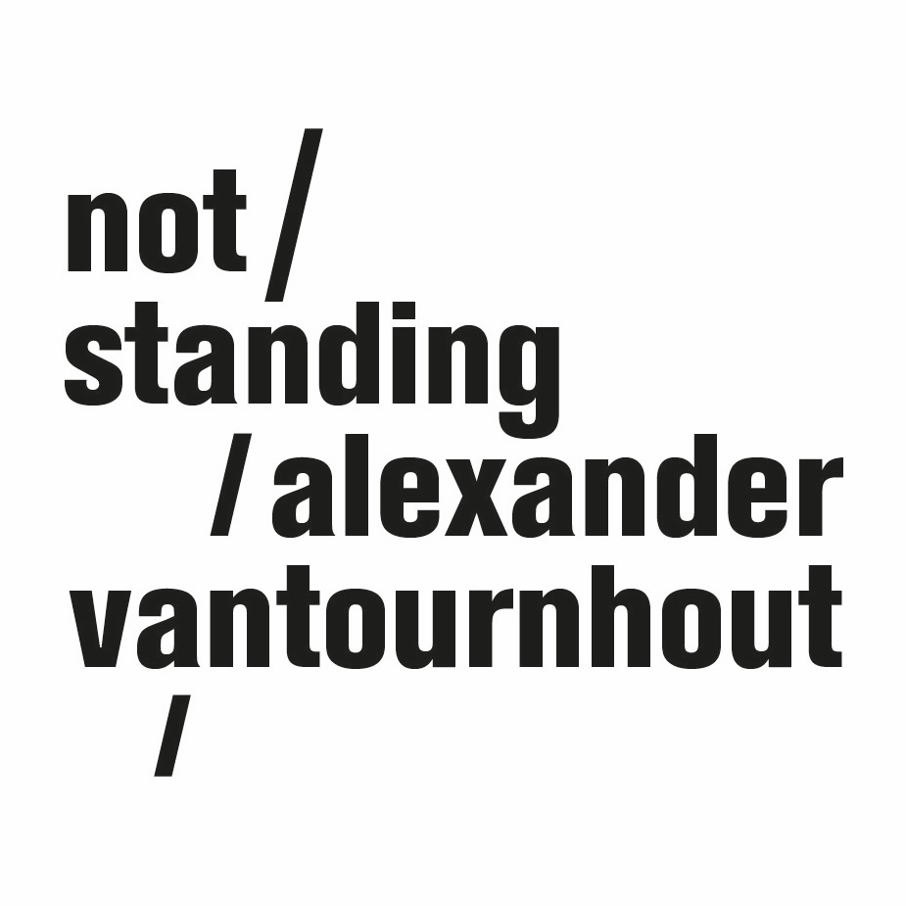
VanThorhout
2022

Whether it be ancient gods, classical heroes, soldiers or athletes, the glorification of male power throughout history has often tended towards a celebration of war, aggression, and violence. Thor, to whom the title refers, is one of its most famous personifications of this. He can unleash a thunderstorm and lives on, to this day, as a superhero in Marvel comics and films, invariably depicted with his Mjölnir, a hammer with an incredibly short handle.

In VanThorhout, Alexander comes on stage as Thor, with his own Mjölnir. As always in Alexander’s oeuvre, the relationship between object and performer quickly becomes ambiguous. When does one lose the strength to manipulate this heavy hammer, and when does the hammer take over and become uncontrollable? What if all these images of power disintegrate?

After a series of group choreographies, Alexander Vantournhout now returns to the stage alone.

Choreography & performance Alexander Vantournhout
Artistic assistant: Emmi Väisänen
Dramaturgy: Rudi Laermans & Sébastien Hendrickx

Prop design: Tom De With & Willy Cauwelier
Light design: Bert Van Dijck
Costumes: Patty Eggerickx

Outside eye: Charlotte Cétaire, Anneleen Keppens, Esse Vanderbruggen & Sandy Williams
Object manipulation outside eyes: Simon Janson & Sebastian Berger
Thanks to: Bojana Cvejić, Ben Mcewen & Tom Van der Borght

Technical coordination: Rinus Samyn
Technicians on tour: Tijs Bonner & Bram Vandeghinste

Company manager: Esther Maas
Production manager: Barbara Falter, Aïda Gabriëls & Kiki Verschueren
Diffusion: Frans Brood Productions

With the support of la Fondation d’entreprise Hermès within the context of the New Settings programme.

Production: not standing
Co-production: Kunstencentrum VIERNULVIER (Gent), Le CENTQUATRE (Paris), Les Subsistances – SUBS (Lyon), Les 2 Pôles Nationaux des Arts du Cirque normands – La Brèche (Cherbourg) & le Cirque-Théâtre d'Elbeuf, 3 bis f – centre d'arts contemporains (Aix-en-Provence)

With the support of the Flemish authorities.
Alexander Vantournhout is artist-in-residence in Kunstencentrum VIERNULVIER in Gent and associated artist of le CENTQUATRE Paris and Cirque-théâtre Elbeuf. He is cultural ambassador of the city of Roeselare and is also supported by Fondation BNP Paribas for the development of his projects. ﻿

https://notstanding.com

Images - © Bart Grietens

