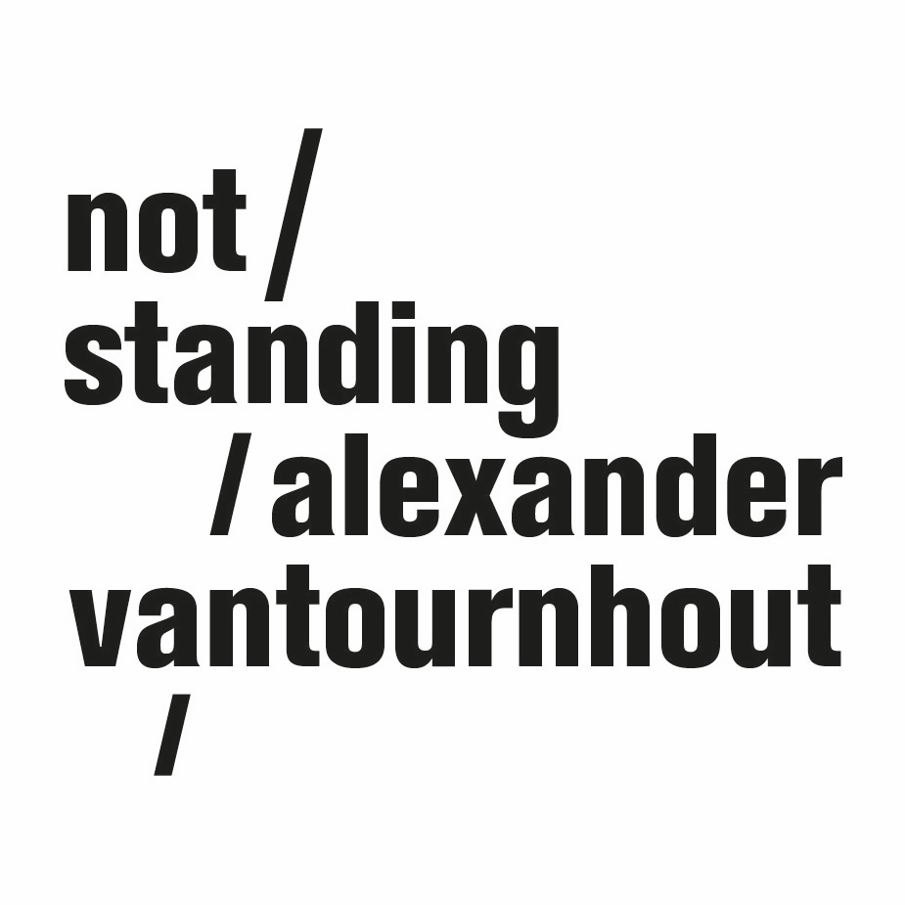
VanThorhout

(creation 2022)

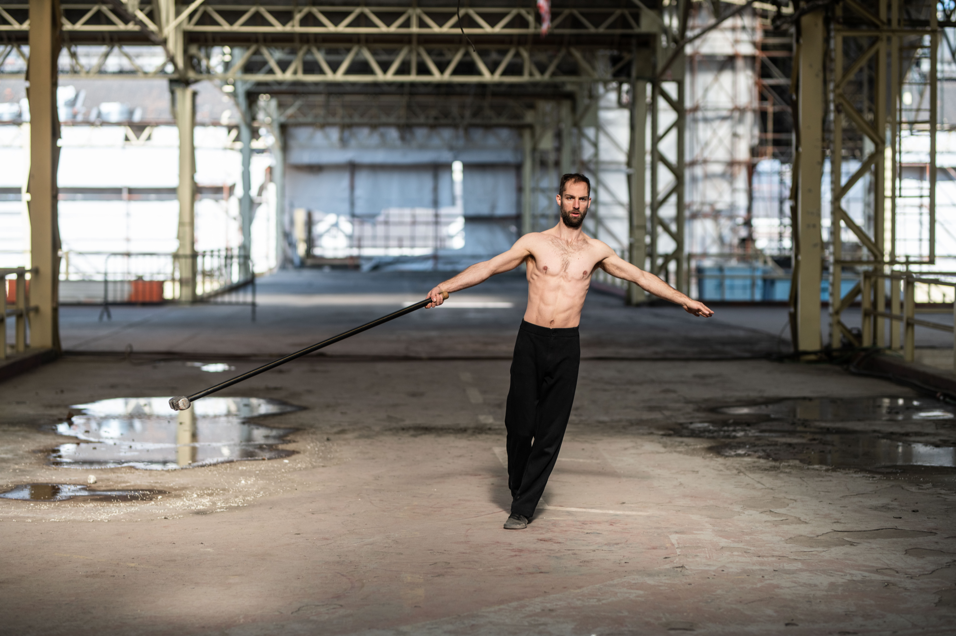

VanThorhout forms an energetic and precise dissection of male power and the cultural imagery surrounding it.

Whether it be ancient gods, classical heroes, soldiers or athletes, the glorification of male power throughout history has often tended towards a celebration of war, aggression, and violence. Thor, to whom the title refers, is one of its most famous personifications of this. He can unleash a thunderstorm and lives on to this day as a superhero in Marvel comics and films, invariably depicted with his Mjölnir, a hammer with an incredibly short handle. At a time when stereotypical forms of masculinity are strongly being challenged, how can we generate new images of men?

In VanThorhout, Alexander comes on stage as Thor, with his own Mjölnir. As always in Alexander’s oeuvre, the relationship between object and performer quickly becomes ambiguous. When do you lose the strength to manipulate this heavy hammer, and when does the hammer take over and become uncontrollable? What if all these images of power disintegrate?

After a series of group choreographies, Alexander Vantournhout now returns to the stage alone.

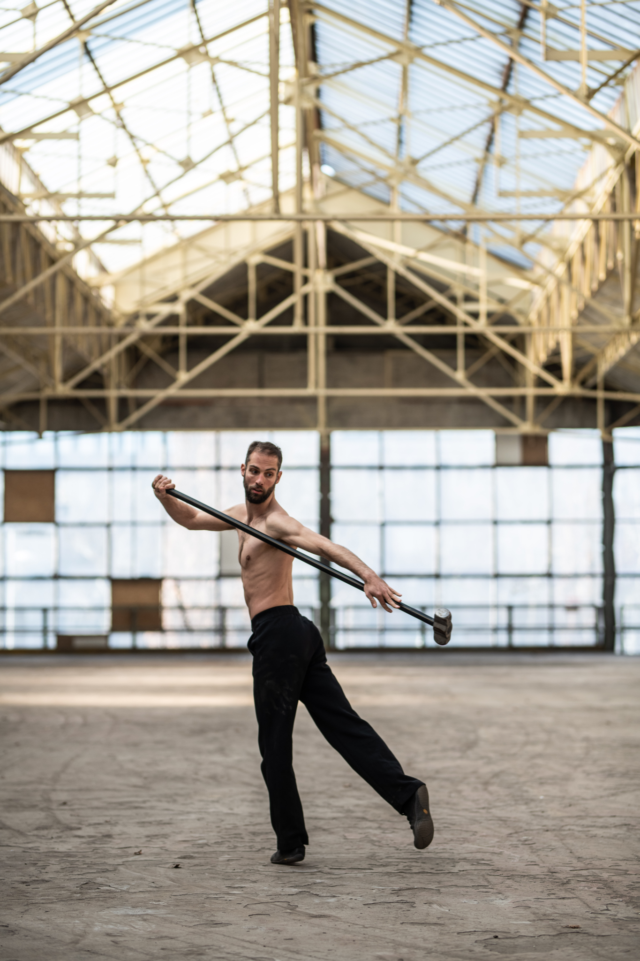
A non-violent Thor
VanThorhout is a new solo by the internationally acclaimed choreographer and circographer Alexander Vantournhout. After a number of group performances, he’s now returning to the stage alone. VanThorhout is an energetic and precise dissection of male power and the cultural images surrounding it. Whether it be ancient gods, heroes of antiquity, soldiers or athletes, the glorification of male power throughout history has often tended towards a celebration of war, aggression and violence. Thor, to whom the title refers, is one of the most famous personifications of this. The Norse and Germanic mythological figure can unleash a thunderstorm. These days his character is present as one of the superheroes in the Marvel comics and films.
At a time when stereotypical forms of masculinity are being questioned, how can we generate new images of men? Vantournhout's solo, which will be performed with an uncovered, muscular torso, dive into the concept of masculine power, going beyond the historical stereotypes and making space for vulnerability and non-violence.
VanThorhout consists of ‘chapters’, each part focusing on an object: sunglasses like those designed by the Inuit, with a narrow slit in a closed surface, a ‘floppy hamer’, an enormous white flag, ... Each of these objects carries cultural references and associations. A Mjölnir, a heavy hammer like Thor's, with a short handle, radiates brute force; the floppy hammer on the other hand, with a long, flexible handle, is both powerful and fragile. Waving the flag has strong nationalistic and militaristic connotations, but a white flag stands for surrender and armistice. Each of these objects also demands a specific set of body movements. In VanThorhout archetypal images are explored by extensive movement research.

The sculptural quality of the work - at times it seems as if you are looking at a sculpture-in-motion, which reminds us of the naked torso of Michelangelo's David - is emphasised by the circular audience set-up. This scenographic context is reminiscent of the circus. In the hammer section, this audience arrangement will create a sense of imminent danger: the floppy hammer that is hurled around could - without Vantournhout's precise body control - potentially injure a spectator. The sequence exudes power without leading to physical violence. In VanThorhout, Thor turns into a non-violent hero.

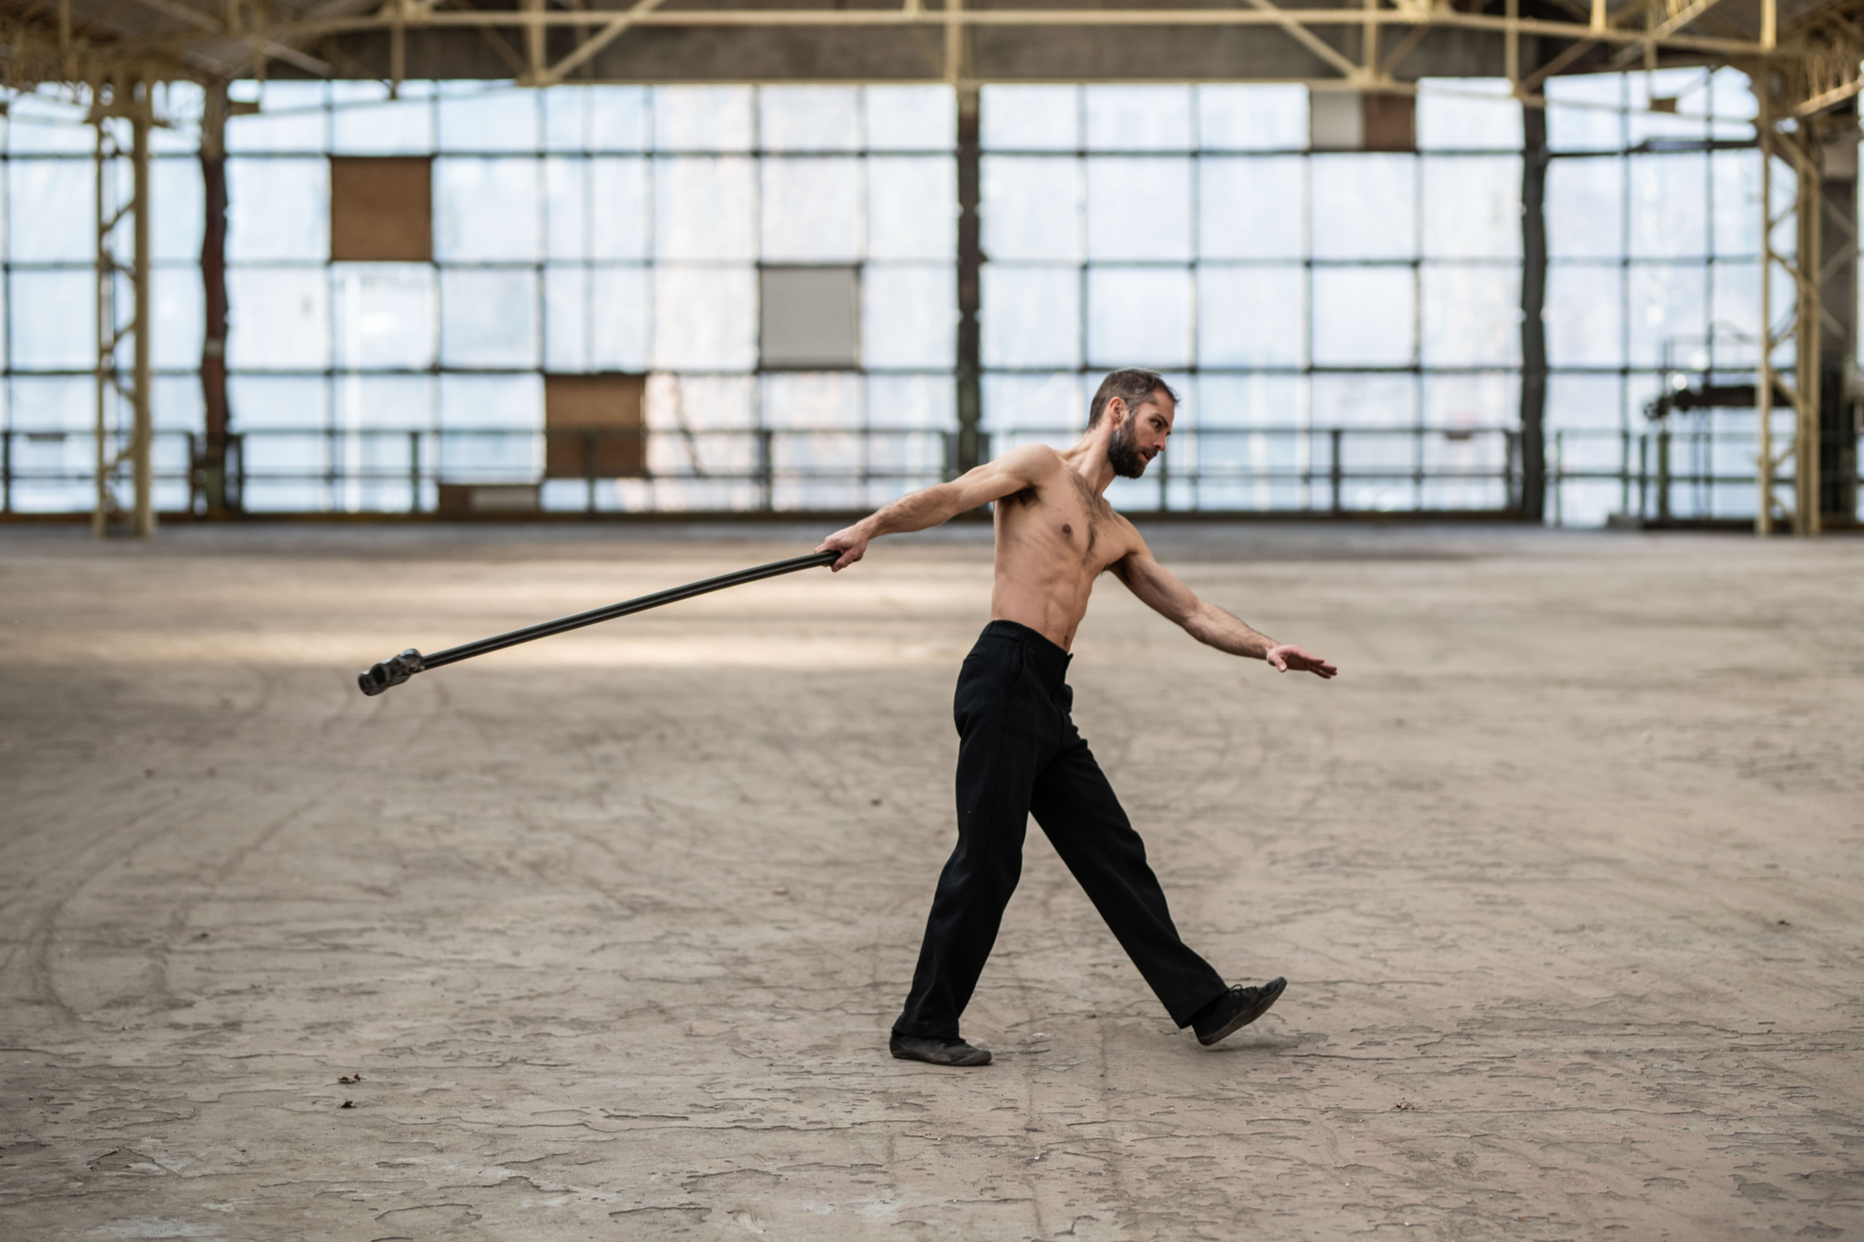
The project within the context of the oeuvre
Alexander Vantournhout's oeuvre, which - VanThorhout included - counts nine productions, is extremely diverse and at the same time very consistent. Whether it be a solo, duet or group choreography, every time again they’re multidisciplinary, combining various media and arts such as acrobatics, contemporary dance and physical theatre.
The relationship of a human performer to a non-human object is omnipresent in the oeuvre of Alexander Vantournhout. When you bring in objects from other contexts such as circus and contemporary dance, something happens to those objects as well as to the disciplines: their everyday functions and affordances become relative. The latter concept refers to the specific manageability that an object presupposes on the basis of its form and constitution. In physical experiments, you can follow the affordance and slowly turn it upside down, or you can go against it, violently. After the roue cyr in Caprices (2014), the buffalo shoes with high soles in Aneckwander (2015, in co-creation with Bauke Lievens) or the ice shoes and bowling ball in Screws (2019), Vantournhout is now adding a number of new objects to his oeuvre.
Movement research in relation to the object
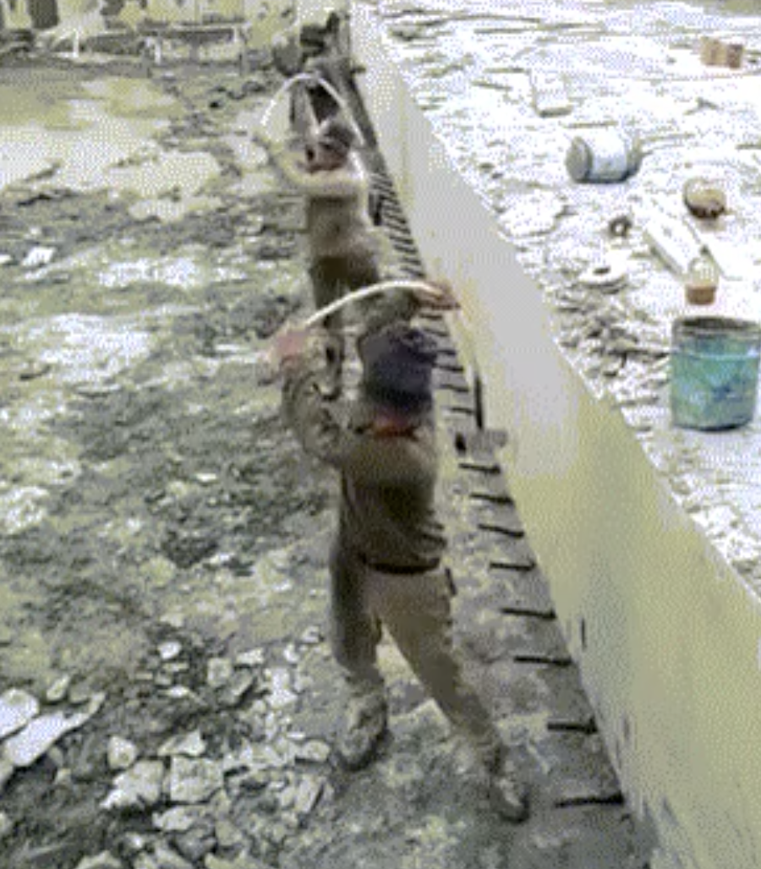
Perhaps the most unusual object used in VanThorhout is the floppy hammer. A hammer is both a weapon and a tool. You can build or destroy something with it. The rigid, phallic shape might easily be associated with patriarchy. Thor's Mjölnir is actually a very inefficient variant. The short handle reduces the efficiency of the heavy hammer, as there is little leverage.
A floppy hammer has very different physical and intrinsic qualities. In 2018, a short video was posted on the internet showing people, allegedly in North Korea, wielding hammers with floppy handles made of bamboo or fibreglass. The hammer was mainly used on metal surfaces and rebar, and in repetitive operations, probably because the slack hammer reduces shock (the force of the impact point returns up through the handle straight to the worker).

A floppy hammer has parallels with some medieval and contemporary weapons, such as the flail or the Indian Urumi, the nunchaku, as well as the snooker ball-in-sock. These weapons are used more for striking or whipping than for actual hammering. However, they are notoriously difficult to use in complex, improvised and fast-moving combat situations. They can pose a real risk to the user: they can throw him off balance and injure him or herself. In these cases, the human subject wielding the hammer simultaneously becomes the object manipulated by the hammer; the perpetrator becomes the victim. When do you lose control over this object? How do power relations suddenly shift?
Credits

Choreography & performance Alexander Vantournhout
Artistic assistant: Emmi Väisänen
Dramaturgy: Rudi Laermans & Sébastien Hendrickx

Prop design: Tom De With & Willy Cauwelier
Light design: Bert Van Dijck
Costumes: Patty Eggerickx

Outside eye: Charlotte Cétaire, Anneleen Keppens, Esse Vanderbruggen & Sandy Williams
Object manipulation outside eyes: Simon Janson & Sebastian Berger
Thanks to: Bojana Cvejić, Ben Mcewen & Tom Van der Borght

Technical coordination: Rinus Samyn
Technicians on tour: Tijs Bonner & Bram Vandeghinste

Company manager: Esther Maas
Production manager: Barbara Falter, Aïda Gabriëls & Kiki Verschueren
Diffusion: Frans Brood Productions

With the support of la Fondation d’entreprise Hermès within the context of the New Settings programme.

Production: not standing
Co-production: Kunstencentrum VIERNULVIER (Gent), Le CENTQUATRE (Paris), Les Subsistances – SUBS (Lyon), Les 2 Pôles Nationaux des Arts du Cirque normands – La Brèche (Cherbourg) & le Cirque-Théâtre d'Elbeuf, 3 bis f – centre d'arts contemporains (Aix-en-Provence)

With the support of the Flemish authorities.
Alexander Vantournhout is artist-in-residence in Kunstencentrum VIERNULVIER in Gent and associated artist of le CENTQUATRE Paris and Cirque-théâtre Elbeuf. He is cultural ambassador of the city of Roeselare and is also supported by Fondation BNP Paribas for the development of his projects. ﻿

Biography Alexander Vantournhout

not standing was founded by choreographer Alexander Vantournhout.

Alexander Vantournhout (Brussels, 1989) studied cyr wheel and juggling at ESAC (Ecole Supérieure des Arts du Cirque) and contemporary dance at P.A.R.T.S. (Performing Arts Research and Training Studios) in Brussels.

Alexander Vantournhout's physical language bears the influences of a varied education and working circumstances. However, it is marked by two constants: his search for the creative and kinetic potential in physical limitation, and the relationship or boundary between performer and object.
2014 marked the premiere of his first piece, Caprices, a choreographic solo set to the music of Sciarrino. Aneckxander (2015), a second solo, co-created with Bauke Lievens, won the CircusNext Prize, as well as the Young Theatre Prize and the Audience Prize at Theater Aan Zee (Ostend, 2015) and the Aerowaves network. His first duet Raphael (2017) was also co-created with Bauke Lievens.
In 2018, Alexander Vantournhout created La Rose en Céramique, a movement solo that accompanied Scali Delpeyrat's theatrical solo at the Avignon Festival. His first piece for four men, Red Haired Men, followed shortly afterwards. In Screws, created in 2019, Alexander Vantournhout guides the audience, accompanied by 4 dancer-acrobats, on a journey of reverberating micro-performances, ranging from short solos and duets to group choreographies.

With Through the Grapevine (2020), Alexander Vantournhout returns to the duet format. This is his first real duet and it’s to some extent inspired by the concept of Aneckxander (2015). The body is reintroduced in a very pure way and the performance dives into the creative and kinetic potential of physical limitations, a theme that is reflected throughout Alexander Vantournhout's work. In Contre-jour (2021) Alexander Vantournhout is no longer on stage as he’s taking on the role of choreographer and gives the floor to a group of five performers from various backgrounds: dance, musical theatre, circus, etc. The premiere took place in November 2021 at the CENTQUATRE in Paris.

Aneckxander (2016) as well as Screws (2020), Through the Grapevine (2021) and Snakearms (2021) were selected for the TheaterFestival, the prize for the most outstanding Belgian performances.

Alexander Vantournhout is artist-in-residence at the Vooruit Art Centre in Ghent, associate artist of the CENTQUATRE Paris and the Cirque-théâtre Elbeuf. He is a cultural ambassador of the city of Roeselare. Alexander Vantournhout is supported by the BNP Paribas Foundation for the development of his projects.

https://notstanding.com/

contact

Alexander Vantournhout
artistic director + choreographer
alexander@notstanding.com
Esther Maas
company manager
esther@notstanding.com

Kiki Verschueren
production + tour manager + communication
kiki@notstanding.com

Barbara Falter
administration + tour manager
barbara@notstanding.com

Rinus Samyn
technical director
rinus@notstanding.com

Diffusion
Flore Roggeman & colleagues at Frans Brood Productions
flore@fransbrood.com
Legal details company not standing
Not Standing vzw
Beversesteenweg 78
8800 Roeselare
VAT: BE 0849 019 917

