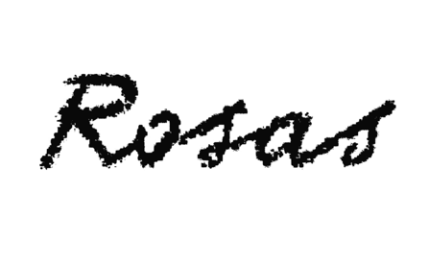

EXIT ABOVE

after the tempest / d'après la tempête / naar de storm

Anne Teresa De Keersmaeker, Meskerem Mees, Jean-Marie Aerts, Carlos Garbin / Rosas

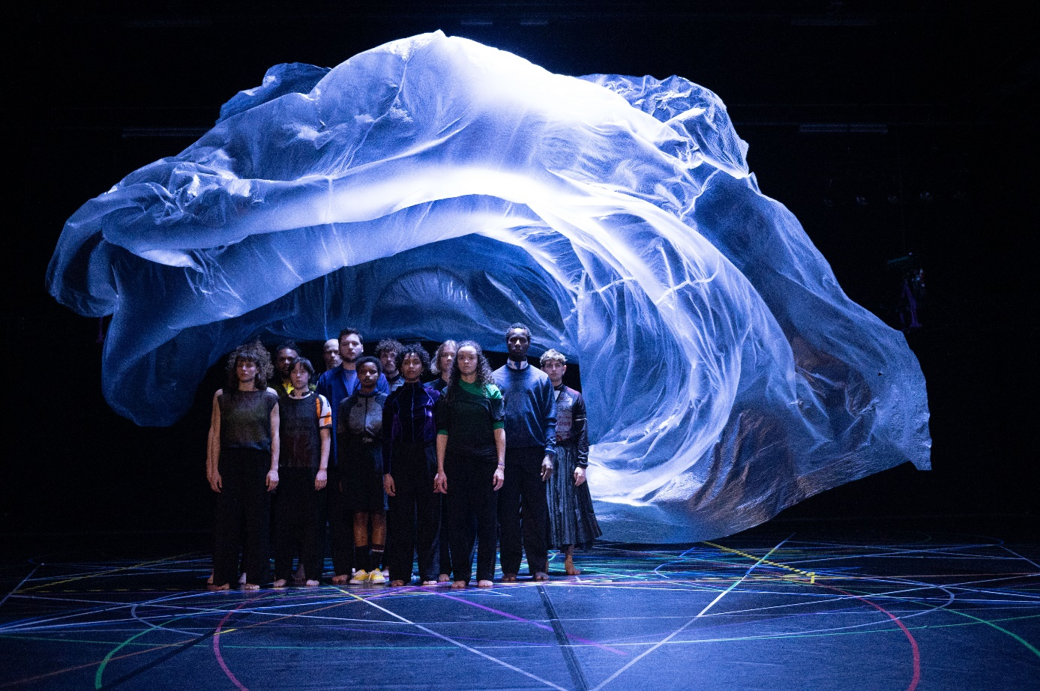
© Anne Van Aarschot - Scenography Michel François

Always contact Rosas before publication.
For EXIT ABOVE, Anne Teresa De Keersmaeker retraces her steps: to the roots of dance, the roots of Western pop music. Since her earliest work, ‘my walking is my dancing’ is one of her guiding principles: walking as a primary form of movement, so familiar that we hardly stop to think about it. Also in terms of the music, De Keersmaeker embarks on a journey towards a starting point that is in fact an intersection: the roots of pop music, the blues, and its mysterious ‘blue notes,’ in-between zones, between major and minor, sorrow and joy. The starting point for the performance is the song Walking Blues by legendary blues artist Robert Johnson; even though the journey leads back to Der Wanderer by Schubert, the best known singer-songwriter of the 19th Century. Meskerem Mees, an upcoming Flemish singer songwriter with Ethiopian roots, composed a series of variations, permutations, and other adaptations of 'walking songs,’ together with Jean-Marie Aerts, sound architect of TC Matic, the legendary Belgian 80s rock formation around singer Arno, and with dancer and guitarist Carlos Garbin.
In EXIT ABOVE, walking as primal motion and the blues as musical source meet. Choreographically, De Keersmaeker always moves from organically opening up simple movement material toward spatial and physical complexity, using precise geometrical patterns. EXIT ABOVE explores the tension between marching together and stepping out, between romantic solitary ‘wandern’ (wandering) and the political potential of a group of unarmed people walking together, the individual and the collective, the line and the circle. The act of walking runs counter to the hegemony of functionality and efficiency. It is an effort that produces nothing aside from the passing of time and the crossing of space. However, walking also generates thoughts and reminiscences that reveal the extent to which our inner world is also a landscape – a landscape that can often only be traversed on foot.

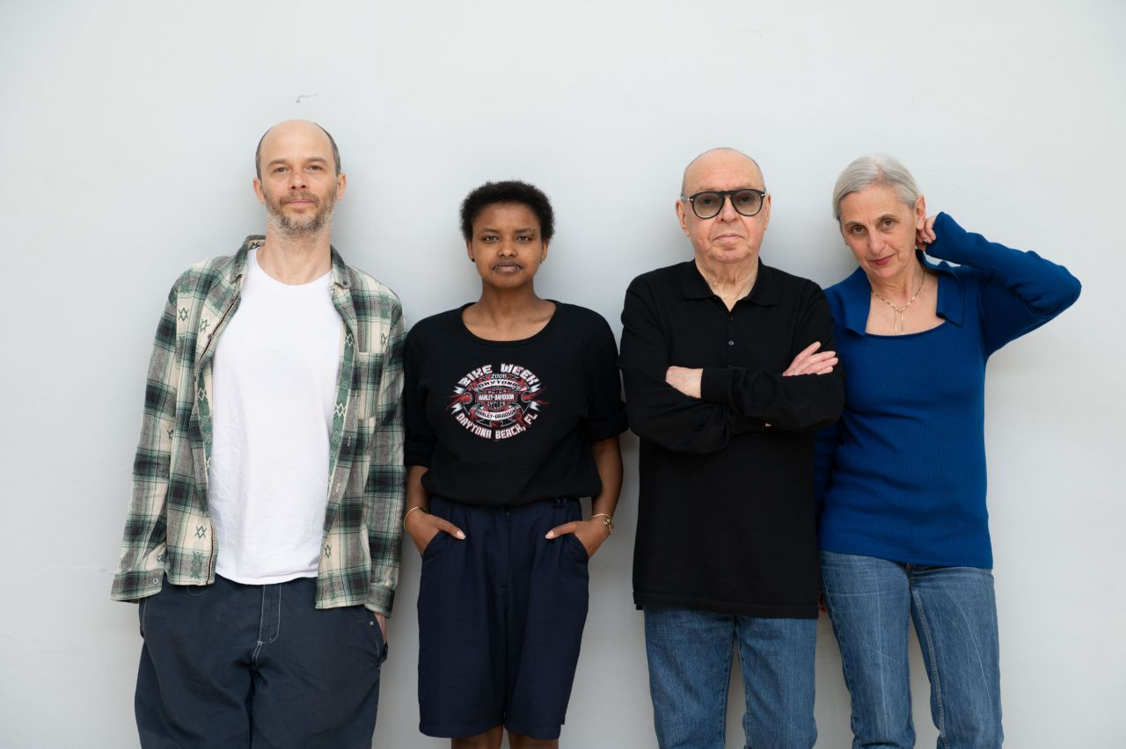

© Anne Van Aarschot

Press

“Forty years after the debut of Rosas, Anne Teresa De Keersmaeker has lost none of her force of invention, here magnified by a young cast. (...) One of the costumes bears the mantra: "I cried to dream again”. De Keersmaeker has turned this waking dream into a manifesto of love.” - Les Inrockuptibles

“One of the highlights of this summer’s Avignon Festival.” – Financial Times

CREDITS
EXIT ABOVE
after the tempest / d'après la tempête / naar de storm

Anne Teresa De Keersmaeker, Meskerem Mees, Jean-Marie Aerts, Carlos Garbin / Rosas
Choreography
Anne Teresa De Keersmaeker
Created with and Danced by
Abigail Aleksander, Jean Pierre Buré, Lav Crnčević, José Paulo dos Santos, Rafa Galdino, Carlos Garbin, Nina Godderis, Solal Mariotte, Meskerem Mees, Mariana Miranda, Ariadna Navarrete Valverde, Cintia Sebők, Jacob Storer
Music
Meskerem Mees, Jean-Marie Aerts, Carlos Garbin
Music performed by
Meskerem Mees, Carlos Garbin
Scenography
Michel François
Light design
Max Adams
Costume design
Aouatif Boulaich
Text and Lyrics
Meskerem Mees, Wannes Gyselinck
Dramaturgy
Wannes Gyselinck
Rehearsal Directors
Cynthia Loemij, Clinton Stringer
Production
Rosas
Coproduction
Concertgebouw Brugge (Bruges), De Munt (Brussels), Internationaal Theater Amsterdam, Le théâtre Garonne (Toulouse), GIE FONDOC OCCITANIE (Le Parvis Tarbes, Scène nationale ALBI Tarn, Le Cratère Alès, Scène nationale Grand Narbonne, Théâtre Garonne)
World Premiere
May 31, 2023, Théâtre National Wallonie-Bruxelles, Brussels
presented by Théâtre National Wallonie-Bruxelles, De Munt, Kaaitheater and Kunstenfestivaldesarts
With the support of Dance Reflections by Van Cleef & Arpels
This production is realized with the support of the Tax Shelter of the Belgian Federal Government, in collaboration with Casa Kafka Pictures – Belfius.
Rosas is supported by the Flemish Community, the Flemish Community Commission (VGC), and by the BNP Paribas Foundation.

CONTACT
Sara Jansen
Press & Communication
T +32 2 344 55 98
sara.jansen@rosas.be
www.rosas.be

Frans Brood Productions
Contact & Distribution
T +32 9 234 12 12
info@fransbrood.be
www.fransbrood.com

