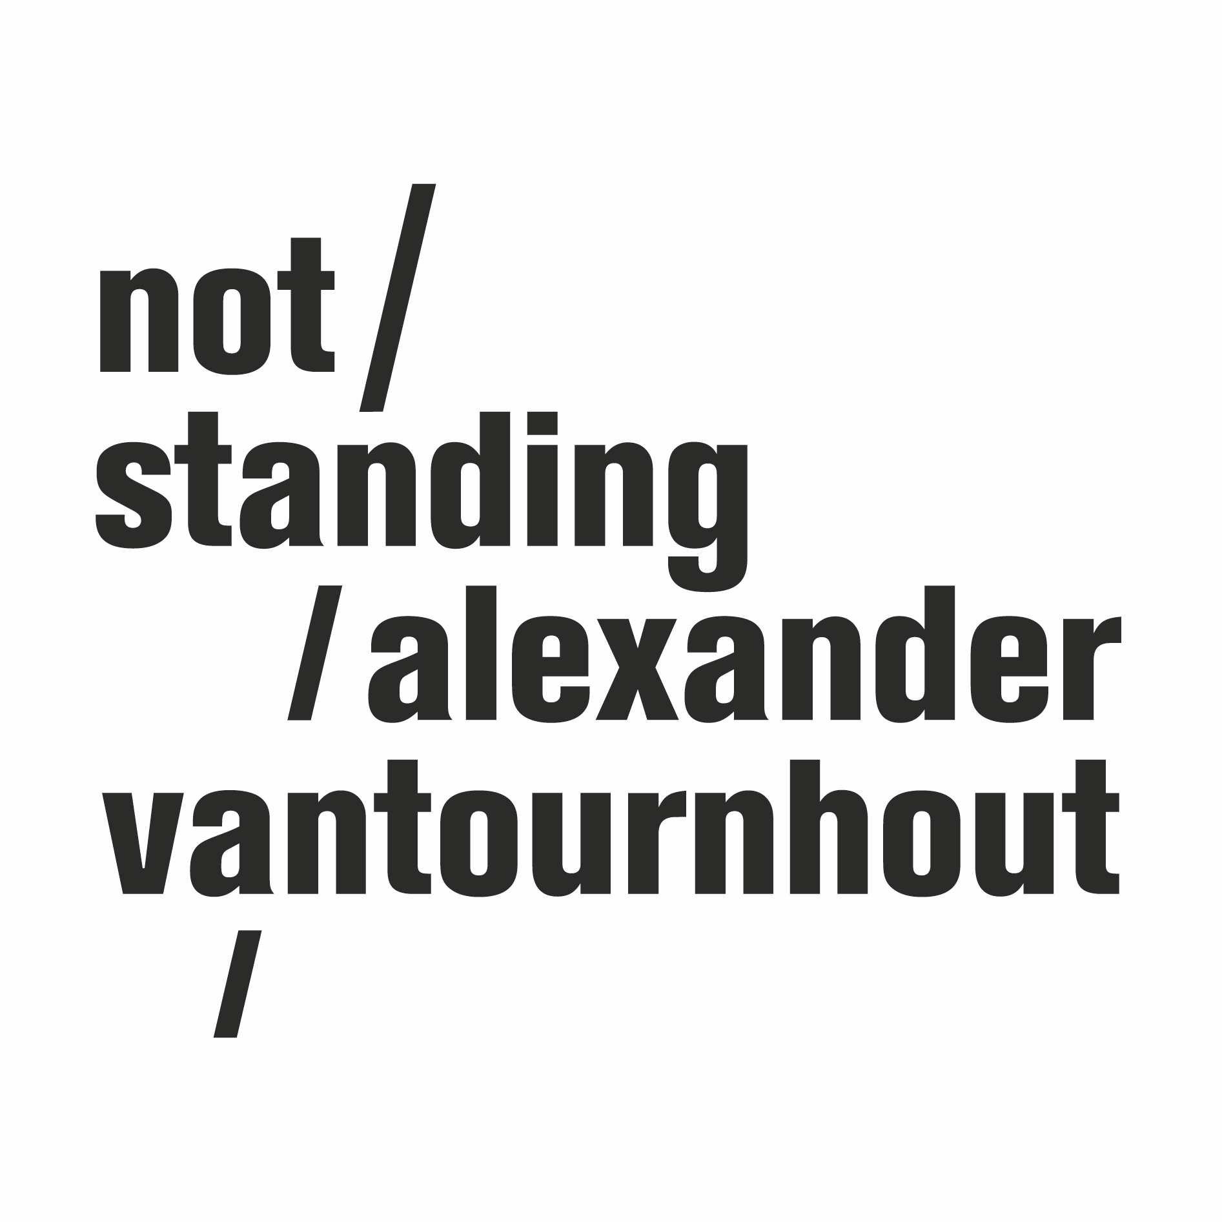
every_body (2024)

In every_body, choreographer Alexander Vantournhout, alongside collaborator Emmi Väisänen, delves into everyday movements. They elevate simple actions like handshakes and walking into a complex canvas of bodily dynamics. The duet transforms an ordinary handshake into an intricate choreography of arms, elbows, and shoulders, while a seemingly endless walk showcases the versatility of leg and footwork. In every_body, the duo crafts a tapestry of choreography, turning even the subtlest of movements into something remarkable.

The performance is further enriched by the sonic landscape created by composer and guitarist Geoffrey Burton. Fashion designer and scenographer Tom Van der Borght designs both the costumes and the surreal setting where every_body takes place.

Over the last decade, Alexander Vantournhout has built a diverse oeuvre. His work includes ensemble pieces like Foreshadow (2023) and SCREWS (2019), as well as solos VanThorhout (2022) and ANECKXANDER (2015). Every_body (2024) is his fourth duet, following projects like Through the Grapevine (2020), La Rose en Céramique (2018), and Raphaël (2017). The new creation marks the next step in his journey to dissect and reinterpret everyday movements, continually challenging and redefining the limits of human physical expression.

Concept: Alexander Vantournhout
Choreography: Emmi Väisänen & Alexander Vantournhout
Performed by: Charlotte Cétaire & Chia-Hung Chung or Emmi Väisänen & Alexander Vantournhout

Costumes & scenography: Tom Van der Borght
Music: Geoffrey Burton

Dramaturgy: Rudi Laermans & Katherina Lindekens
Rehearsal director: Esse Vanderbruggen & Anneleen Keppens
Research collaborator: Esse Vanderbruggen
Constructions: Simon Callens

Tour management: Frans Brood Productions
Company management: Esther Maas
Technical coordination: Bram Vandeghinste
Production & tour management: Barbara Falter & Kiki Verschueren
Communication: Aïda Gabriëls

Production: not standing

Co-production: Kunstencentrum VIERNULVIER, Ghent (BE), La Soufflerie, Rezé (FR), Plateforme 2 Pôles Cirque en Normandie / La Brèche à Cherbourg & le Cirque-Théâtre d’Elbeuf (FR), Theater op de Markt - Dommelhof, Neerpelt (BE)

Residencies: Turku.Dance, Turku (FI), Kunstencentrum VIERNULVIER, Gent (BE), Theater op de Markt - Dommelhof, Neerpelt (BE), Plateforme 2 Pôles Cirque en Normandie / La Brèche à Cherbourg & le Cirque-Théâtre d’Elbeuf (FR), Wood Cube, Roeselare (BE) & CC De Schakel, Waregem (BE)

Special thanks to Kalle Nio

every_body is created with the support of the Tax Shelter of the Belgian Federal Government, via Flanders Tax Shelter.

not standing is supported by the Flemish Government.

Alexander Vantournhout is artist-in-residence at Kunstencentrum VIERNULVIER in Ghent and associated artist of le CENTQUATRE Paris. He is cultural ambassador of the city of Roeselare and is also supported by Fondation BNP Paribas for the development of his projects.

PREMIERE 17 - 18 October 2024 - Cirque-Théâtre d’Elbeuf (FR)

Website
https://notstanding.com
Facebook
https://www.facebook.com/alexandervantournhoutofficial
Instagram
https://www.instagram.com/alexandervantournhout/
Vimeo
https://vimeo.com/user15396321
Youtube
https://www.youtube.com/channel/UCYJuD22fASxeAqx-mdtyJUw

Subscribe to our newsletter
https://bit.ly/newsletternotstanding

