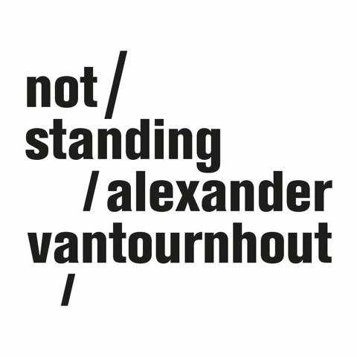

every_body (2024)
movement in a moving way

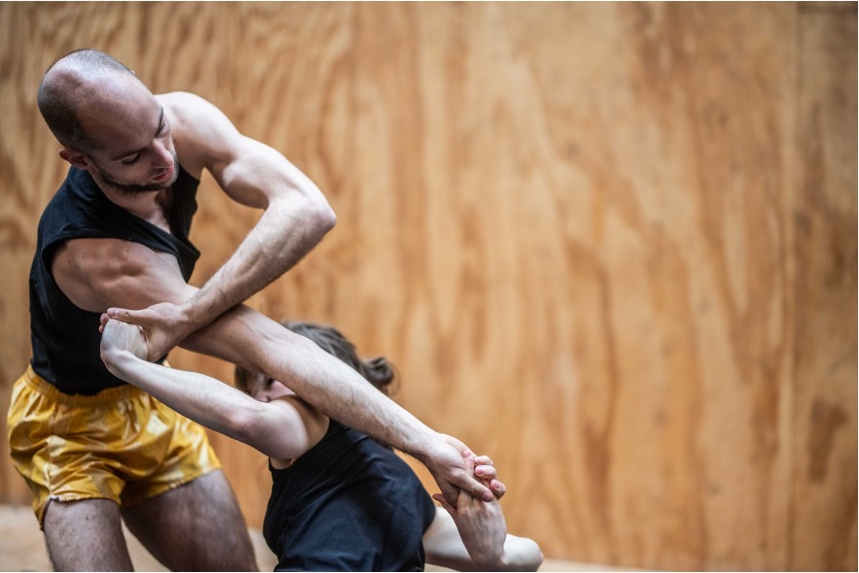

In 2024, Alexander Vantournhout and artistic partner, Emmi Väisänen, will collaborate on every_body. This duet is dedicated to deconstructing and reimagining everyday gestures like handshakes, walking, and balancing, transforming them into intricate sequences of movement, in a moving way. Conceived as a triptych, every_body is organized into distinct but interrelated chapters, each exploring unique aspects of bodily movement.

- SNAKEARMS

Snakearms originated from research for the sake of research. In the midst of the pandemic, in the fall of 2020, Alexander Vantournhout invited long-term collaborator Emmi Väisänen to embark on a research journey focused specifically on the concept of grips. These grips, interpreted abstractly, served as the initial points of contact in various forms of touch and partnering situations, ranging from simple greetings to intricate partner dances.

The choreography was constructed in a manner akin to a palindromic structure. Beginning with the most commonplace point of contact: the handshake, the research in Snakearms expanded to more complex grips that engaged the mobility of the wrist, forearm, and shoulder. Notably, the shoulder emerged as the most agile joint, boasting the widest range of motion within the entire body. Drawing inspiration from monkeys, particularly gibbons, the movement research incorporated their wrist functionality, which resembles our shoulder joint's ability to rotate 360 degrees. Acknowledging the shared ancestry between humans and primates, especially apes, the exploration aimed to enhance the potential of the lower-arm region

“Vantournhout has been inspired by ‘locomotions’ (walking like animals) since his first creation ten years ago. From the wrist joint of a gibbon (which rotates exactly like our shoulder) to the circular symmetry of an octopus, starfish, jellyfish, or sea anemone. Not by imitating the movements of the animals, as that is impossible for humans, but by incorporating them slightly differently into his movement language.”
— de Volkskrant

The opportunity to create a film arose through a commission from VRT (Flemish public TV), Kunstencentrum VIERNULVIER, and Schouwburg Kortrijk. Snakearms, the dance film, was awarded with a selection for Het TheaterFestival → https://vimeo.com/537614716

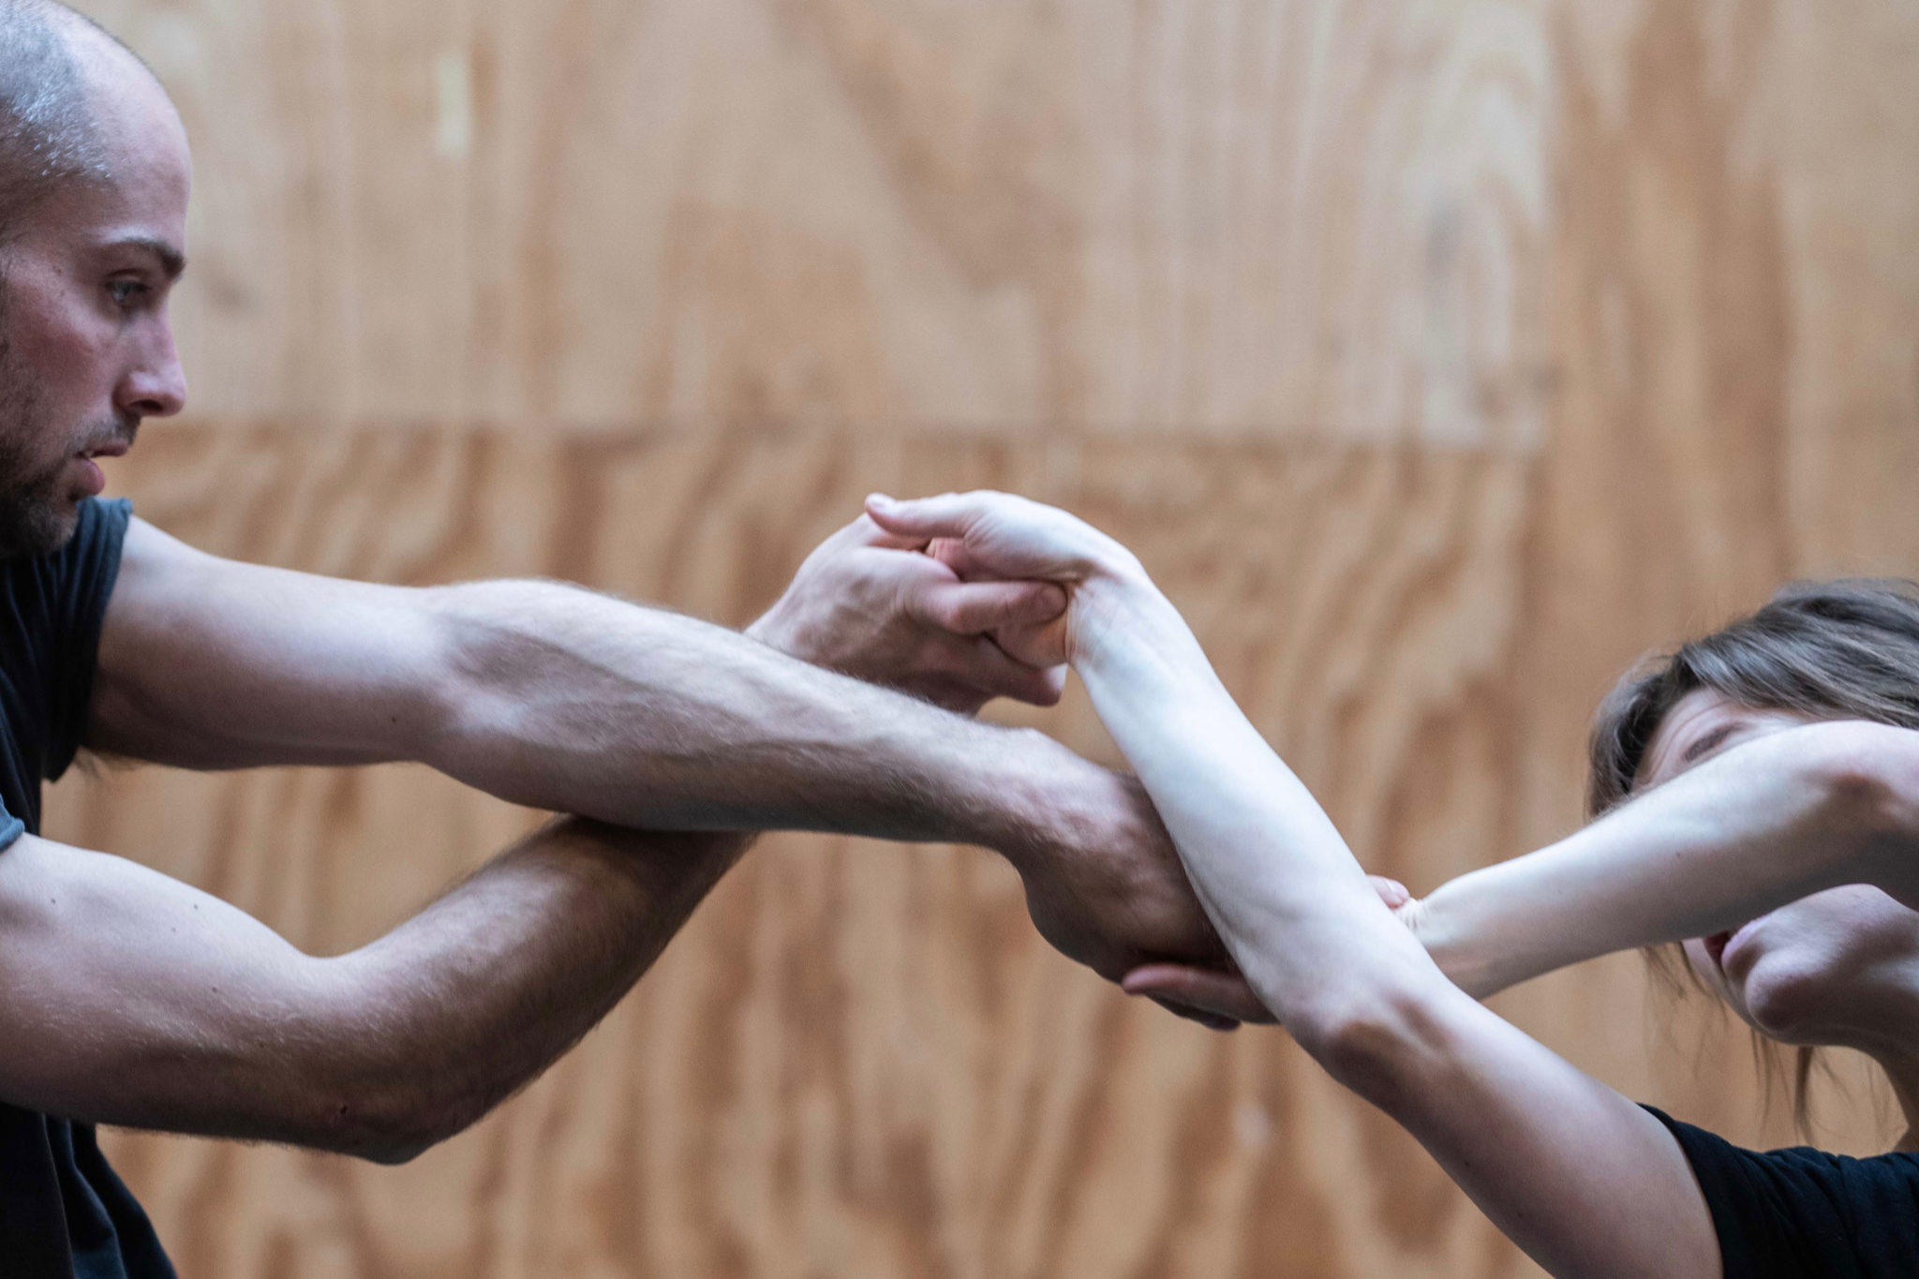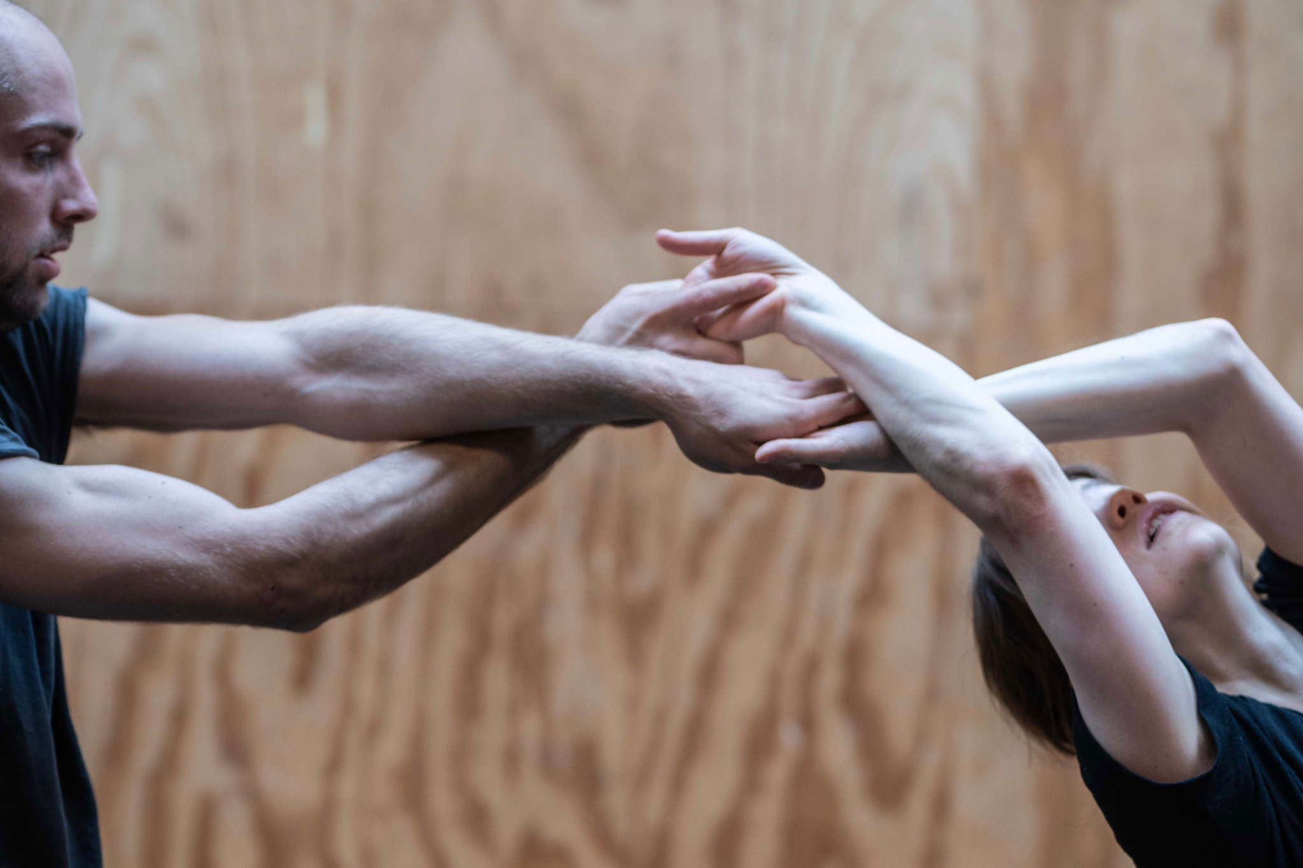

- PRECARIOUS DUET

After a duet focusing on the four hands and arms in Snakearms, the second part of every_body introduces the other limbs — legs and feet — into the foreground through intricate movement play on a treadmill. By placing the act of walking on this treadmill, constant motion is possible without actual forward progress, thereby creating an infinite movement, akin to a perpetual motion machine.

"Frequently, a stage is just too small; even a more spacious theatre may only allow for a mere 20 meters of running before reaching either the backdrop or the front row. This has often been a source of frustration for me."
– Alexander Vantournhout
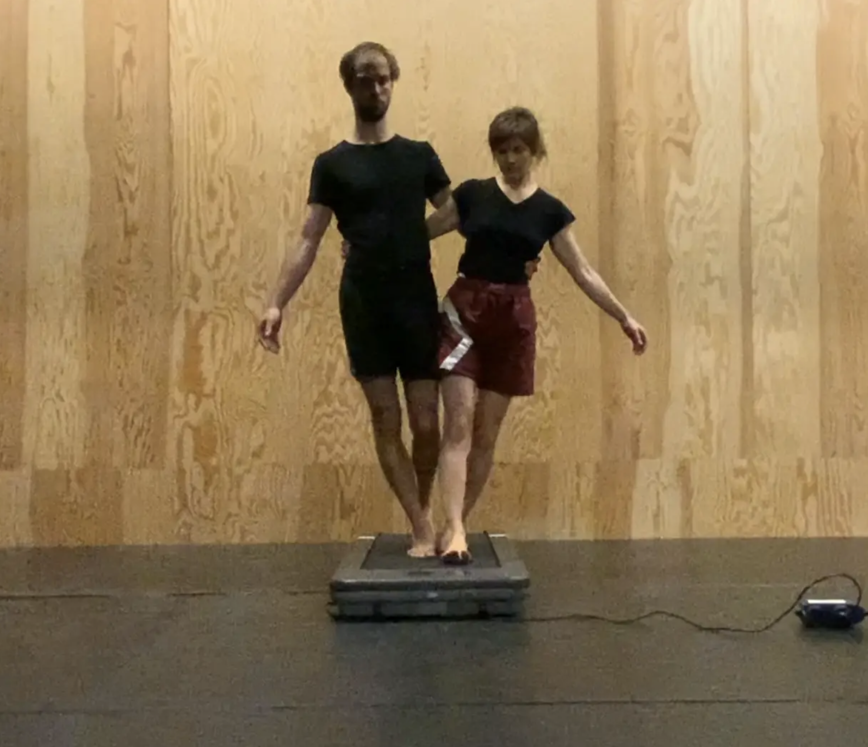

Although walking together on a treadmill may seem simple, it is technically quite challenging. Trust in the other person is constantly at stake. In this precarious duet, the pas-de-deux could not be more literal. Individually the dancer is off balance, but together the dancers are in a constantly evolving balance that again and again emerges in between them, as Johann le Guillerm writes, “Balance is the time between two imbalances.”

First research →
https://vimeo.com/878662219/b86518862f?share=copy

- HANGING DUET

To take the idea of limb entanglement even further and remove the limitations of the floor, Emmi and Alexander began research on a hanging duet. The position is inspired by daily commuting scenarios in trams, metros, and buses, where individuals hold onto a bar for stability.

In the hanging duet, the idea is counterbalanced by completely losing contact with the floor. Choreography — or 'circography' — will be created while hanging. A bar is positioned at a height that Alexander can reach while standing, but Emmi falls just short, necessitating a connection or interlinking between them.
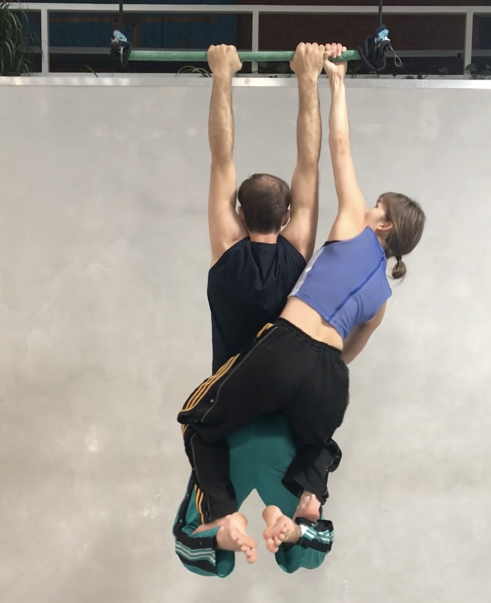

First research → https://vimeo.com/648476595/bd3c9169eb?share=copy

BIOGRAPHIES

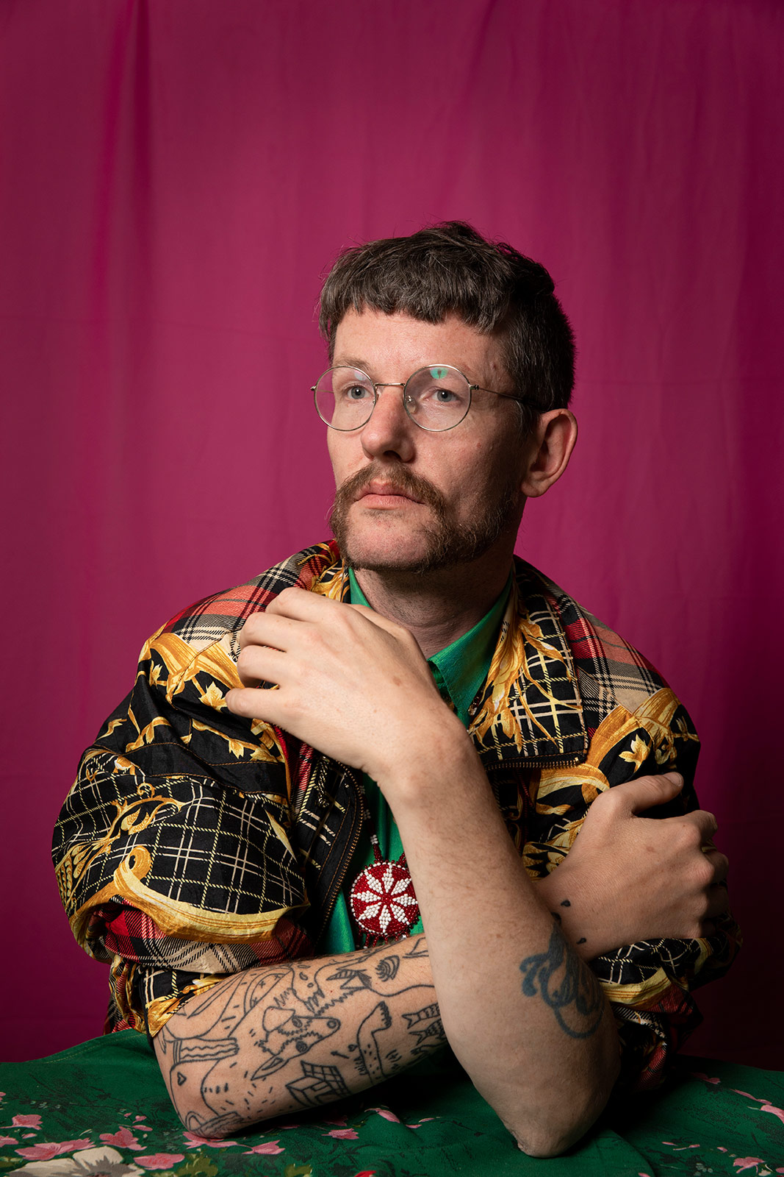
COSTUME DESIGN

For costumes, Alexander will collaborate with fashion designer and visual artis Tom Van der Borght. His expressive creations boldly combine vivid colors, psychedelic patterns, and original textures. The designer challenges traditional notions of beauty, offering his own interpretation of this timeless concept. Always in search of the unconventional, Tom Van der Borght questions dominant social structures: What does society consider normal, and why? In his couture collections, he unhesitatingly employs industrial and high-tech materials and machinery, blending contemporary techniques with traditional craftsmanship. Similarly, Alexander consistently incorporates craftsmanship into a new, contemporary language of movement.

Discover the work of Tom Van der Borght → https://tomvanderborght.com

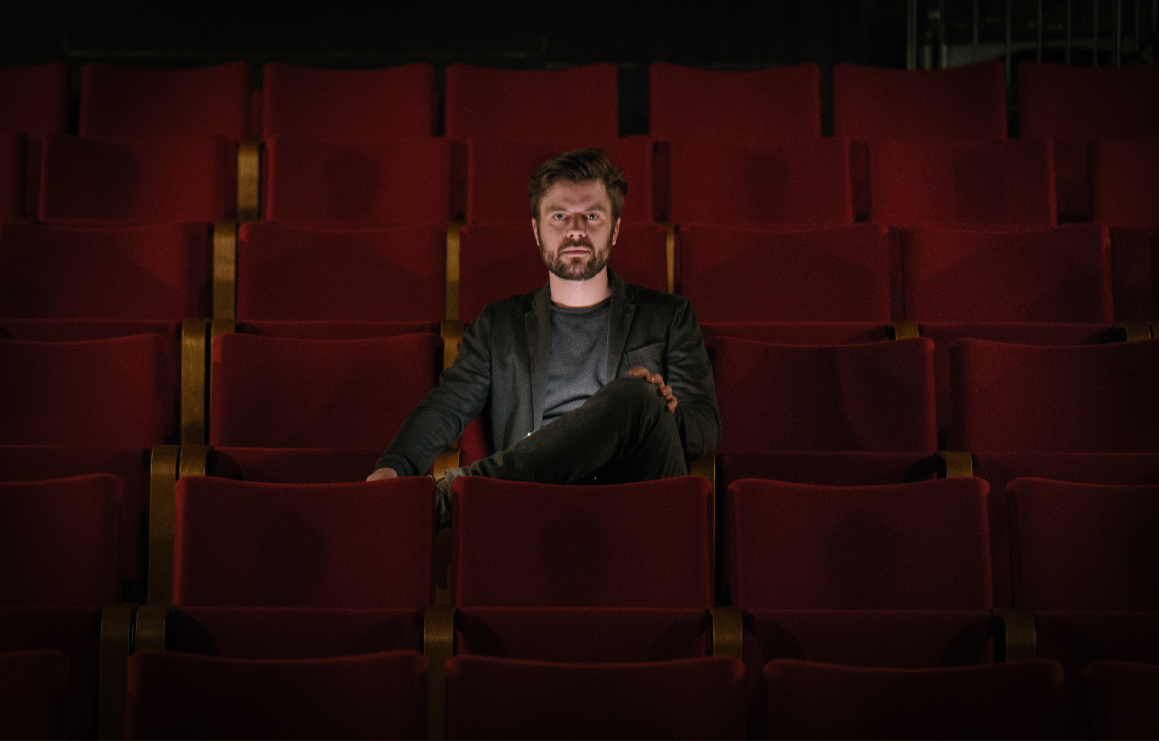
SCENOGRAPHY

The scenography will be developed by Kalle Nio. Together with Alexander, they’ll explore the concept of relativity theory. They will attempt to represent static movement in a dynamic way, oscillating the perception of speed. They may also experiment with the old cinematographic technique of moving backdrops to create the illusion of movement while remaining stationary.

The work of visual artist, magician and stage director Kalle Nio is a combination of magic, visual arts, cinema, art history, circus and theatre. In his stage performances and cinematic installations, Nio creates encounters between past and the present, between magic and visual arts, between craft and technology, between real and illusions. He often uses elements from 19th century stage magic as the starting point for his highly visual explorations of the human body and human relationships in our society.

Discover the universe of Kalle Nio → https://kallenio.com/projects
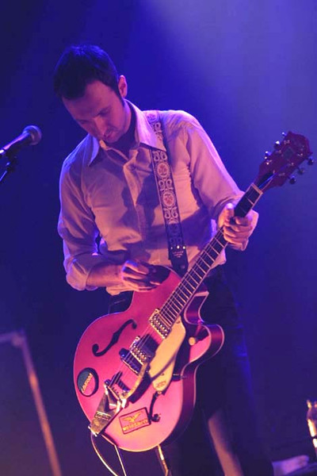
MUSIC

The music for every_body will be created by Geoffrey Burton. Geoffrey Burton has established himself as one of the most respected and recognized guitarists, not just in Belgium but internationally. His career, spanning over 25 years, has seen him collaborate both as musician and producer with a list of renowned artists, including Alain Bashung, Arno, Charlotte Adigéry, Sophie Hunger, Iggy Pop, Grace Jones, Mísia, Botanica, Soulwax, Stéphane Eicher, Rodolphe Burger, Jacques Higelin, Roland, The Rhythme Junks, Warhaus, Daan, and Triggerfinger.

In September 2020, Burton released his first solo album, Me Ta Podia. It was well-received by the audience and the music press, marking Burton's versatility and skill not only as a guitarist and a collaborator but also as a solo artist. Burton's capacities extend beyond traditional music performances. He has frequently contributed his musical talents to theater productions and television work.

Listen to Geoffrey Burton →
https://open.spotify.com/album/2YR8nNkOC3dJRgtqKp9Fri?si=Ko_o02dFSIaw8bL3S8k7yw

CAST

every_body will primarily be developed by Alexander Vantournhout and Emmi Väisänen, who will also perform the show. However, a second cast — consisting of Charlotte Cétaire and Chia-Hung Chung — will be involved in both the creation and performance of the show. They will join the tour immediately, not as understudies, but as a fully-fledged second cast.

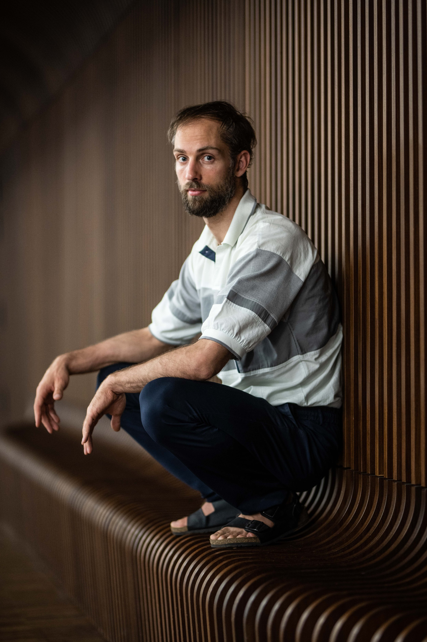
CONCEPT, CHOREOGRAPHY & PERFORMANCE

not standing was founded by choreographer Alexander Vantournhout.

Alexander Vantournhout (Brussels, 1989) studied cyr wheel and juggling at ESAC (Ecole Supérieure des Arts du Cirque) and contemporary dance at P.A.R.T.S. (Performing Arts Research and Training Studios) in Brussels.

Alexander Vantournhout's physical language bears the influences of a varied education and working circumstances. However, it is marked by two constants: his search for the creative and kinetic potential in physical limitation, and the relationship or boundary between performer and object.

2014 marked the premiere of his first piece, Caprices, a choreographic solo set to the music of Sciarrino. Aneckxander (2015), a second solo, co-created with Bauke Lievens, won the CircusNext Prize, as well as the Young Theatre Prize and the Audience Prize at Theater Aan Zee (Ostend, 2015) and the Aerowaves network. His first duet Raphael (2017) was also co-created with Bauke Lievens. In 2018, Alexander Vantournhout created La Rose en Céramique, a movement solo that accompanied Scali Delpeyrat's theatrical solo at the Festival d’Avignon. His first piece for four men, Red Haired Men, followed shortly afterwards. In SCREWS, created in 2019, Alexander Vantournhout guides the audience, accompanied by 4 dancer-acrobats, on a journey of reverberating micro-performances, ranging from short solos and duets to group choreographies. With Through the Grapevine (2020), Alexander Vantournhout returns to the duet format. This is his first real duet and is to some extent inspired by the concept of Aneckxander (2015). The body is reintroduced in a very pure way and the performance dives into the creative and kinetic potential of physical limitations, a theme that is reflected throughout Alexander Vantournhout's work. In Contre-jour (2021) Alexander Vantournhout takes on the role of choreographer for the first time and gives the floor to a group of five performers from various backgrounds: dance, musical, theatre, circus, etc. In 2022 Alexander Vantournhout returns solo on stage with VanThorhout. Foreshadow, a creation with 8 performers, premiered in 2023 at Julidans in Amsterdam. 2024 marks the premiere of every_body.

Aneckxander as well as SCREWS, Through the Grapevine and VanThorhout were selected for het TheaterFestival, the prize for the most outstanding Belgian performances.

Alexander Vantournhout has created two dance films, Screws & Stones and Snakearms. The latter was selected for het TheaterFestival, NY Segal Film Festival and Cinedans Festival.

Alexander Vantournhout is artist-in-residence at the Kunstencentrum VIERNULVIER in Ghent and associate artist of the CENTQUATRE Paris. He is a cultural ambassador of the city of Roeselare and supported by the BNP Paribas Foundation for the development of his projects.

“Alexander Vantournhout's work is so ingenious. In just a few years Vantournhout has developed a unique choreographic language that draws on dance techniques, martial arts, circus, yoga, anatomy and the animal world.”
— Charlotte de Somviele, De Standaard

CHOREOGRAPHY & PERFORMANCE
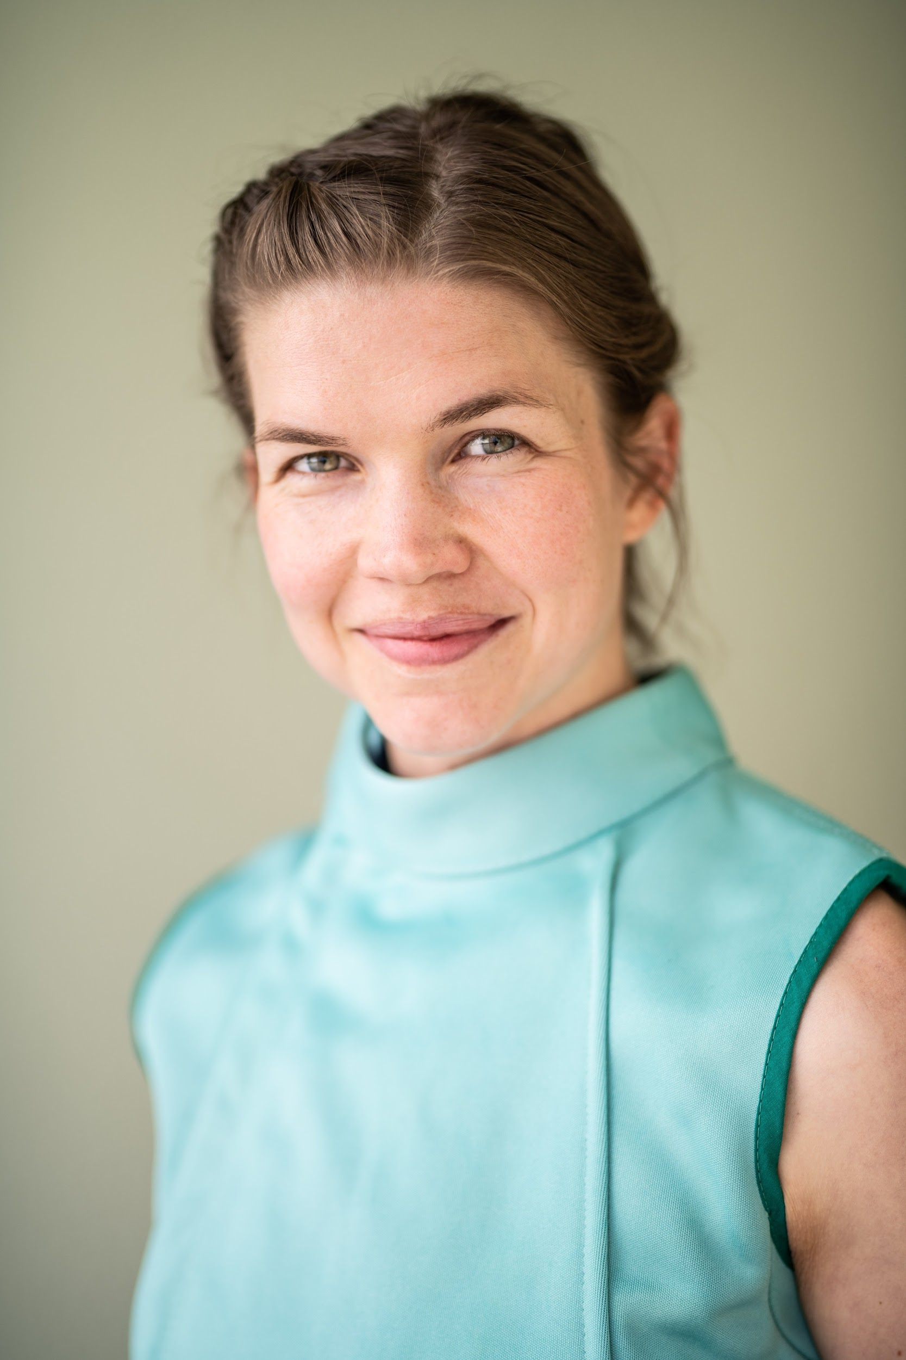
Emmi Väisänen is a contemporary dancer based in Brussels, Belgium. Trained at Turku Conservatory (Finland) and S.E.A.D (Salzburg Experimental Academy of Dance, Austria), she collaborated with choreographers like Alexandra Waierstall, Julia Schwarzbach, Kinga Jaczewska and Alice Van der Wielen-Honinckx. Notably, Emmi has worked extensively with ECCE/Claire Croizé & Etienne Guilloteau and not standing/Alexander Vantournhout for whom she’s been involved both as a performer, research collaborator and choreographer for multiple creations such as Screws, Through the Grapevine, Snakearms, Contre-jour, VanThorhout, Foreshadow and every_body.

Emmi has shared her expertise through teaching dance workshops in Belgium (P.A.R.T.S, Passerelle) and Finland, as well as partnering workshops with Alexander Vantournhout at P.A.R.T.S summerschool/Brussels, Tanzwerkstatt/Münich, Deltebre danza/Spain, and Summer Intensive/Vilnius Lithuania.
PERFORMANCE INFO

Genre: dance
Duration of the performance: 60 minutes
Age limit: +14 (performance for adult audience)

Capacity: max 400 (depending on the space)
Minimum size stage: 6m x 6m (rigging needs to be possible for static aerial apparatus)

The team on tour consists of 4 or 5 people:
- 2 performers
- 1 technician
- 1 tour manager
- 1 company manager (depending on the tour)

CREDITS

Concept: Alexander Vantournhout
Choreography: Emmi Väisänen & Alexander Vantournhout
Performed by: Emmi Väisänen & Alexander Vantournhout or Charlotte Cétaire & Chia-Hung Chung

Costumes: Tom Van der Borght
Scenography: Kalle Nio
Music: Geoffrey Burton
Dramaturgy: Rudi Laermans & Katherina Lindekens
Rehearsal director: Anneleen Keppens
Research collaborator: Esse Vanderbruggen

Tour management: Frans Brood Productions
Company management: Esther Maas
Technical coordination: Bram Vandeghinste
Production & tour management: Barbara Falter & Kiki Verschueren
Communication: Aïda Gabriëls
Images: Bart Grietens

Production: not standing

Co-production: Kunstencentrum VIERNULVIER, Ghent (BE), La Soufflerie, Rezé (FR), Plateforme 2 Pôles Cirque en Normandie / La Brèche à Cherbourg & le Cirque-Théâtre d’Elbeuf (FR), Theater op de Markt - Dommelhof, Neerpelt (BE), Theater Freiburg (GE)

Residencies: Turku.Dance (FI), Kunstencentrum VIERNULVIER, Ghent (BE), Theater op de Markt - Dommelhof, Neerpelt (BE), 2 Pôles Cirque en Normandie / La Brèche à Cherbourg – Cirque-Théâtre d’Elbeuf (FR), Wood Cube, Roeselare (BE)

Created with the support of the Tax Shelter of the Belgian Federal Government, via Flanders Tax Shelter

not standing is supported by the Flemish Government.
Alexander Vantournhout is artist-in-residence at Kunstencentrum VIERNULVIER in Ghent and associated artist of le CENTQUATRE Paris. He is cultural ambassador of the city of Roeselare and supported by Fondation BNP Paribas for the development of his projects.

PREMIERE

17 - 19 October 2024 - Cirque-Théâtre d’Elbeuf (FR)
CONTACT

Alexander Vantournhout
Artistic director, choreographer
info@notstanding.com

Esther Maas
Company manager
esther@notstanding.com

Barbara Falter
Administration, production manager
barbara@notstanding.com

Kiki Verschueren
Tour manager
kiki@notstanding.com

Aïda Gabriëls
Communication
aida@notstanding.com

Bram Vandeghinste
Technical coordination
bram@notstanding.com

Flore Roggeman - Frans Brood Productions
Tour planning
flore@fransbrood.com

Not Standing vzw
Beversesteenweg 78
8800 Roeselare
BELGIUM
BTW: BE 0849 019 917

Website
https://notstanding.com
Facebook
https://www.facebook.com/alexandervantournhoutofficial
Instagram
https://www.instagram.com/alexandervantournhout/
Vimeo
https://vimeo.com/user15396321
Youtube
https://www.youtube.com/channel/UCYJuD22fASxeAqx-mdtyJUw

Subscribe to our newsletter:
https://bit.ly/newsletternotstanding

